**January LeetCoding Challenge 2021**

Week 1: January 1st - January 7th

~~+35~~

**Palindrome Permutation**

~~+10~~

**Check Array Formation Through Concatenation**

~~+10~~

**Find a Corresponding Node of a Binary Tree in a Clone of That Tree**

~~+10~~

**Beautiful Arrangement**

~~+10~~

 Merge Two Sorted Lists

~~+10~~

**Remove Duplicates from Sorted List II**

~~+10~~

**Kth Missing Positive Number**

~~+10~~

Longest Substring Without Repeating Characters

Week 2: January 8th - January 14th

~~+35~~

**Find Root of N-Ary Tree**

~~+10~~

**Check If Two String Arrays are Equivalent**

~~+10~~

Word Ladder

~~+10~~

**Create Sorted Array through Instructions**

~~+10~~

Merge Sorted Array

~~+10~~

Add Two Numbers

~~+10~~

**Boats to Save People**

~~+10~~

**Minimum Operations to Reduce X to Zero**

Week 3: January 15th - January 21st

~~+35~~

Nested List Weight Sum

~~+10~~

**Get Maximum in Generated Array**

~~+10~~

Kth Largest Element in an Array

~~+10~~

**Count Sorted Vowel Strings**

~~+10~~

**Max Number of K-Sum Pairs**

~~+10~~

Longest Palindromic Substring

~~+10~~

 Valid Parentheses

~~+10~~

**Find the Most Competitive Subsequence**

Week 4: January 22nd - January 28th

~~+35~~

One Edit Distance

~~+10~~

**Determine if Two Strings Are Close**

~~+10~~

**Sort the Matrix Diagonally**

~~+10~~

 Merge k Sorted Lists

~~+10~~

**Check If All 1's Are at Least Length K Places Away**

~~+10~~

**Path With Minimum Effort**

~~+10~~

**Concatenation of Consecutive Binary Numbers**

~~+10~~

**Smallest String With A Given Numeric Value**

Week 5: January 29th - January 31st

~~+35~~

**Number Of Corner Rectangles**

~~+10~~

**Vertical Order Traversal of a Binary Tree**

~~+10~~

**Minimize Deviation in Array**

~~+10~~

Next Permutation

**Palindrome Permutation**

Given a string, determine if a permutation of the string could form a palindrome.

**Example 1:**

**Input:** "code"

**Output:** false

**Example 2:**

**Input:** "aab"

**Output:** true

**Example 3:**

**Input:** "carerac"

**Output:** true

   Hide Hint #1

Consider the palindromes of odd vs even length. What difference do you notice?

   Hide Hint #2

Count the frequency of each character.

   Hide Hint #3

If each character occurs even number of times, then it must be a palindrome. How about character which occurs odd number of times?

Solution

Approach #1 Brute Force [Accepted]

If a string with an even length is a palindrome, every character in the string must always occur an even number of times. If the string with an odd length is a palindrome, every character except one of the characters must always occur an even number of times. Thus, in case of a palindrome, the number of characters with odd number of occurrences can't exceed 1(1 in case of odd length and 0 in case of even length).

Based on the above observation, we can find the solution for the given problem. The given string could contain almost all the ASCII characters from 0 to 127. Thus, we iterate over all the characters from 0 to 127. For every character chosen, we again iterate over the given string s*s* and find the number of occurrences, ch*ch*, of the current character in s*s*. We also keep a track of the number of characters in the given string s*s* with odd number of occurrences in a variable \text{count}count.

If, for any character currently considered, its corresponding count, ch*ch*, happens to be odd, we increment the value of \text{count}count, to reflect the same. In case of even value of ch*ch* for any character, the \text{count}count remains unchanged.

If, for any character, the count*count* becomes greater than 1, it indicates that the given string s*s* can't lead to the formation of a palindromic permutation based on the reasoning discussed above. But, if the value of \text{count}count remains lesser than 2 even when all the possible characters have been considered, it indicates that a palindromic permutation can be formed from the given string s*s*.

|  |
| --- |
| public class Solution {  public boolean canPermutePalindrome(String s) {  int count = 0;  for (char i = 0; i < 128 && count <= 1; i++) {  int ct = 0;  for (int j = 0; j < s.length(); j++) {  if (s.charAt(j) == i)  ct++;  }  count += ct % 2;  }  return count <= 1;  }  } |

**Complexity Analysis**

* Time complexity : O(n)*O*(*n*). We iterate constant number of times(128) over the string s*s* of length n*n*, i.e. O(128 \cdot n) = O(n)*O*(128⋅*n*)=*O*(*n*).
* Space complexity : O(1)*O*(1). Constant extra space is used.

#### Approach #2 Using HashMap [Accepted]

**Algorithm**

From the discussion above, we know that to solve the given problem, we need to count the number of characters with odd number of occurrences in the given string s*s*. To do so, we can also make use of a hashmap, \text{map}map. This \text{map}map takes the form (\text{character}, \text{number of occurrences of character})(character,number of occurrences of character).

We traverse over the given string s*s*. For every new character found in s*s*, we create a new entry in the \text{map}map for this character with the number of occurrences as 1. Whenever we find the same character again, we update the number of occurrences appropriately.

At the end, we traverse over the \text{map}map created and find the number of characters with odd number of occurrences. If this \text{count}count happens to exceed 1 at any step, we conclude that a palindromic permutation isn't possible for the string s*s*. But, if we can reach the end of the string with \text{count}count lesser than 2, we conclude that a palindromic permutation is possible for s*s*.

The following animation illustrates the process.



|  |
| --- |
| public class Solution {  public boolean canPermutePalindrome(String s) {  HashMap < Character, Integer > map = new HashMap < > ();  for (int i = 0; i < s.length(); i++) {  map.put(s.charAt(i), map.getOrDefault(s.charAt(i), 0) + 1);  }  int count = 0;  for (char key: map.keySet()) {  count += map.get(key) % 2;  }  return count <= 1;  }  } |

**Complexity Analysis**

* Time complexity : O(n)*O*(*n*). We traverse over the given string s*s* with n*n* characters once. We also traverse over the \text{map}map which can grow up to a size of n*n* in case all characters in s*s* are distinct.
* Space complexity : O(1)*O*(1). The \text{map}map can grow up to a maximum number of all distinct elements. However, the number of distinct characters are bounded, so as the space complexity.

#### Approach #3 Using Array [Accepted]

**Algorithm**

Instead of making use of the inbuilt Hashmap, we can make use of an array as a hashmap. For this, we make use of an array \text{map}map with length 128. Each index of this \text{map}map corresponds to one of the 128 ASCII characters possible.

We traverse over the string s*s* and put in the number of occurrences of each character in this \text{map}map appropriately as done in the last case. Later on, we find the number of characters with odd number of occurrences to determine if a palindromic permutation is possible for the string s*s* or not as done in previous approaches.

|  |
| --- |
| public class Solution {  public boolean canPermutePalindrome(String s) {  int[] map = new int[128];  for (int i = 0; i < s.length(); i++) {  map[s.charAt(i)]++;  }  int count = 0;  for (int key = 0; key < map.length && count <= 1; key++) {  count += map[key] % 2;  }  return count <= 1;  }  } |

**Complexity Analysis**

* Time complexity : O(n)*O*(*n*). We traverse once over the string s*s* of length n*n*. Then, we traverse over the \text{map}map of length 128(constant).
* Space complexity : O(1)*O*(1). Constant extra space is used for \text{map}map of size 128.

#### Approach #4 Single Pass [Accepted]:

**Algorithm**

Instead of first traversing over the string s*s* for finding the number of occurrences of each element and then determining the \text{count}count of characters with odd number of occurrences in s*s*, we can determine the value of \text{count}count on the fly while traversing over s*s*.

For this, we traverse over s*s* and update the number of occurrences of the character just encountered in the \text{map}map. But, whevenever we update any entry in \text{map}map, we also check if its value becomes even or odd. We start of with a \text{count}count value of 0. If the value of the entry just updated in map*map* happens to be odd, we increment the value of \text{count}count to indicate that one more character with odd number of occurrences has been found. But, if this entry happens to be even, we decrement the value of \text{count}count to indicate that the number of characters with odd number of occurrences has reduced by one.

But, in this case, we need to traverse till the end of the string to determine the final result, unlike the last approaches, where we could stop the traversal over \text{map}map as soon as the \text{count}count exceeded 1. This is because, even if the number of elements with odd number of occurrences may seem very large at the current moment, but their occurrences could turn out to be even when we traverse further in the string s*s*.

At the end, we again check if the value of \text{count}count is lesser than 2 to conclude that a palindromic permutation is possible for the string s*s*.

|  |
| --- |
| public class Solution {  public boolean canPermutePalindrome(String s) {  int[] map = new int[128];  int count = 0;  for (int i = 0; i < s.length(); i++) {  map[s.charAt(i)]++;  if (map[s.charAt(i)] % 2 == 0)  count--;  else  count++;  }  return count <= 1;  }  } |

**Complexity Analysis**

* Time complexity : O(n)*O*(*n*). We traverse over the string s*s* of length n*n* once only.
* Space complexity : O(1)*O*(1). A map*map* of constant size(128) is used.

#### Approach #5 Using Set [Accepted]:

**Algorithm**

Another modification of the last approach could be by making use of a \text{set}set for keeping track of the number of elements with odd number of occurrences in s*s*. For doing this, we traverse over the characters of the string s*s*. Whenever the number of occurrences of a character becomes odd, we put its entry in the \text{set}set. Later on, if we find the same element again, lead to its number of occurrences as even, we remove its entry from the \text{set}set. Thus, if the element occurs again(indicating an odd number of occurrences), its entry won't exist in the \text{set}set.

Based on this idea, when we find a character in the string s*s* that isn't present in the \text{set}set(indicating an odd number of occurrences currently for this character), we put its corresponding entry in the \text{set}set. If we find a character that is already present in the \text{set}set(indicating an even number of occurrences currently for this character), we remove its corresponding entry from the \text{set}set.

At the end, the size of \text{set}set indicates the number of elements with odd number of occurrences in s*s*. If it is lesser than 2, a palindromic permutation of the string s*s* is possible, otherwise not.

Below code is inspired by [@StefanPochmann](http://leetcode.com/stefanpochmann)

|  |
| --- |
| public class Solution {  public boolean canPermutePalindrome(String s) {  Set < Character > set = new HashSet < > ();  for (int i = 0; i < s.length(); i++) {  if (!set.add(s.charAt(i)))  set.remove(s.charAt(i));  }  return set.size() <= 1;  }  } |

**Complexity Analysis**

* Time complexity : O(n)*O*(*n*). We traverse over the string s*s* of length n*n* once only.
* Space complexity : O(1)*O*(1). The \text{set}set can grow up to a maximum number of all distinct elements. However, the number of distinct characters are bounded, so as the space complexity.

**Check Array Formation Through Concatenation**

You are given an array of **distinct** integers arr and an array of integer arrays pieces, where the integers in pieces are **distinct**. Your goal is to form arr by concatenating the arrays in pieces **in any order**. However, you are **not** allowed to reorder the integers in each array pieces[i].

Return true if it is possible to form the array arr from pieces. Otherwise, return false.

**Example 1:**

**Input:** arr = [85], pieces = [[85]]

**Output:** true

**Example 2:**

**Input:** arr = [15,88], pieces = [[88],[15]]

**Output:** true

**Explanation:** Concatenate [15] then [88]

**Example 3:**

**Input:** arr = [49,18,16], pieces = [[16,18,49]]

**Output:** false

**Explanation:** Even though the numbers match, we cannot reorder pieces[0].

**Example 4:**

**Input:** arr = [91,4,64,78], pieces = [[78],[4,64],[91]]

**Output:** true

**Explanation:** Concatenate [91] then [4,64] then [78]

**Example 5:**

**Input:** arr = [1,3,5,7], pieces = [[2,4,6,8]]

**Output:** false

**Constraints:**

* 1 <= pieces.length <= arr.length <= 100
* sum(pieces[i].length) == arr.length
* 1 <= pieces[i].length <= arr.length
* 1 <= arr[i], pieces[i][j] <= 100
* The integers in arr are **distinct**.
* The integers in pieces are **distinct** (i.e., If we flatten pieces in a 1D array, all the integers in this array are distinct).

Hide Hint #1

Note that the distinct part means that every position in the array belongs to only one piece

   Hide Hint #2

Note that you can get the piece every position belongs to naively

## Solution

#### Overview

Once you notice that the integers in pieces are distinct, the problem becomes simple. We can use several different methods to match the target array without worrying about duplicates.

Below, we will discuss three methods: One by One, Binary Search, and HashMap. We recommend the third approach since it's the fastest and easiest to implement.

#### Approach 1: One by One

**Intuition**

Let's start with the most natural approach.

For a given array arr, we need to find all corresponding integers from pieces for all integers arr[i].

Let's go from left to right. Consider the leftmost element arr[0].

We need to find a piece containing arr[0]. Of course, arr[0] should be at the start of the target piece.

Now, we have an essential characteristic of our target piece: it should start with arr[0].

OK. With this characteristic, we can iterate over pieces to find our target piece. Since there is no duplicate integer in pieces, we will have at most one eligible piece.

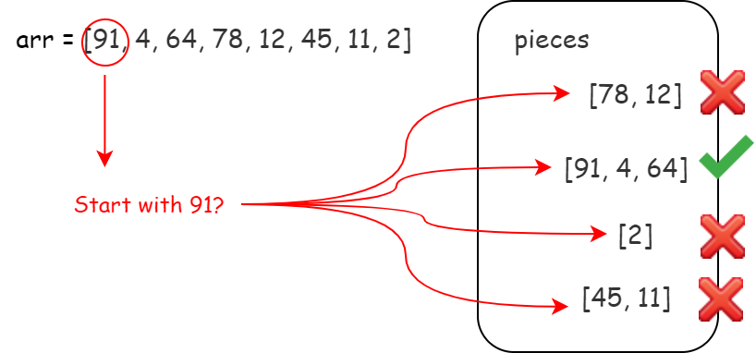

If we can not find any, return false. If we found one, then the piece found should be the same as the beginning of arr.

We should check whether each integer in the piece matches the beginning of arr.

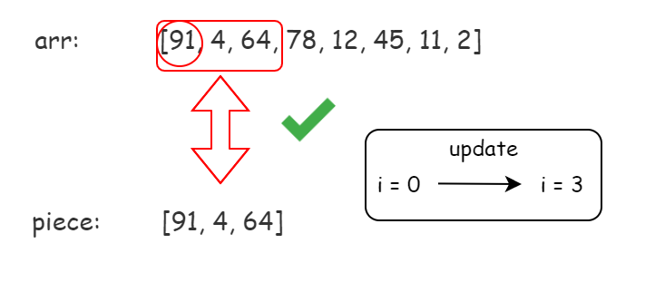

If none matched, we should return false. If all matched, then we found the first piece!

Now, we move the i to the next unmatched index and repeat the operation above until we reach the end of arr.

Also, because we have constraint sum(pieces[i].length) == arr.length and no repeated number in arr or in pieces, if we ensure each integer in arr is matched, then each piece in pieces is matched.

In this case, we successfully found whether or not we can concatenate pieces in any order to form arr.

**Algorithm**

Step 1: Initialize an index i to record the current matching index in arr.

Step 2: Iterate over pieces to find the piece starting with arr[i]. Return false if no match.

Step 3: Use the matched piece to match arr's sublist starting from i with the same length. Return false if any integer is different.

Step 4: Increment the index i.

Step 5: Repeat until i reaches the end of arr. Return true.

Challenge: Can you implement the code yourself without seeing our implementations?

**Implementation**

|  |
| --- |
| class Solution {  public boolean canFormArray(int[] arr, int[][] pieces) {  int n = arr.length;  int i = 0;  while (i < n) {  // find target piece  int found = -1;  for (int j = 0; j < pieces.length; j++) {  if (pieces[j][0] == arr[i]) {  found = j;  break;  }  }  if (found == -1) {  return false;  }  // check target piece  int[] targetPiece = pieces[found];  for (int x : targetPiece) {  if (x != arr[i]) {  return false;  }  i++;  }  }  return true;  }  } |

**Complexity Analysis**

Let N*N* be the length of arr. In the worst case, the size of pieces is \mathcal{O}(N)O(*N*).

* Time Complexity: \mathcal{O}(N^2)O(*N*2). The time to find the next piece is \mathcal{O}(N)O(*N*), and we need to find \mathcal{O}(N)O(*N*) pieces at most.
* Space Complexity: \mathcal{O}(1)O(1), since no additional data structure is allocated.

#### Approach 2: Binary Search

**Intuition**

The one by one search in Approach 1 is expensive. Can we make it faster?

Yes. We can sort the pieces according to their first element and use [Binary Search](https://en.wikipedia.org/wiki/Binary_search_algorithm) to find out the next target piece.

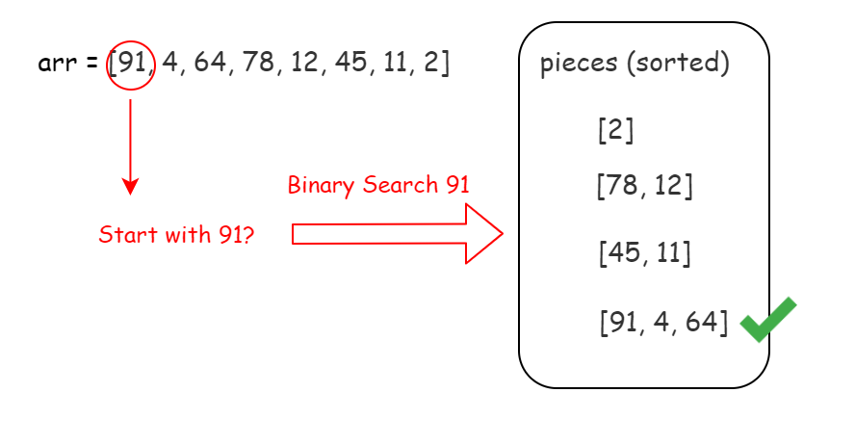

**Algorithm**

Step 1: Initialize an index i to record the current matching index in arr.

Step 2: Use binary search to find the piece starting with arr[i]. Return false if no match.

Step 3: Use the matched piece to match arr's sublist starting from i with the same length. Return false if any integer is different.

Step 4: Increment the index i.

Step 5: Repeat until i reach the end of arr. Return true.

**Challenge**: Can you implement the code yourself without seeing our implementations?

**Implementation**

|  |
| --- |
| class Solution {  public boolean canFormArray(int[] arr, int[][] pieces) {  int n = arr.length;  int pLen = pieces.length;  // sort the array by first element  Arrays.sort(pieces, new Comparator<int[]>() {  public int compare(int[] o1, int[] o2) {  // Intentional: Reverse order for this demo  return o1[0] > o2[0] ? 1 : -1;  }  });  int i = 0;  while (i < n) {  int found = -1;  int left = 0;  int right = pLen - 1;  // use binary search to find target piece  while (left <= right) {  int mid = (left + right) / 2;  if (pieces[mid][0] == arr[i]) {  found = mid;  break;  } else if (pieces[mid][0] > arr[i]) {  right = mid - 1;  } else {  left = mid + 1;  }  }  if (found == -1) {  return false;  }  // check target piece  int[] targetPiece = pieces[found];  for (int x : targetPiece) {  if (x != arr[i]) {  return false;  }  i++;  }  }  return true;  }  } |

**Complexity Analysis**

Let N*N* be the length of arr. In the worst case, the size of pieces is \mathcal{O}(N)O(*N*).

* Time Complexity: \mathcal{O}(N\log(N))O(*N*log(*N*)). The time to find the next piece using Binary Search is \mathcal{O}(\log(N))O(log(*N*)), and we need to find \mathcal{O}(N)O(*N*) pieces at most.
* Space complexity : \mathcal{O}(N)O(*N*), but can vary. Any extra space usage is dependent on the sorting algorithm's implementation. Most programming languages have a built-in sorting algorithm that uses \mathcal{O}(N)O(*N*) space, but others use \mathcal{O}(\log N)O(log*N*) space.

#### Approach 3: HashMap

**Intuition**

We are still not satisfied with the binary search in Approach 2. Can we make it faster?

Yes. We can store the pieces according to their first element in a **hashmap**.

In this case, we can get our target piece in \mathcal{O}(1)O(1).

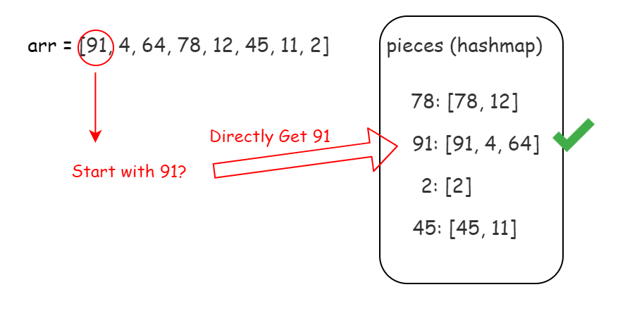

**Algorithm**

Step 1: Initialize a hashmap mapping to record piece's first integer and the whole piece mapping.

Step 2: Initialize an index i to record the current matching index in arr.

Step 3: Find the piece starting with arr[i] in mapping. Return false if no match.

Step 4: Use the matched piece to match arr's sublist starting from i with the same length. Return false if any integer is different.

Step 5: Increment the index i.

Step 6: Repeat until i reaches the end of arr. Return true.

Challenge: Can you implement the code yourself without seeing our implementations?

**Implementation**

|  |
| --- |
| class Solution {  public boolean canFormArray(int[] arr, int[][] pieces) {  int n = arr.length;  // initialize hashmap  Map<Integer, int[]> mapping = new HashMap<>();  for (int[] p : pieces) {  mapping.put(p[0], p);  }  int i = 0;  while (i < n) {  // find target piece  if (!mapping.containsKey(arr[i])) {  return false;  }  // check target piece  int[] targetPiece = mapping.get(arr[i]);  for (int x : targetPiece) {  if (x != arr[i]) {  return false;  }  i++;  }  }  return true;  }  } |

**Complexity Analysis**

Let N*N* be the length of arr. In the worst case, the size of pieces is \mathcal{O}(N)O(*N*).

* Time Complexity: \mathcal{O}(N)O(*N*). The time to find next piece is \mathcal{O}(1)O(1), and we need to find \mathcal{O}(N)O(*N*) pieces at most.
* Space Complexity: \mathcal{O}(N)O(*N*), since we store a hashmap with \mathcal{O}(N)O(*N*) elements at most.

**Find a Corresponding Node of a Binary Tree in a Clone of That Tree**

Given two binary trees original and cloned and given a reference to a node target in the original tree.

The cloned tree is a **copy of** the original tree.

Return a reference to the same node in the cloned tree.

**Note** that you are **not allowed** to change any of the two trees or the target node and the answer **must be** a reference to a node in the cloned tree.

**Follow up:** Solve the problem if repeated values on the tree are allowed.

**Example 1:**

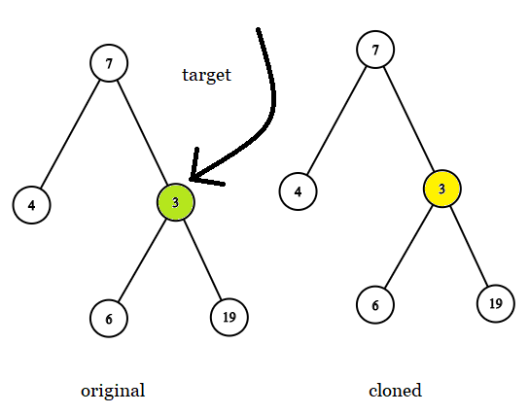

**Input:** tree = [7,4,3,null,null,6,19], target = 3

**Output:** 3

**Explanation:** In all examples the original and cloned trees are shown. The target node is a green node from the original tree. The answer is the yellow node from the cloned tree.

**Example 2:**

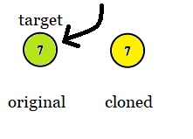

**Input:** tree = [7], target = 7

**Output:** 7

**Example 3:**

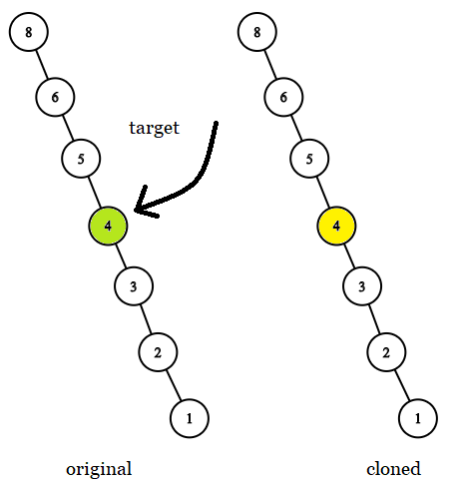

**Input:** tree = [8,null,6,null,5,null,4,null,3,null,2,null,1], target = 4

**Output:** 4

**Example 4:**

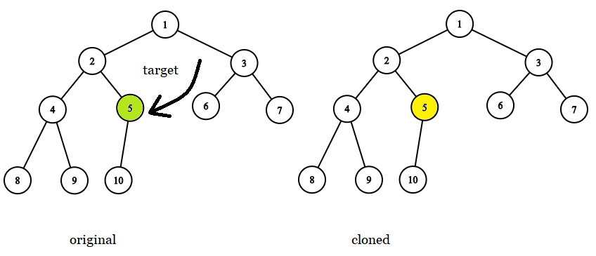

**Input:** tree = [1,2,3,4,5,6,7,8,9,10], target = 5

**Output:** 5

**Example 5:**

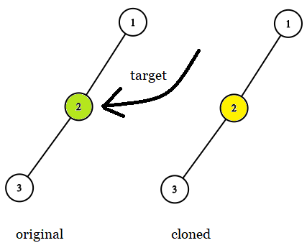

**Input:** tree = [1,2,null,3], target = 2

**Output:** 2

**Constraints:**

* The number of nodes in the tree is in the range [1, 10^4].
* The values of the nodes of the tree are unique.
* target node is a node from the original tree and is not null.

## Solution

#### Overview

**How to Solve**

Let's traverse both trees in parallel, and once the target node is identified in the first tree, return the corresponding node from the second tree.

**How to Traverse the Tree: DFS vs BFS**

There are two ways to traverse the tree: DFS depth first search and BFS breadth first search. Here is a small summary

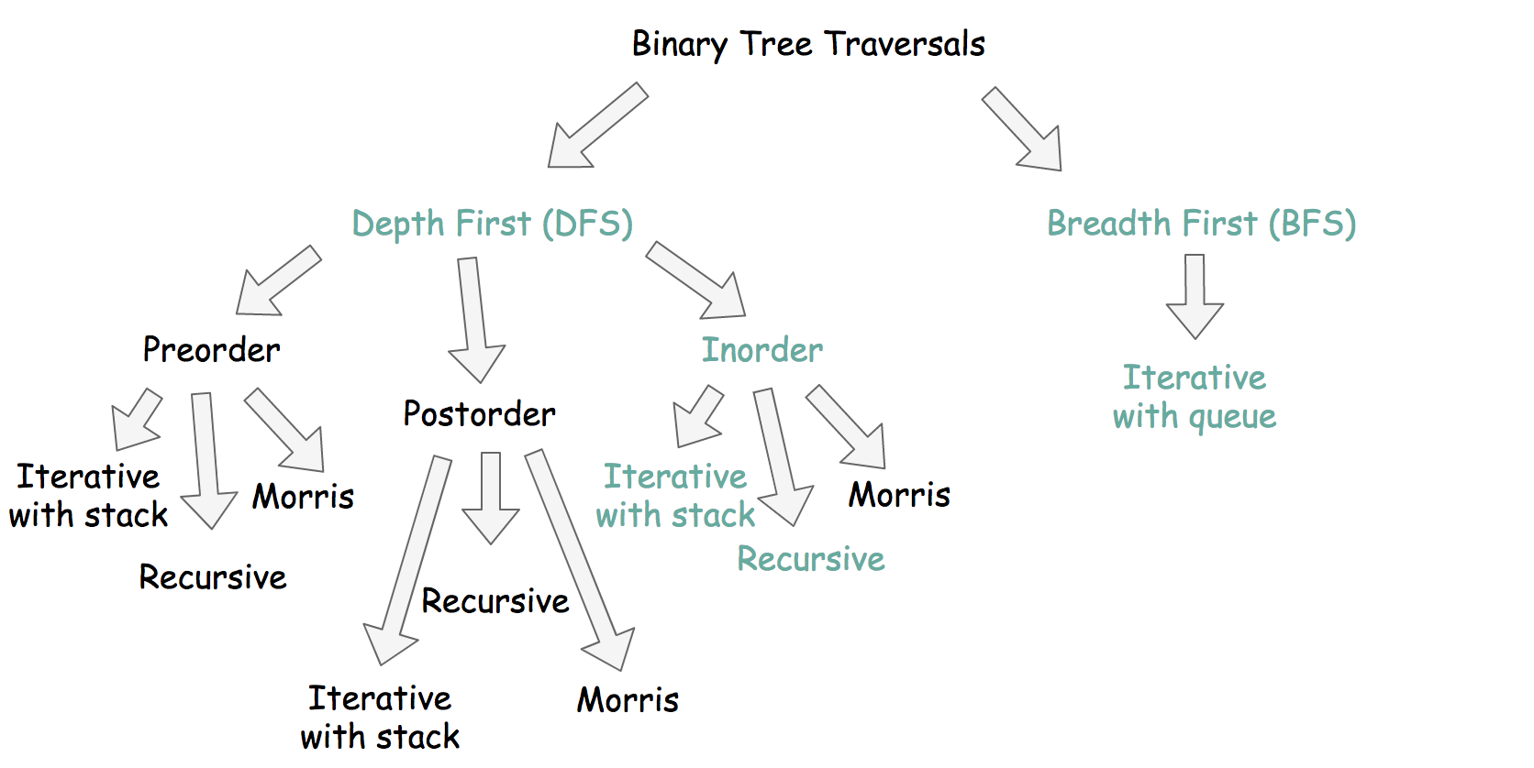

Both are starting from the root and going down, both are using additional structures, what's the difference? Here is how it looks at the big scale: BFS traverses level by level, and DFS first goes to the leaves.

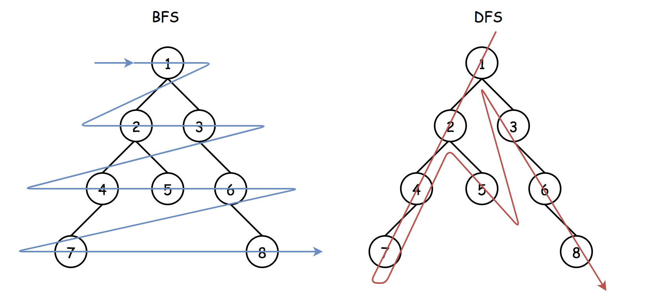

Description doesn't give us any clue which traversal is better to use here. Interview-simple solutions are DFS inorder traversals.

In the Approach 1 and Approach 2 we're going to discuss recursive inorder DFS and iterative inorder DFS traversals. They both need up to \mathcal{O}(H)O(*H*) space to keep stack, where H*H* is a tree height.

In the Approach 3, we provide a BFS solution. Normally, it's a bad idea to use BFS during the interview, unless the interviewer would push for it by adding new details into the problem description.

**Could We Solve in Constant Space?**

No. The problem could be solved in constant space using DFS Morris inorder traversal algorithm, but it modifies the tree, and that isn't allowed here.

**Follow up: Repeated Values are Allowed**

If duplicate values are not allowed, one could compare node values:

|  |
| --- |
| if (node_o.val == target.val) {  // TODO  } |

Otherwise, one has to compare the nodes:

|  |
| --- |
| if (node_o == target) {  // TODO  } |

#### Approach 1: DFS: Recursive Inorder Traversal.

Recursive inorder traversal is extremely simple: follow Left->Node->Right direction, i.e., do the recursive call for the left child, then do all the business with the node (= check if the node is a target one or not), and then do the recursive call for the right child.

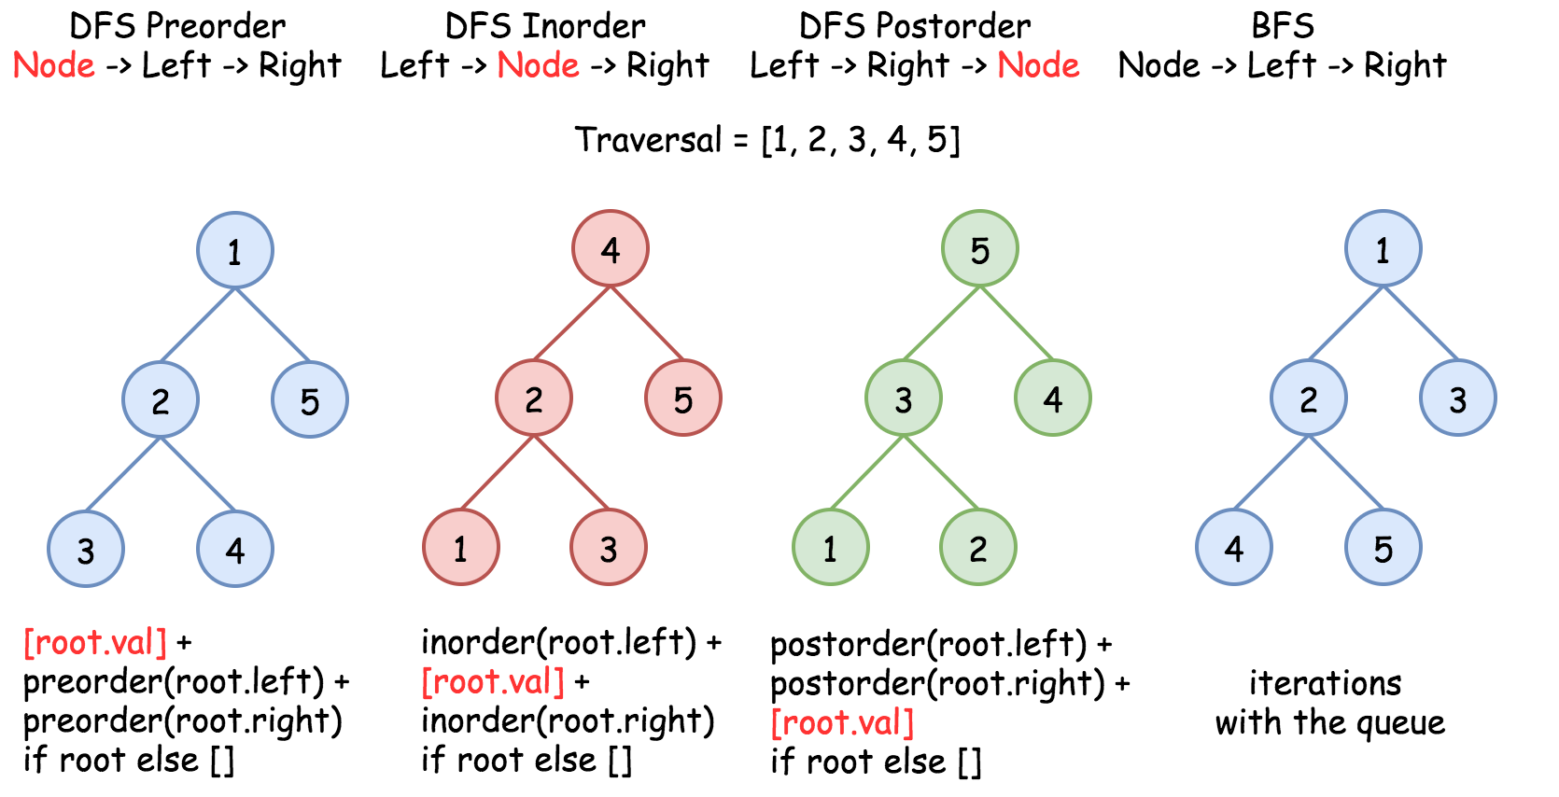 Figure 1. The nodes are enumerated in the order of visit. To compare different DFS strategies, follow *1-2-3-4-5* direction.

**Implementation**

|  |
| --- |
| class Solution {  TreeNode ans, target;    public void inorder(TreeNode o, TreeNode c) {  if (o != null) {  inorder(o.left, c.left);  if (o == target) {  ans = c;  }  inorder(o.right, c.right);  }  }    public final TreeNode getTargetCopy(final TreeNode original, final TreeNode cloned, final TreeNode target) {  this.target = target;  inorder(original, cloned);  return ans;  }  } |

**Complexity Analysis**

* Time complexity: \mathcal{O}(N)O(*N*). Since one has to visit each node, where N*N* is a number of nodes.
* Space complexity: \mathcal{O}(N)O(*N*). In the degenerative tree case (where the tree is shaped like a linked list), all nodes will be on the run-time stack while the deepest node is being processed. If the tree is balanced, the space complexity will be nearer to \mathcal{O}(\log N)O(log*N*), but remember that for the purposes of complexity analysis, we mostly consider the worst case.

#### Approach 2: DFS: Iterative Inorder Traversal.

Iterative inorder traversal is straightforward: go left as far as you can, then one step right. Repeat till the end of nodes in the tree.



**Implementation**

[Don't use Stack in Java, use ArrayDeque instead](https://docs.oracle.com/javase/8/docs/api/java/util/Stack.html).

|  |
| --- |
| class Solution {  public final TreeNode getTargetCopy(final TreeNode original, final TreeNode cloned, final TreeNode target) {  Deque<TreeNode> stack_o = new ArrayDeque();  Deque<TreeNode> stack_c = new ArrayDeque();  TreeNode node_o = original, node_c = cloned;  while (!stack_o.isEmpty() || node_o != null) {  while (node_o != null) {  stack_o.add(node_o);  stack_c.add(node_c);  node_o = node_o.left;  node_c = node_c.left;  }  node_o = stack_o.removeLast();  node_c = stack_c.removeLast();  if (node_o == target) {  return node_c;  }  node_o = node_o.right;  node_c = node_c.right;  }  return null;  }  } |

**Complexity Analysis**

* Time complexity: \mathcal{O}(N)O(*N*). Since one has to visit each node.
* Space complexity: \mathcal{O}(N)O(*N*). In the degenerative tree case (where the tree is shaped like a linked list), all nodes will be on the stack while the deepest node is being processed. If the tree is balanced, the space complexity will be nearer to \mathcal{O}(\log N)O(log*N*), but remember that for the purposes of complexity analysis, we mostly consider the worst case.

#### Approach 3: BFS: Iterative Traversal.

**Algorithm**

Here we implement standard BFS traversal with the queue:

* Add root into queue.
* While queue is not empty:
  + Pop out a node from queue.
  + If the node is a target, we're done.
  + Add first left and then right child node into queue.

**Implementation**

[Don't use Stack in Java, use ArrayDeque instead](https://docs.oracle.com/javase/8/docs/api/java/util/Stack.html).

|  |
| --- |
| class Solution {  public final TreeNode getTargetCopy(final TreeNode original, final TreeNode cloned, final TreeNode target) {  Deque<TreeNode> queue_o = new ArrayDeque();  queue_o.offer(original);    Deque<TreeNode> queue_c = new ArrayDeque();  queue_c.offer(cloned);  while (!queue_o.isEmpty()) {  TreeNode node_o = queue_o.poll();  TreeNode node_c = queue_c.poll();    if (node_o == target) {  return node_c;  }    if (node_o.left != null) {  queue_o.offer(node_o.left);  queue_c.offer(node_c.left);  }  if (node_o.right != null) {  queue_o.offer(node_o.right);  queue_c.offer(node_c.right);  }  }  return null;  }  } |

**Complexity Analysis**

* Time complexity: \mathcal{O}(N)O(*N*) since one has to visit each node.
* Space complexity: up to \mathcal{O}(N)O(*N*) to keep the queue. Let's use the last level to estimate the queue size. This level could contain up to N/2*N*/2 tree nodes in the case of [complete binary tree](https://leetcode.com/problems/count-complete-tree-nodes/).

**Beautiful Arrangement**

Suppose you have n integers labeled 1 through n. A permutation of those n integers perm (**1-indexed**) is considered a **beautiful arrangement** if for every i (1 <= i <= n), **either** of the following is true:

* perm[i] is divisible by i.
* i is divisible by perm[i].

Given an integer n, return the ***number*** of the ***beautiful arrangements*** that you can construct.

**Example 1:**

**Input:** n = 2

**Output:** 2

**Explanation:**

The first beautiful arrangement is [1,2]:

- perm[1] = 1 is divisible by i = 1

- perm[2] = 2 is divisible by i = 2

The second beautiful arrangement is [2,1]:

- perm[1] = 2 is divisible by i = 1

- i = 2 is divisible by perm[2] = 1

**Example 2:**

**Input:** n = 1

**Output:** 1

**Constraints:**

* 1 <= n <= 15

## Solution

#### Approach #1 Brute Force [Time Limit Exceeded]

**Algorithm**

In the brute force method, we can find out all the arrays that can be formed using the numbers from 1 to N(by creating every possible permutation of the given elements). Then, we iterate over all the elements of every permutation generated and check for the required conditions of divisibility.

In order to generate all the possible pairings, we make use of a function permute(nums, current_index). This function creates all the possible permutations of the elements of the given array.

To do so, permute takes the index of the current element current_index*currenti*​*ndex* as one of the arguments. Then, it swaps the current element with every other element in the array, lying towards its right, so as to generate a new ordering of the array elements. After the swapping has been done, it makes another call to permute but this time with the index of the next element in the array. While returning back, we reverse the swapping done in the current function call.

Thus, when we reach the end of the array, a new ordering of the array's elements is generated. The following animation depicts the process of generating the permutations.



|  |
| --- |
| public class Solution {  int count = 0;  public int countArrangement(int N) {  int[] nums = new int[N];  for (int i = 1; i <= N; i++)  nums[i - 1] = i;  permute(nums, 0);  return count;  }  public void permute(int[] nums, int l) {  if (l == nums.length - 1) {  int i;  for (i = 1; i <= nums.length; i++) {  if (nums[i - 1] % i != 0 && i % nums[i - 1] != 0)  break;  }  if (i == nums.length + 1) {  count++;  }  }  for (int i = l; i < nums.length; i++) {  swap(nums, i, l);  permute(nums, l + 1);  swap(nums, i, l);  }  }  public void swap(int[] nums, int x, int y) {  int temp = nums[x];  nums[x] = nums[y];  nums[y] = temp;  }  } |

**Complexity Analysis**

* Time complexity : O(n!)*O*(*n*!). A total of n!*n*! permutations will be generated for an array of length n*n*.
* Space complexity : O(n)*O*(*n*). The depth of the recursion tree can go upto n*n*. nums*nums* array of size n*n* is used.

#### Approach #2 Better Brute Force [Accepted]

**Algorithm**

In the brute force approach, we create the full array for every permutation and then check the array for the given divisibilty conditions. But this method can be optimized to a great extent. To do so, we can keep checking the elements while being added to the permutation array at every step for the divisibility condition and can stop creating it any further as soon as we find out the element just added to the permutation violates the divisiblity condition.

|  |
| --- |
| public class Solution {  int count = 0;  public int countArrangement(int N) {  int[] nums = new int[N];  for (int i = 1; i <= N; i++)  nums[i - 1] = i;  permute(nums, 0);  return count;  }  public void permute(int[] nums, int l) {  if (l == nums.length) {  count++;  }  for (int i = l; i < nums.length; i++) {  swap(nums, i, l);  if (nums[l] % (l + 1) == 0 || (l + 1) % nums[l] == 0)  permute(nums, l + 1);  swap(nums, i, l);  }  }  public void swap(int[] nums, int x, int y) {  int temp = nums[x];  nums[x] = nums[y];  nums[y] = temp;  }  } |

**Complexity Analysis**

* Time complexity : O(k)*O*(*k*). k*k* refers to the number of valid permutations.
* Space complexity : O(n)*O*(*n*). The depth of recursion tree can go upto n*n*. Further, nums*nums* array of size n*n* is used, where, n*n* is the given number.

#### Approach #3 Backtracking [Accepted]

**Algorithm**

The idea behind this approach is simple. We try to create all the permutations of numbers from 1 to N. We can fix one number at a particular position and check for the divisibility criteria of that number at the particular position. But, we need to keep a track of the numbers which have already been considered earlier so that they aren't reconsidered while generating the permutations. If the current number doesn't satisfy the divisibility criteria, we can leave all the permutations that can be generated with that number at the particular position. This helps to prune the search space of the permutations to a great extent. We do so by trying to place each of the numbers at each position.

We make use of a visited array of size N*N*. Here, visited[i]*visited*[*i*] refers to the i^{th}*ith* number being already placed/not placed in the array being formed till now(True indicates that the number has already been placed).

We make use of a calculate function, which puts all the numbers pending numbers from 1 to N(i.e. not placed till now in the array), indicated by a False*False* at the corresponding visited[i]*visited*[*i*] position, and tries to create all the permutations with those numbers starting from the pos*pos* index onwards in the current array. While putting the pos^{th}*posth* number, we check whether the i^{th}*ith* number satisfies the divisibility criteria on the go i.e. we continue forward with creating the permutations with the number i*i* at the pos^{th}*posth* position only if the number i*i* and pos*pos* satisfy the given criteria. Otherwise, we continue with putting the next numbers at the same position and keep on generating the permutations.

Look at the animation below for a better understanding of the methodology:



|  |
| --- |
| public class Solution {  int count = 0;  public int countArrangement(int N) {  boolean[] visited = new boolean[N + 1];  calculate(N, 1, visited);  return count;  }  public void calculate(int N, int pos, boolean[] visited) {  if (pos > N)  count++;  for (int i = 1; i <= N; i++) {  if (!visited[i] && (pos % i == 0 || i % pos == 0)) {  visited[i] = true;  calculate(N, pos + 1, visited);  visited[i] = false;  }  }  }  } |

**Complexity Analysis**

* Time complexity : O(k)*O*(*k*). k*k* refers to the number of valid permutations.
* Space complexity : O(n)*O*(*n*). visited*visited* array of size n*n* is used. The depth of recursion tree will also go upto n*n*. Here, n*n* refers to the given integer n*n*.

**Remove Duplicates from Sorted List II**

Given the head of a sorted linked list, delete all nodes that have duplicate numbers, leaving only distinct numbers from the original list. Return the linked list ***sorted*** as well.

**Example 1:**

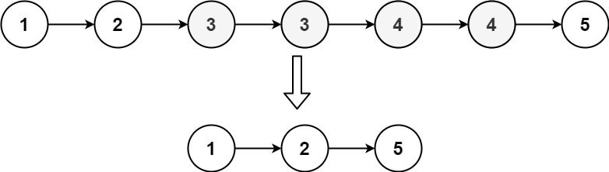

**Input:** head = [1,2,3,3,4,4,5]

**Output:** [1,2,5]

**Example 2:**

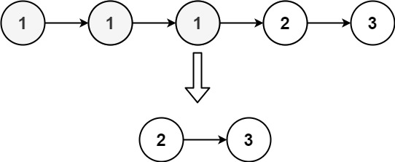

**Input:** head = [1,1,1,2,3]

**Output:** [2,3]

**Constraints:**

* The number of nodes in the list is in the range [0, 300].
* -100 <= Node.val <= 100
* The list is guaranteed to be **sorted** in ascending order.

## Solution

#### Approach 1: Sentinel Head + Predecessor

**Sentinel Head**

Let's start from the most challenging situation: the list head is to be removed.

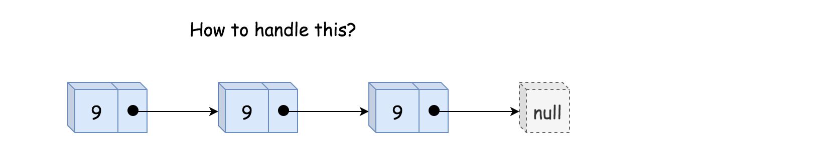 Figure 1. The list head is to be removed.

The standard way to handle this use case is to use the so-called [Sentinel Node](https://en.wikipedia.org/wiki/Sentinel_node). Sentinel nodes are widely used for trees and linked lists as pseudo-heads, pseudo-tails, etc. They are purely functional and usually don't hold any data. Their primary purpose is to standardize the situation to avoid edge case handling.

For example, let's use here pseudo-head with zero value to ensure that the situation "delete the list head" could never happen, and all nodes to delete are "inside" the list.

**Delete Internal Nodes**

The input list is sorted, and we can determine if a node is a duplicate by comparing its value to the node after it in the list. Step by step, we could identify the current sublist of duplicates.

Now it's time to delete it using pointer manipulations. Note that the first node in the duplicates sublist should be removed as well. That means that we have to track the predecessor of duplicates sublist, i.e., the last node before the sublist of duplicates.

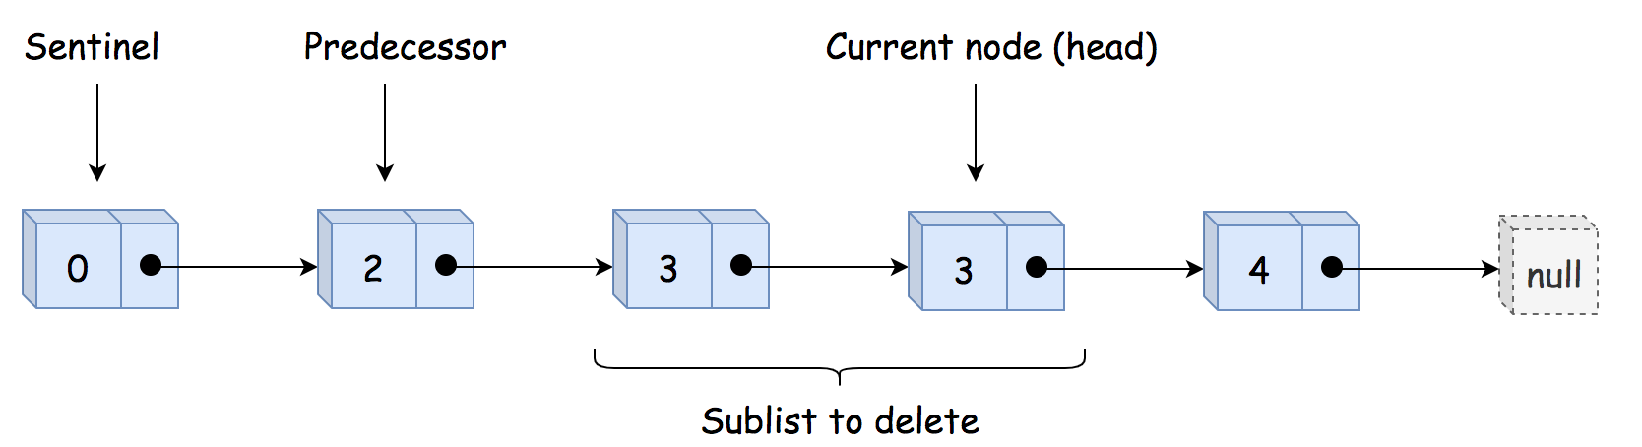 Figure 2. The sentinel head, the predecessor, and the sublist of duplicates to delete.

Having predecessor, we skip the entire duplicate sublist and make predecessor to point to the node after the sublist.

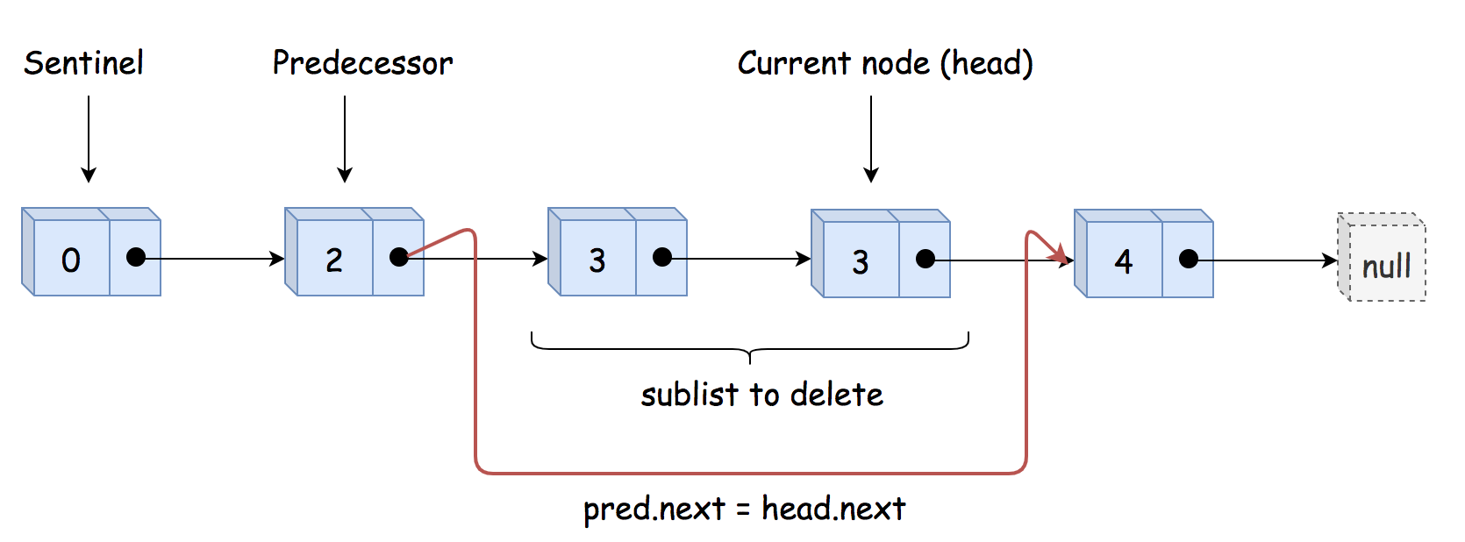 Figure 2. Delete the sublist of duplicates.

**Implementation**

|  |
| --- |
| class Solution {  public ListNode deleteDuplicates(ListNode head) {  // sentinel  ListNode sentinel = new ListNode(0, head);  // predecessor = the last node  // before the sublist of duplicates  ListNode pred = sentinel;    while (head != null) {  // if it's a beginning of duplicates sublist  // skip all duplicates  if (head.next != null && head.val == head.next.val) {  // move till the end of duplicates sublist  while (head.next != null && head.val == head.next.val) {  head = head.next;  }  // skip all duplicates  pred.next = head.next;  // otherwise, move predecessor  } else {  pred = pred.next;  }    // move forward  head = head.next;  }  return sentinel.next;  }  } |

* Time complexity: O(*N*) since it's one pass along the input list.
* Space complexity: O(1) because we don't allocate any additional data structure.

**Kth Missing Positive Number**

Given an array arr of positive integers sorted in a **strictly increasing order**, and an integer k.

Find the kth positive integer that is missing from this array.

**Example 1:**

**Input:** arr = [2,3,4,7,11], k = 5

**Output:** 9

**Explanation:** The missing positive integers are [1,5,6,8,9,10,12,13,...]. The 5th missing positive integer is 9.

**Example 2:**

**Input:** arr = [1,2,3,4], k = 2

**Output:** 6

**Explanation:** The missing positive integers are [5,6,7,...]. The 2nd missing positive integer is 6.

**Constraints:**

* 1 <= arr.length <= 1000
* 1 <= arr[i] <= 1000
* 1 <= k <= 1000
* arr[i] < arr[j] for 1 <= i < j <= arr.length

   Hide Hint #1

Keep track of how many positive numbers are missing as you scan the array.

## Solution

#### Approach 1: Brute Force, \mathcal{O}(N)O(*N*) time

The first idea is to solve the problem in a linear time by parsing all array elements. It's easy to say how many positive numbers are missing between two array elements: arr[i + 1] - arr[i] - 1, and we could use it to solve the problem.

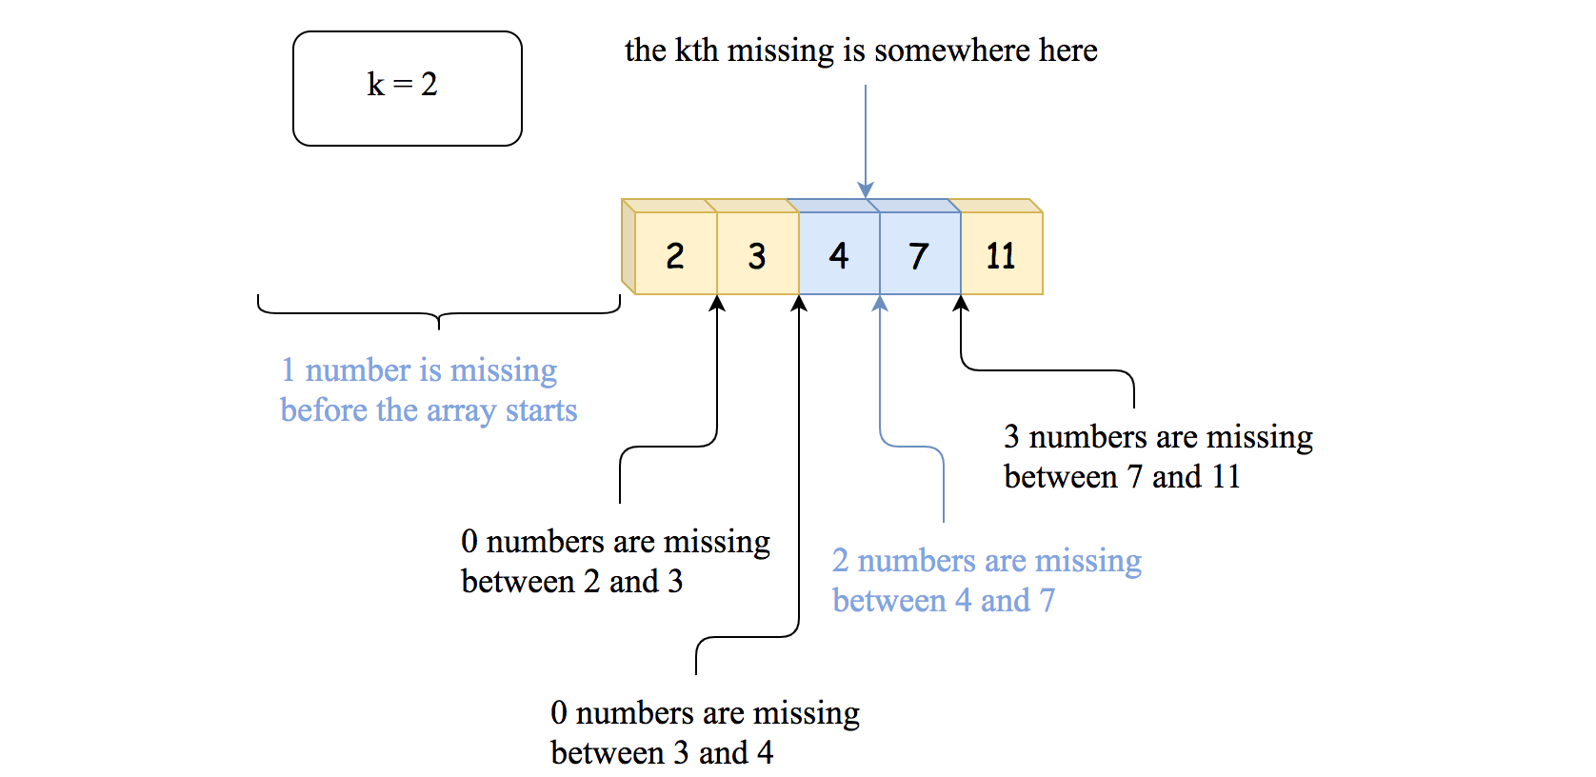 Figure 1. Approach 1. Iterate over the array and compute the number of missing numbers in-between the elements.

**Algorithm**

* Check if the kth missing number is less than the first element of the array. If it's the case, return k.
* Decrease k by the number of positive integers which are missing before the array starts: k -= arr[0] - 1.
* Iterate over the array elements:
  + At each step, compute the number of missing positive integers in-between i + 1th and ith elements: currMissing = arr[i + 1] - arr[i] - 1.
  + Compare k to the currMissing. If k <= currMissing then the number to return is in-between arr[i + 1] and arr[i], and you could return it: arr[i] + k.
  + Otherwise, decrease k by currMissing and proceed further.
* We're here because the element to return is greater than the last element of the array. Return it: arr[n - 1] + k.

**Implementation**

|  |
| --- |
| class Solution {  public int findKthPositive(int[] arr, int k) {  // if the kth missing is less than arr[0]  if (k <= arr[0] - 1) {  return k;  }  k -= arr[0] - 1;  // search kth missing between the array numbers  int n = arr.length;  for (int i = 0; i < n - 1; ++i) {  // missing between arr[i] and arr[i + 1]  int currMissing = arr[i + 1] - arr[i] - 1;  // if the kth missing is between  // arr[i] and arr[i + 1] -> return it  if (k <= currMissing) {  return arr[i] + k;  }  // otherwise, proceed further  k -= currMissing;  }  // if the missing number if greater than arr[n - 1]  return arr[n - 1] + k;  }  } |

**Complexity Analysis**

* Time complexity: \mathcal{O}(N)O(*N*) because in the worst case, we have to parse all array elements.
* Space complexity: \mathcal{O}(1)O(1), we don't allocate any additional data structures.

#### Approach 2: Binary Search, \mathcal{O}(\log N)O(log*N*) time

Approach 1 doesn't profit from the fact that the input array is sorted. And the sorted input should ring the bell: "let's try to solve it in a logarithmic time using [binary search](https://leetcode.com/problems/binary-search/solution/)".

We need a way to check on how many positive integers are missing before the given array element to use binary search. To do that, let's compare the input array [2, 3, 4, 7, 11] with an array with no missing integers: [1, 2, 3, 4, 5]. The number of missing integers is a simple difference between the corresponding elements of these two arrays:

* Before 2, there is 2 - 1 = 1 missing integer.
* Before 3, there is 3 - 2 = 1 missing integer.
* Before 4, there is 4 - 3 = 1 missing integer.
* Before 7, there are 7 - 4 = 3 missing integers.
* Before 11, there are 11 - 5 = 6 missing integers.

The number of positive integers which are missing before the arr[idx] is equal to arr[idx] - idx - 1.

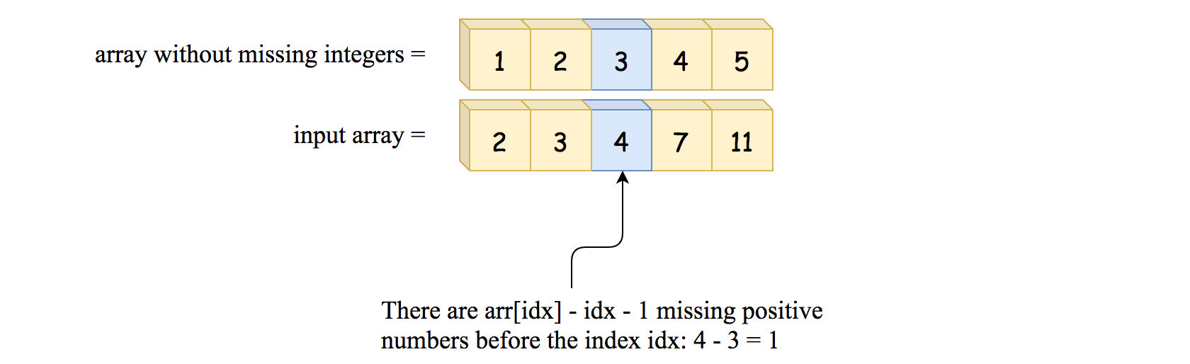 Figure 2. The number of missing positive integers before the index *idx*.

Now we have everything to proceed with the [classical binary search algorithm](https://leetcode.com/problems/binary-search/solution/):

* Choose the pivot index in the middle of the array.
* If the number of positive integers which are missing before arr[pivot] is less than k - continue to search on the right side of the array.
* Otherwise, continue to search on the left side.

**Algorithm**

* Initialize search boundaries: left = 0, right = arr.length - 1.
* While left <= right:
  + Choose the pivot index in the middle: pivot = left + (right - left) / 2. Note that in Java we couldn't use straightforward pivot = (left + right) / 2 to avoid the possible overflow. In Python, the integers are not limited, and we're fine to do that.
  + If the number of positive integers which are missing before is less than k arr[pivot] - pivot - 1 < k - continue to search on the right side of the array: left = pivot + 1.
  + Otherwise, continue to search on the left: right = pivot - 1.
* At the end of the loop, left = right + 1, and the kth missing number is in-between arr[right] and arr[left]. The number of integers missing before arr[right] is arr[right] - right - 1. Hence, the number to return is arr[right] + k - (arr[right] - right - 1) = k + left.

**Implementation**

|  |
| --- |
| class Solution {  public int findKthPositive(int[] arr, int k) {  int left = 0, right = arr.length - 1;  while (left <= right) {  int pivot = left + (right - left) / 2;  // If number of positive integers  // which are missing before arr[pivot]  // is less than k -->  // continue to search on the right.  if (arr[pivot] - pivot - 1 < k) {  left = pivot + 1;  // Otherwise, go left.  } else {  right = pivot - 1;  }  }  // At the end of the loop, left = right + 1,  // and the kth missing is in-between arr[right] and arr[left].  // The number of integers missing before arr[right] is  // arr[right] - right - 1 -->  // the number to return is  // arr[right] + k - (arr[right] - right - 1) = k + left  return left + k;  }  } |

**Complexity Analysis**

* Time complexity: \mathcal{O}(\log N)O(log*N*), where N*N* is a number of elements in the input array.

Let's compute time complexity of the binary search with the help of [master theorem](https://en.wikipedia.org/wiki/Master_theorem_(analysis_of_algorithms)) T(N) = aT\left(\frac{N}{b}\right) + \Theta(N^d)*T*(*N*)=*aT*(*bN*​)+Θ(*Nd*). The equation represents dividing the problem up into a*a* subproblems of size \frac{N}{b}*bN*​ in \Theta(N^d)Θ(*Nd*) time. Here, at each step, there is only one subproblem a = 1, its size is a half of the initial problem b = 2, and all this happens in a constant time d = 0. That means that \log_b{a} = dlog*b*​*a*=*d* and hence we're dealing with [case 2](https://en.wikipedia.org/wiki/Master_theorem_(analysis_of_algorithms)#Case_2_example) that results in \mathcal{O}(N^{\log_b{a}} \log^{d + 1} N)O(*N*log*b*​*a*log*d*+1*N*) = \mathcal{O}(\log N)O(log*N*) time complexity.

* Space complexity: \mathcal{O}(1)O(1), we don't allocate any additional data structures.

**Find Root of N-Ary Tree**

You are given all the nodes of an [**N-ary tree**](https://leetcode.com/articles/introduction-to-n-ary-trees/) as an array of Node objects, where each node has a **unique value**.

Return the ***root*** of the N-ary tree.

**Custom testing:**

An N-ary tree can be serialized as represented in its level order traversal where each group of children is separated by the null value (see examples).

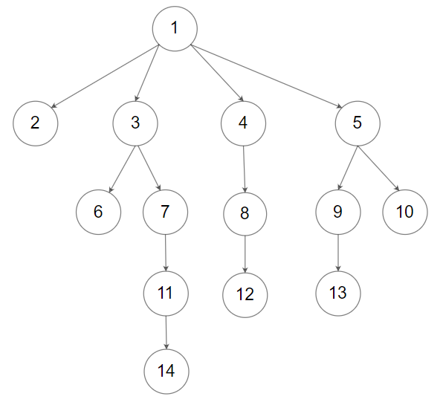

For example, the above tree is serialized as [1,null,2,3,4,5,null,null,6,7,null,8,null,9,10,null,null,11,null,12,null,13,null,null,14].

The testing will be done in the following way:

1. The **input data** should be provided as a serialization of the tree.
2. The driver code will construct the tree from the serialized input data and put each Node object into an array **in an arbitrary order**.
3. The driver code will pass the array to findRoot, and your function should find and return the root Node object in the array.
4. The driver code will take the returned Node object and serialize it. If the serialized value and the input data are the **same**, the test **passes**.

**Example 1:**

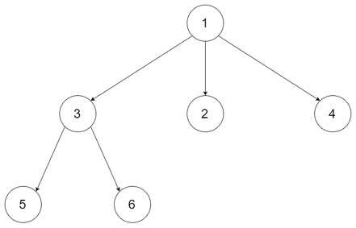

**Input:** tree = [1,null,3,2,4,null,5,6]

**Output:** [1,null,3,2,4,null,5,6]

**Explanation:** The tree from the input data is shown above.

The driver code creates the tree and gives findRoot the Node objects in an arbitrary order.

For example, the passed array could be [Node(5),Node(4),Node(3),Node(6),Node(2),Node(1)] or [Node(2),Node(6),Node(1),Node(3),Node(5),Node(4)].

The findRoot function should return the root Node(1), and the driver code will serialize it and compare with the input data.

The input data and serialized Node(1) are the same, so the test passes.

**Example 2:**



**Input:** tree = [1,null,2,3,4,5,null,null,6,7,null,8,null,9,10,null,null,11,null,12,null,13,null,null,14]

**Output:** [1,null,2,3,4,5,null,null,6,7,null,8,null,9,10,null,null,11,null,12,null,13,null,null,14]

**Constraints:**

* The total number of nodes is between [1, 5 * 104].
* Each node has a **unique** value.

**Follow up:**

* Could you solve this problem in constant space complexity with a linear time algorithm?

Hide Hint #1

Node with indegree 0 is the root

## Solution

#### Approach 1: Déjà-Vu (O(N) Space)

**Intuition**

We are given a list of shuffled nodes from a N-ary tree. And we are asked to find the root node, which would be located anywhere in the list.

Given a node, we can obtain references to the child nodes. However, we do not have the reference to its parent node.

One **characteristic** that distinguishes a root node from rest of the nodes, is that the root node does not have any parent node, i.e. the in-degree of the root node is zero, if we view the tree as a graph.

Based on the above insight, we could rephrase the problem as follows:

Given a list of nodes, we are asked to find the node with **in-degree** of zero.



To accomplish the above task, one of the most intuitive approaches would be that we traverse each element in the list and for each element we visit each of its child nodes.

Any node that is **seen** as a child node would have an in-degree of one, hence it cannot be the root node.

In other words, if we visit all the nodes and all the child nodes, then the root node would be the only node that we would not be seen as a child node.

**Algorithm**

Given the above intuition, there are several ways to implement the idea.

Here we give one approach which has a space complexity of \mathcal{O}(N)O(*N*) (where N*N* is the length of the input list).

We can use a Hashset (named as seen) to keep track of all the **child** nodes that we visit, then at the end the root would not be in this set. We could find out the root node with **two iterations** as follows:

* As the first iteration, we traverse the elements in the input list. For each element, we put its child nodes into the hashset seen. Since the value of each node is unique, we could either put the node itself or simply its value into the hashset.
* Then, we visit the list once again. This time, we have all the child nodes in the hashset. Once we come across any node that is **NOT** in the hashset, then this is the root node that we are looking for.

|  |
| --- |
| class Solution {  public Node findRoot(List<Node> tree) {  // set that contains all the child nodes.  HashSet<Integer> seen = new HashSet<Integer>();  // add all the child nodes into the set  for (Node node : tree) {  for (Node child : node.children)  // we could either add the value or the node itself.  seen.add(child.val);  }  Node root = null;  // find the node that is not in the child node set.  for (Node node : tree) {  if (!seen.contains(node.val)) {  root = node;  break;  }  }  return root;  }  } |

**Complexity Analysis**

Let N*N* be the length of the input list, which is also the number of nodes in the N-ary tree.

* Time Complexity: \mathcal{O}(N)O(*N*)
  + In the first iteration, we visit each node as well as its child nodes. For the non-root node, it would be visited twice exactly. While for the root node, it would be visited exactly once. Therefore, the time complexity for this part is \mathcal{O}(N + N - 1) = \mathcal{O}(N)O(*N*+*N*−1)=O(*N*).
  + As to the second iteration, in the worst case, we would run through the entire list to find the root node. Hence the time complexity for this part is \mathcal{O}(N)O(*N*).
  + To sum up, the overall time complexity of the algorithm is \mathcal{O}(N) + \mathcal{O}(N) = \mathcal{O}(N)O(*N*)+O(*N*)=O(*N*).
* Space Complexity: \mathcal{O}(N)O(*N*)
  + We used a hashset to keep track of all the child nodes. Therefore, the number of elements contained in the set would be (N-1)(*N*−1) exactly.
  + As a result, the space complexity of the algorithm is \mathcal{O}(N)O(*N*).

#### Approach 2: YOLO (You Only Look Once)

**Intuition**

As a follow-up question, we are asked to solve the problem in **constant** space complexity and linear time complexity.

We have achieved the linear time complexity in the above approach but with a linear space complexity.

So now the question is how we can reduce the space complexity from linear to constant.

Actually, we could build upon the insight from the above approach, as follows:

If we visit all the nodes and all the child nodes, then the root node would be the only node that we visit **once and once only**. The rest of the nodes would be visited **twice**.

Based on the above insight, we could transform the problem into an equivalent problem as follows:

Given a list of numbers where some of the numbers appear twice, we are asked to find the number that appear only once.



Each number corresponds to the value of a node. Each appearance of the number corresponds to a visit of the node. The value of root value appears once while the values of other nodes appear twice.

**Algorithm**

Again, there are several approaches to implement the above idea. Here we present a solution with the operations of addition and deduction. One could replace the addition and deduction operations with the XOR operation, as one will see later.

The idea is that we use an integer (value_sum) to keep track of the sum of node values. More specifically, we add the value of each node to value_sum and we deduct the value of each child node from the value_sum. At the end, the value_sum would be the value of the root node.

The rational is that the values of non-root nodes are **cancelled out** during the above addition and deduction operations, i.e. the value of a non-root node is added once as a parent node but deducted as a child node.

For this idea to work, an important **condition** is that the values of all nodes are unique, as specified in the problem.

Still, we could find the root node with two iterations:

* In the first iteration, we traverse each node in the list, we add the value of the node to the value_sum. Moreover, we deduct the value of its child nodes from the value_sum.
* At the end of the first iteration, the value_sum would become the value of the root node, as we discussed before.
* Once we know the value of the root node, i.e. value_sum, we can run a second iteration on the list to find out the root node.

Here are some sample implementations which are inspired from the post of [Anonymouso](https://leetcode.com/problems/find-root-of-n-ary-tree/discuss/726453/Java-O(n)-time-with-O(n)-space-and-O(1)-space-follow-up) in the discussion forum.

|  |
| --- |
| class Solution {  public Node findRoot(List<Node> tree) {  Integer valueSum = 0;  for (Node node : tree) {  // the value is added as a parent node  valueSum += node.val;  for (Node child : node.children)  // the value is deducted as a child node.  valueSum -= child.val;  }  Node root = null;  // the value of the root node is `valueSum`  for (Node node : tree) {  if (node.val == valueSum) {  root = node;  break;  }  }  return root;  }  } |

Here are two characteristics about the XOR operator:

* A XOR A = 0
* 0 XOR A = A

As one can see, these characteristics can serve as the same cancelling-out effect as the addition and deduction operations.

Given a list of [ABA] where the root node is B, we can perform an accumulated XOR operation on each element to obtain the value of root node, i.e. A XOR B XOR A = B.

**Complexity Analysis**

Let N*N* be the length of the input list, which is also the number of nodes in the N-ary tree.

* Time Complexity: \mathcal{O}(N)O(*N*)
  + In the first iteration, we visit each node as well as its child nodes. Therefore, the time complexity for this part is \mathcal{O}(2 * N) = \mathcal{O}(N)O(2∗*N*)=O(*N*).
  + As to the second iteration, in the worst case, we would run through the entire list to find the root node. Hence the time complexity for this part is \mathcal{O}(N)O(*N*).
  + To sum up, the overall time complexity of the algorithm is \mathcal{O}(N) + \mathcal{O}(N) = \mathcal{O}(N)O(*N*)+O(*N*)=O(*N*).
* Space Complexity: \mathcal{O}(1)O(1)
  + We used a variable (value_sum) which is of constant-space, regardless of the input.

**Check If Two String Arrays are Equivalent**

Given two string arrays word1 and word2, return true if the two arrays ***represent*** the same string, and false otherwise.

A string is **represented** by an array if the array elements concatenated **in order** forms the string.

**Example 1:**

**Input:** word1 = ["ab", "c"], word2 = ["a", "bc"]

**Output:** true

**Explanation:**

word1 represents string "ab" + "c" -> "abc"

word2 represents string "a" + "bc" -> "abc"

The strings are the same, so return true.

**Example 2:**

**Input:** word1 = ["a", "cb"], word2 = ["ab", "c"]

**Output:** false

**Example 3:**

**Input:** word1 = ["abc", "d", "defg"], word2 = ["abcddefg"]

**Output:** true

**Constraints:**

* 1 <= word1.length, word2.length <= 103
* 1 <= word1[i].length, word2[i].length <= 103
* 1 <= sum(word1[i].length), sum(word2[i].length) <= 103
* word1[i] and word2[i] consist of lowercase letters.

   Hide Hint #1

Concatenate all strings in the first array into a single string in the given order, the same for the second array.

   Hide Hint #2

Both arrays represent the same string if and only if the generated strings are the same.

## Solution

#### Overview

It's a fairly basic problem and we have many different ways to solve it.

Below, we will discuss five approaches: Connecting, Splitting, No Pretreatment, Splitting One, and Connecting One.

Generally, we recommend Connecting and Splitting since they are easy to implement. We also provide other solutions for exploring possibilities. The ideas of those solutions are similar, but their implementations are different.

#### Approach 1: Connecting

**Intuition**

Since many programming languages have built-in methods to compare two strings, it is natural to concatenate word1 and word2 into whole strings, and then compare them.

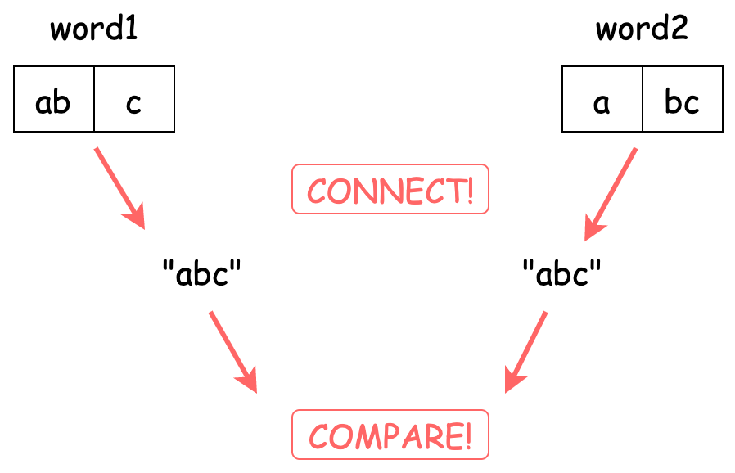

**Algorithm**

Step 1: Build concatenated strings for word1 and word2.

Step 2: Check if the strings are the same.

Challenge: Can you implement the code yourself without seeing our implementations?

**Implementation**

|  |
| --- |
| class Solution {  public boolean arrayStringsAreEqual(String[] word1, String[] word2) {  return (String.join("", word1)).equals(String.join("", word2));  }  } |

**Complexity Analysis**

Let N*N* be the maximum of the number of all characters in word1 and the number of all characters in word2.

* Time Complexity: \mathcal{O}(N)O(*N*), since we need to iterate over all characters in word1 and word2 to build the new strings.
* Space Complexity: \mathcal{O}(N)O(*N*), since we need extra \mathcal{O}(N)O(*N*) space to store the new built strings.

#### Approach 2: Splitting

**Intuition**

If you do not like concatenating, we can split them into single characters, and then use for-loop to compare them.

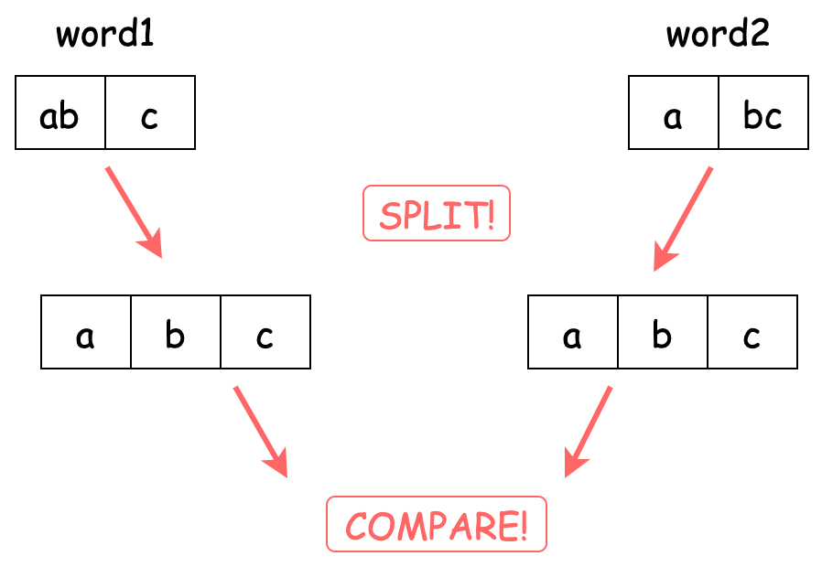

**Algorithm**

Step 1: Build lists of split characters for word1 and word2.

Step 2: Check if the lists are the same.

Challenge: Can you implement the code yourself without seeing our implementations?

**Implementation**

|  |
| --- |
| class Solution {  public boolean arrayStringsAreEqual(String[] word1, String[] word2) {  List<Character> list1 = new ArrayList<>();  for (String s : word1) {  for (char c : s.toCharArray()) {  list1.add(c);  }  }  List<Character> list2 = new ArrayList<>();  for (String s : word2) {  for (char c : s.toCharArray()) {  list2.add(c);  }  }  if (list1.size() != list2.size()) {  return false;  }  int size = list1.size();  for (int i = 0; i < size; i++) {  if (list1.get(i) != list2.get(i)) {  return false;  }  }  return true;  }  } |

**Complexity Analysis**

Let N*N* be the maximum of the number of all characters in word1 and the number of all characters in word2.

* Time Complexity: \mathcal{O}(N)O(*N*), since we need to iterate over all characters in word1 and word2 to split them in the list.
* Space Complexity: \mathcal{O}(N)O(*N*), since we need extra \mathcal{O}(N)O(*N*) space to store the lists.

#### Approach 3: No Pretreatment

**Intuition**

Both approaches above require some preprocessing on word1 or word2. Can we compare them directly?

Of course. We can iterate over each character in one string array and compare the corresponding character in the other string array.

To achieve this, we need some index to track the character in the other string array.

Here we use two indexes: stringIndex and characterIndex. stringIndex points to the index of the string in the string array, and characterIndex represents the index of the character in the string.

For example:

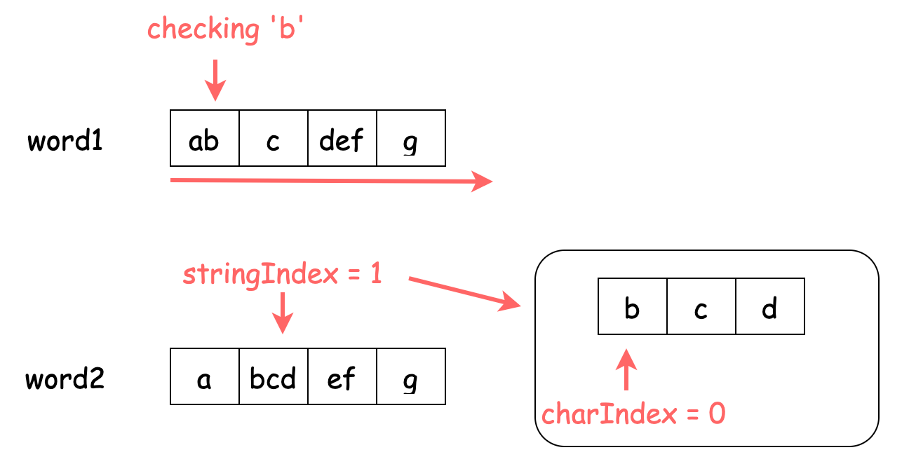

**Algorithm**

Step 1: Iterate over word1 and check if the corresponding character in word2 is the same.

Note: You can switch the position of word1 and word2.

Challenge: Can you implement the code yourself without seeing our implementations?

**Implementation**

|  |
| --- |
| class Solution {  public boolean arrayStringsAreEqual(String[] word1, String[] word2) {  int stringIndex = 0;  int characterIndex = 0;  int word2Length = word2.length;  List<Integer> word2LengthList = new ArrayList<>();  for (String s : word2) {  word2LengthList.add(s.length());  }  for (String s : word1) {  for (char c : s.toCharArray()) {  if (stringIndex >= word2Length ||  c != word2[stringIndex].charAt(characterIndex)) {  return false;  }  characterIndex++;  if (characterIndex == word2LengthList.get(stringIndex)) {  stringIndex++;  characterIndex = 0;  }  }  }  return true;  }  } |

Note: We precalculate the lengths of strings in word2 to prevent re-calculate it during the iteration. However, some built-in data structures automatically maintain the lengths as integers (such as list in Python). In this case, you can skip this precalculation. We here explicitly write the precalculation to emphasize it.

**Complexity Analysis**

Let N*N* be the number of all characters in word1, and M*M* be the length of word2.

* Time Complexity: \mathcal{O}(N)O(*N*), since we need to iterate over word1 to check if characters match.
* Space Complexity: \mathcal{O}(M)O(*M*), since we need extra \mathcal{O}(M)O(*M*) space to store the lengths of strings in word2. You can save this space if the data structure automatically stores the lengths.

#### Approach 4: Splitting One

**Intuition**

The tracking method in Approach 3 seems to be a little complicated: we need two indexes! Can we simplify it?

Yes! If we split the string array into a character array, then only one index is needed.

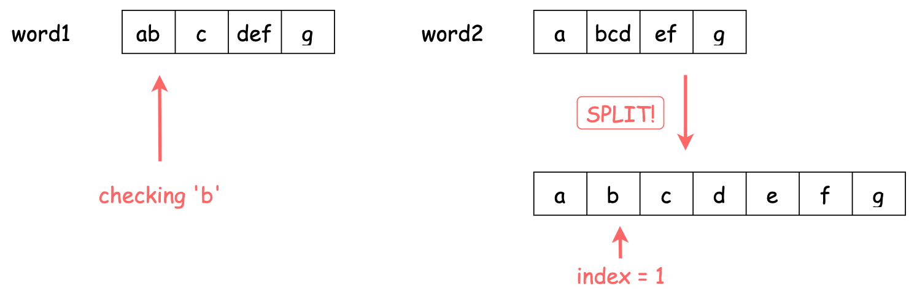

**Algorithm**

Step 1: Build lists of split characters for word2.

Step 2: Iterate over word1 and check if the corresponding character in word2 is the same.

Note: You can switch the position of word1 and word2.

Challenge: Can you implement the code yourself without seeing our implementations?

**Implementation**

|  |
| --- |
| class Solution {  public boolean arrayStringsAreEqual(String[] word1, String[] word2) {  List<Character> list2 = new ArrayList<>();  for (String s : word2) {  for (char c : s.toCharArray()) {  list2.add(c);  }  }  int list2Length = list2.size();  int index = 0;  for (String s : word1) {  for (char c : s.toCharArray()) {  if (index >= list2Length || c != list2.get(index)) {  return false;  }  index++;  }  }  return true;  }  } |

**Complexity Analysis**

Let N*N* be the maximum of the number of all characters in word1 and the number of all characters in word2.

* Time Complexity: \mathcal{O}(N)O(*N*), since we need to iterate over word1 to check if characters match.
* Space Complexity: \mathcal{O}(N)O(*N*), since we need extra \mathcal{O}(N)O(*N*) space to store the list in the worst case.

#### Approach 5: Connecting One

**Intuition**

Of course, instead of splitting in Approach 4, we can connect them into a whole array. In this case also, we only need one index.

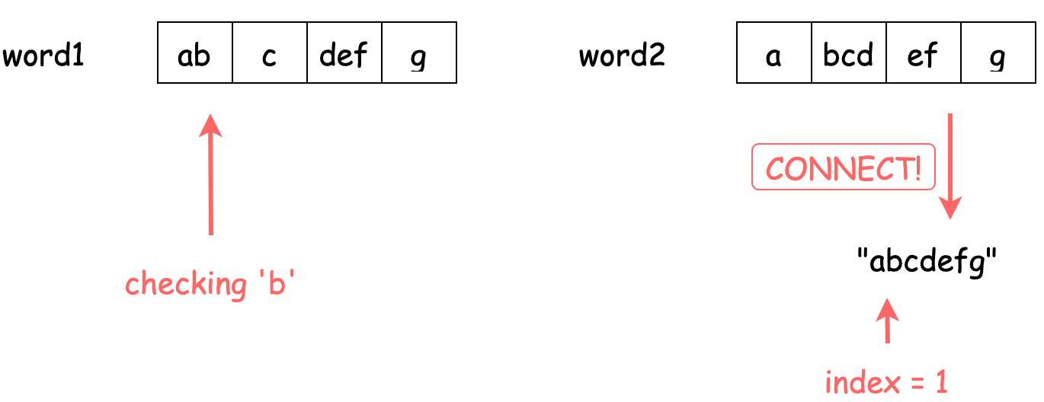

**Algorithm**

Step 1: Build concatenated strings for word2.

Step 2: Iterate over word1 and check if the corresponding character in word2 is the same.

Note: You can switch the position of word1 and word2.

Challenge: Can you implement the code yourself without seeing our implementations?

**Implementation**

|  |
| --- |
| class Solution {  public boolean arrayStringsAreEqual(String[] word1, String[] word2) {  String string2 = String.join("", word2);  int string2Length = string2.length();  int index = 0;  for (String s : word1) {  for (char c : s.toCharArray()) {  if (index >= string2Length || c != string2.charAt(index)) {  return false;  }  index++;  }  }  return true;  }  } |

**Complexity Analysis**

Let N*N* be the maximum of the number of all characters in word1 and the number of all characters in word2.

* Time Complexity: \mathcal{O}(N)O(*N*), since we need to iterate over word1 to check if characters match.
* Space Complexity: \mathcal{O}(N)O(*N*), since we need extra \mathcal{O}(N)O(*N*) space to store the new string in the worst case.

**Create Sorted Array through Instructions**

**Solution**

Given an integer array instructions, you are asked to create a sorted array from the elements in instructions. You start with an empty container nums. For each element from **left to right** in instructions, insert it into nums. The **cost** of each insertion is the **minimum** of the following:

* The number of elements currently in nums that are **strictly less than** instructions[i].
* The number of elements currently in nums that are **strictly greater than** instructions[i].

For example, if inserting element 3 into nums = [1,2,3,5], the **cost** of insertion is min(2, 1) (elements 1 and 2 are less than 3, element 5 is greater than 3) and nums will become [1,2,3,3,5].

Return the ***total cost*** to insert all elements from instructions into nums. Since the answer may be large, return it **modulo** 109 + 7

**Example 1:**

**Input:** instructions = [1,5,6,2]

**Output:** 1

**Explanation:** Begin with nums = [].

Insert 1 with cost min(0, 0) = 0, now nums = [1].

Insert 5 with cost min(1, 0) = 0, now nums = [1,5].

Insert 6 with cost min(2, 0) = 0, now nums = [1,5,6].

Insert 2 with cost min(1, 2) = 1, now nums = [1,2,5,6].

The total cost is 0 + 0 + 0 + 1 = 1.

**Example 2:**

**Input:** instructions = [1,2,3,6,5,4]

**Output:** 3

**Explanation:** Begin with nums = [].

Insert 1 with cost min(0, 0) = 0, now nums = [1].

Insert 2 with cost min(1, 0) = 0, now nums = [1,2].

Insert 3 with cost min(2, 0) = 0, now nums = [1,2,3].

Insert 6 with cost min(3, 0) = 0, now nums = [1,2,3,6].

Insert 5 with cost min(3, 1) = 1, now nums = [1,2,3,5,6].

Insert 4 with cost min(3, 2) = 2, now nums = [1,2,3,4,5,6].

The total cost is 0 + 0 + 0 + 0 + 1 + 2 = 3.

**Example 3:**

**Input:** instructions = [1,3,3,3,2,4,2,1,2]

**Output:** 4

**Explanation:** Begin with nums = [].

Insert 1 with cost min(0, 0) = 0, now nums = [1].

Insert 3 with cost min(1, 0) = 0, now nums = [1,3].

Insert 3 with cost min(1, 0) = 0, now nums = [1,3,3].

Insert 3 with cost min(1, 0) = 0, now nums = [1,3,3,3].

Insert 2 with cost min(1, 3) = 1, now nums = [1,2,3,3,3].

Insert 4 with cost min(5, 0) = 0, now nums = [1,2,3,3,3,4].

​​​​​​​Insert 2 with cost min(1, 4) = 1, now nums = [1,2,2,3,3,3,4].

​​​​​​​Insert 1 with cost min(0, 6) = 0, now nums = [1,1,2,2,3,3,3,4].

​​​​​​​Insert 2 with cost min(2, 4) = 2, now nums = [1,1,2,2,2,3,3,3,4].

The total cost is 0 + 0 + 0 + 0 + 1 + 0 + 1 + 0 + 2 = 4.

**Constraints:**

* 1 <= instructions.length <= 105
* 1 <= instructions[i] <= 105

Hide Hint #1

This problem is closely related to finding the number of inversions in an array

   Hide Hint #2

if i know the position in which i will insert the i-th element in I can find the minimum cost to insert it

## Solution

#### Overview

The problem is straightforward. We need to obtain the cost of inserting each element in sorted order and return the total cost.

How to determine the cost? According to the description, we need to find the number of elements on the left side strictly less/larger than the current element.

One natural idea is to maintain a sorted array and search with [Binary Search](https://leetcode.com/explore/learn/card/binary-search/). However, the array insertion takes \mathcal{O}(M)O(*M*), given that M*M* is the length of the array, which is too slow. We need something quicker.

Luckily, there are two helpful and fast data structures: Segment Tree and Binary Indexed Tree.

Also, if one is not familiar with those trees, a solution of simple modifications on [Merge Sort](https://en.wikipedia.org/wiki/Merge_sort) is available.

Below, we will discuss three approaches: Segment Tree, Binary Indexed Tree, and Merge Sort.

At the end of the article, in Extra part, we will present some interesting relevant facts that may not be useful in the interview though. We leave that for interested readers.

#### Approach 1: Segment Tree

**Intuition**

Since we already have some great explanations on [Segment Tree](https://en.wikipedia.org/wiki/Segment_tree), here we will not provide a detailed explanation of implementation. You can find some comprehensive tutorials on [Recursive Approach to Segment Trees](https://leetcode.com/articles/a-recursive-approach-to-segment-trees-range-sum-queries-lazy-propagation/) or [Range Sum Query - Mutable](https://leetcode.com/problems/range-sum-query-mutable/solution/).

Now, we will have a quick review of the segment tree and then explain how we can use it to tackle our problem.

As we know, segment tree is a data structure used for storing information about intervals. Given that M*M* is the size of the tree, this data structure allows us to query and to update the information about a certain interval in \mathcal{O}(\log(M))O(log(*M*)) time.

Take the segment tree for querying interval **sum** for an example:

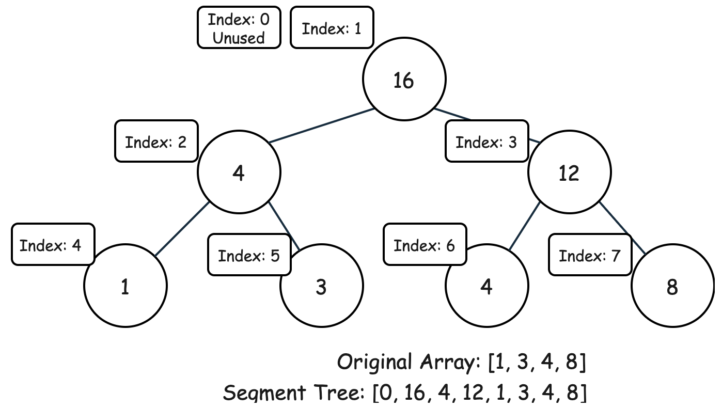

Usually, we store the tree in an array. We need twice the size of the original array to store the segment tree.

Here, we leave the index 0 unused for the convenience of indexing. You can also choose to use it by shifting the whole tree one unit left. In our approach, the left and right children of node i are 2*i and 2*i+1 respectively.

Given that m is the size of the original array, from the node m to node 2*m - 1, we store the original array itself. For other nodes, we store the value of node i as the sum of node 2*i and node 2*i+1.

The segment tree allows us to query the **sum** of a certain interval and to update the values of elements. It should be able to process both actions in \mathcal{O}(\log(M))O(log(*M*)) time. Let's see some examples.

Updating Value

For update, what we do is simple. Just update the value from the leaf to the root. For instance:

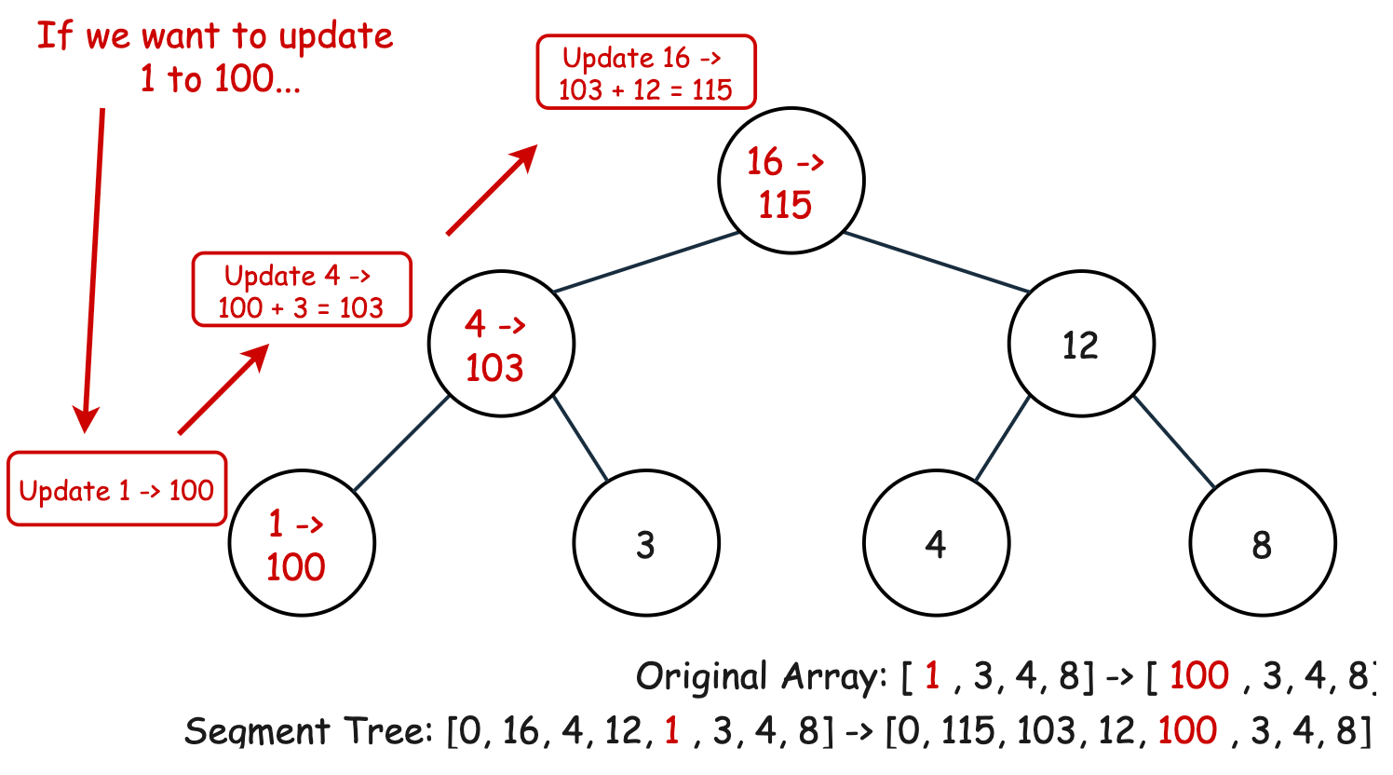

Querying Sum

For query, the case is a bit complicated. Generally speaking, we are dividing the target interval into a few pre-calculated segments to reduced run time. For example:

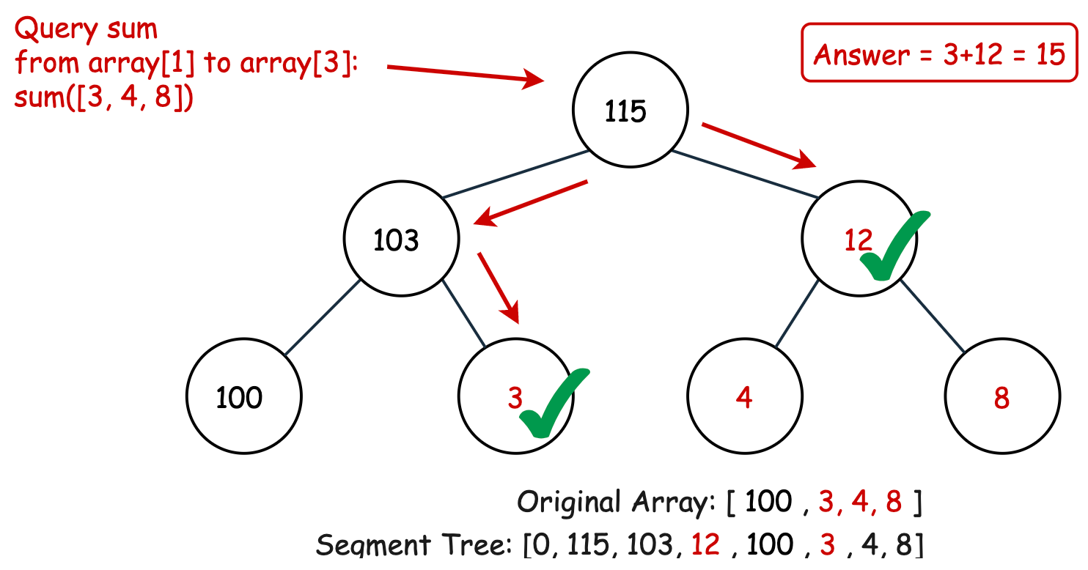

OK. Now back to our problem. We need to find the cost of each element. How can we use the segment tree?

Using some idea from [Bucket](https://en.wikipedia.org/wiki/Bucket_(computing)), we can store the **occurrence number** of values in a bucket array. Then, by querying the interval sum for the current value to the maximum value, we obtain the number of larger elements.

To give you an idea, consider this case: instructions is [2, 3, 3, 3, 3, 1, 0], and we are processing element instructions[5] = 1. When we want to query the number of larger elements, we want to query the sum from 2 to the largest value 3 (i.e., the sum on the right of value 1 in Segment Tree):

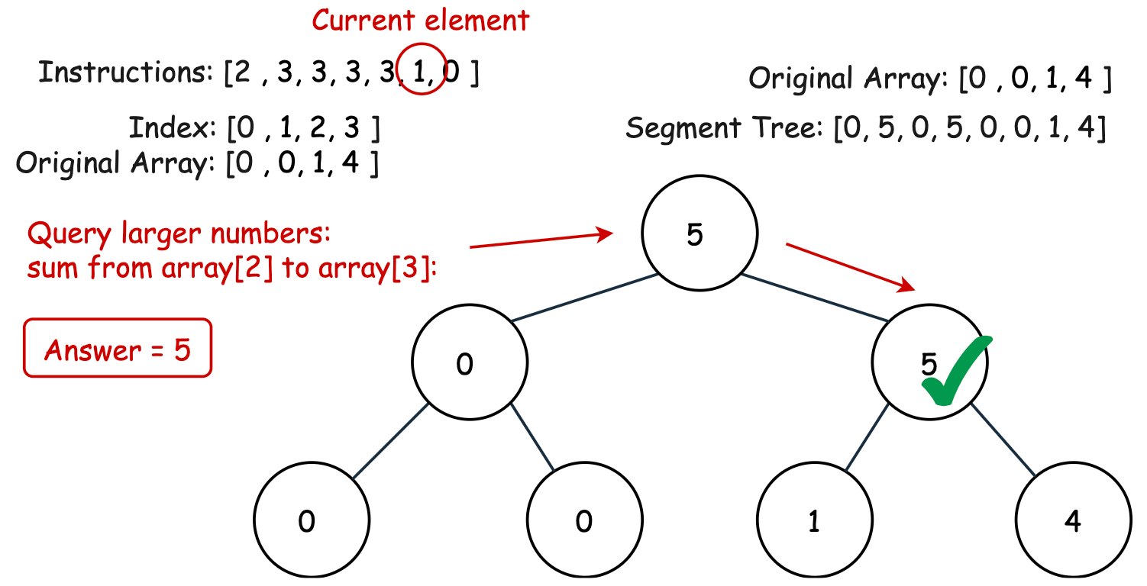

Updating the segment tree is also easy. We just need to add 1 to the node of the current element and all the path up to the root.

**Algorithm**

Step 1: Implement the Segment Tree. Since the tree is initialized to all zeros, only update and query needs to be implemented.

Step 2: Iterate over instructions. For each element:

* Calculate the left cost (smaller cost) and right cost (larger cost).
* Add the minimal one to the total cost.
* Update the element into the Segment Tree.

Step 3: Return the total cost after iteration.

Challenge: Can you implement the code yourself without seeing our implementations?

**Implementation**

|  |
| --- |
| class Solution {  public int createSortedArray(int[] instructions) {  int m = (int) 1e5 + 1;  int[] tree = new int[m * 2];  long cost = 0;  long MOD = (int) 1e9 + 7;  for (int x : instructions) {  cost += Math.min(query(0, x, tree, m), query(x + 1, m, tree, m));  update(x, 1, tree, m);  }  return (int) (cost % MOD);  }  // implement Segment Tree  private void update(int index, int value, int[] tree, int m) {  index += m;  tree[index] += value;  for (index >>= 1; index > 0; index >>= 1)  tree[index] = tree[index << 1] + tree[(index << 1) + 1];  }  private int query(int left, int right, int[] tree, int m) {  int result = 0;  for (left += m, right += m; left < right; left >>= 1, right >>= 1) {  if ((left & 1) == 1)  result += tree[left++];  if ((right & 1) == 1)  result += tree[--right];  }  return result;  }  } |

**Complexity Analysis**

Let N*N* be the length of instructions and M*M* be the maximum value in instructions.

* Time Complexity: \mathcal{O}(N\log(M))O(*N*log(*M*)). We need to iterate over instructions, and for each element, the time to find the left cost and right cost is \mathcal{O}(\log(M))O(log(*M*)), and we spend \mathcal{O}(\log(M))O(log(*M*)) inserting the current element into the Segment Tree. In total, we need \mathcal{O}(N \cdot \log(M)) = \mathcal{O}(N\log(M))O(*N*⋅log(*M*))=O(*N*log(*M*)).
* Space Complexity: \mathcal{O}(M)O(*M*), since we need an array of size 2M2*M* to store Segment Tree.

#### Approach 2: Binary Indexed Tree (BIT)

**Intuition**

[Binary indexed tree](https://en.wikipedia.org/wiki/Fenwick_tree) (or Fenwick Tree, BIT) is a data structure similar to the segment tree that maintains information about the **prefix**.

Compared with the segment tree, BIT has smaller space complexity and faster performance (same complexity but smaller constant) but lower expandability. For example, it is hard for BIT to address the interval minimum problem while the segment tree can easily handle it.

You can find some relevant tutorials on [Reverse Pairs](https://leetcode.com/problems/reverse-pairs/solution/) or [Range Sum Query 2D - Mutable](https://leetcode.com/problems/range-sum-query-2d-mutable/solution/).

Now, we will have a quick review of BIT and then explain how we can use it to tackle our problem.

Like the segment tree, BIT empowers us to update the values of elements and to query the information from node 0 to node i. It can answer both actions in \mathcal{O}(\log(M))O(log(*M*)) time, given that the size of BIT is \mathcal{O}(M)O(*M*).

For intuitive understanding, it is not recommended to view BIT as a tree but as an **array** with parents relationship for beginners.

Take the BIT for querying prefix **sum** for an example.

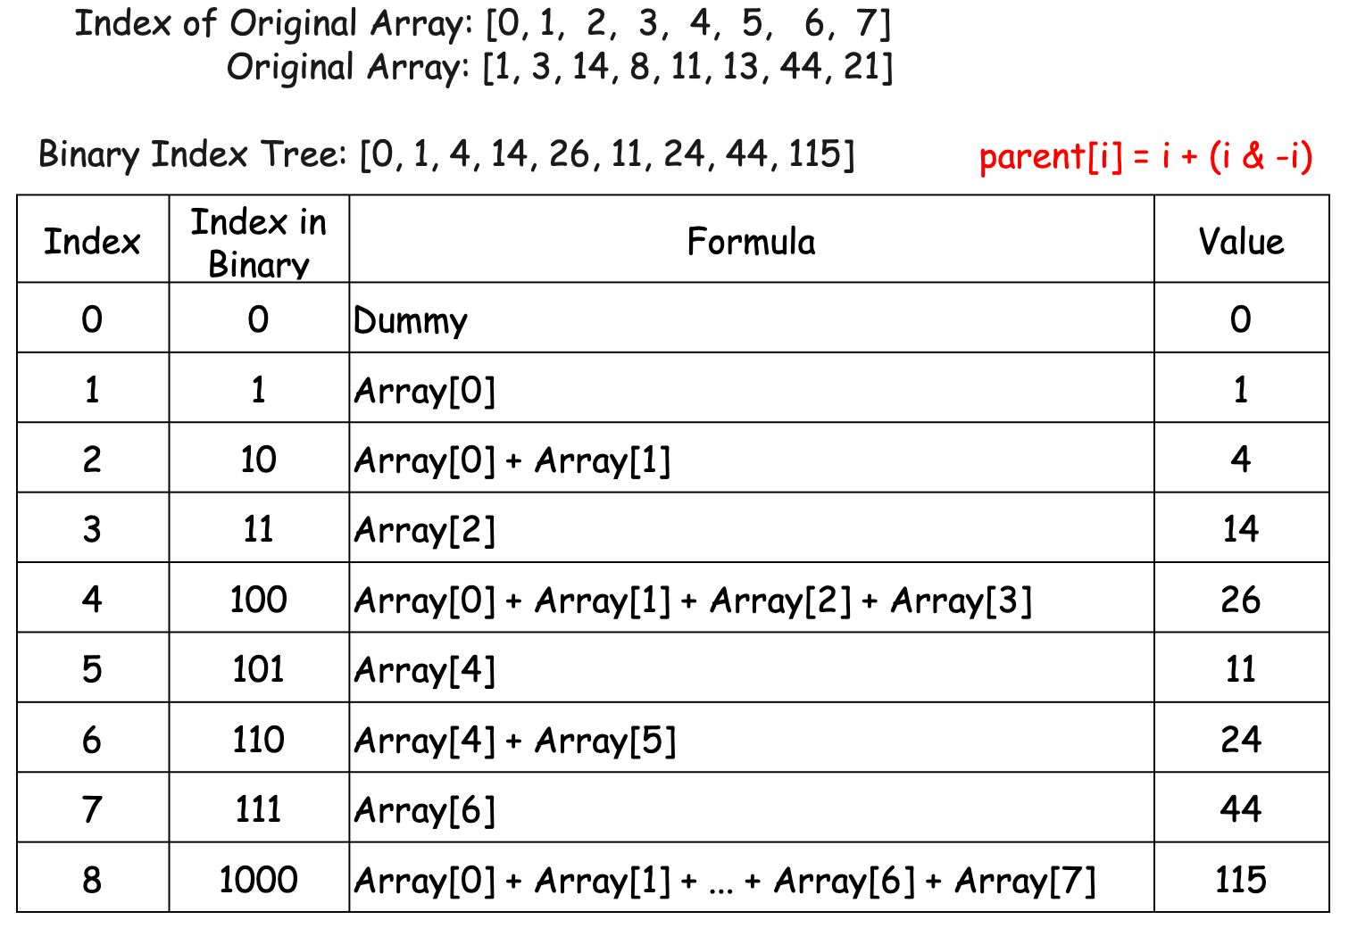

We construct this relationship: the parent of node i is node i + (i & -i), where & is the bitwise AND operator.

In fact, i \& -i*i*&−*i* have some connections to the position of the rightmost 11 in binary form counting from right. Say, the position of the rightmost 11 in binary representation of i*i* is k*k*, and then we have i \& -i = 2^{k-1}*i*&−*i*=2*k*−1.

For example, the base-2 form of 66 is 110110, the position of the rightmost 11 is in the **second** position counting from right. We have 6 \& -6 = 2^{2-1} = 26&−6=22−1=2.

Also, 2^{k-1}2*k*−1 represents the number of elements adding up. For instance, BIT[6] = arr[4] + arr[5], which consists of **two** elements: arr[4] and arr[5].

When building BIT, we initialize the array BIT of length M+1*M*+1, where M*M* is the size of the original array.

We use index 0 as a dummy node for the convenience of indexing. Then for each element arr[j] in original array arr, we put it in BIT[j+1]. Also, we maintain BIT such that the value of every node is the sum of the values of its children. Therefore, we add arr[j] all the path from BIT[j+1] to the root in BIT.

Similarly, update and query are available in BIT. Let's check the detail.

*Updating Value*

It is easy to update an element. For instance, if we need to update 1 to 100 in the last example:

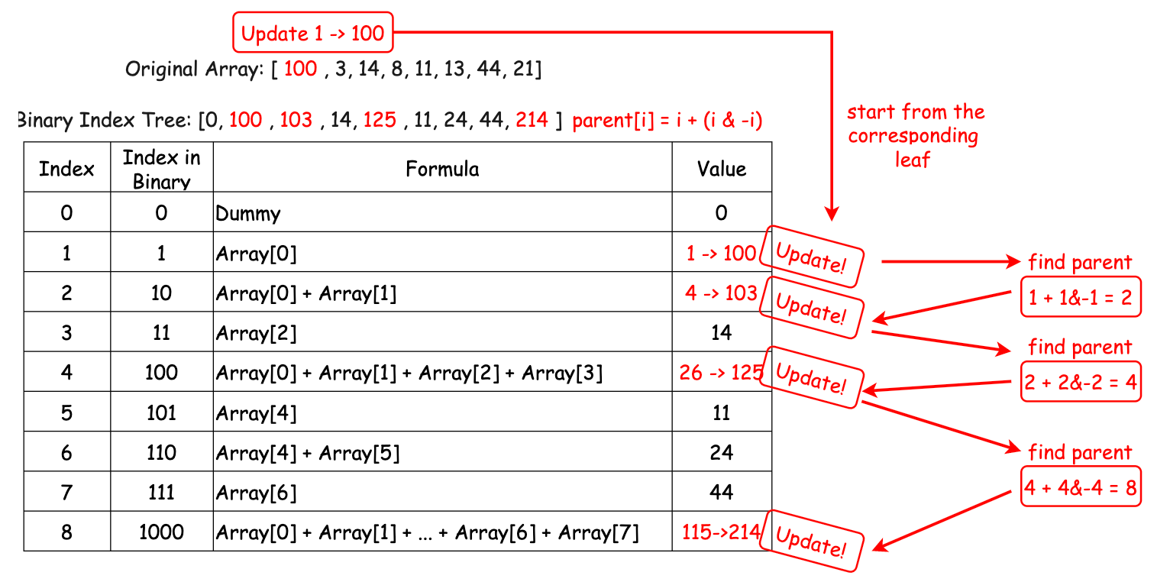

*Querying Sum*

For query, it is also simple. Say, if we want to calculate the prefix sum to arr[j]. We need to initialize i to j+1, and then add BIT[i] to the query answer. After that, replace i to i - (i & -i), and then add new BIT[i], until i reaches 0.

For example, if we need to sum up from arr[0] to arr[4]:

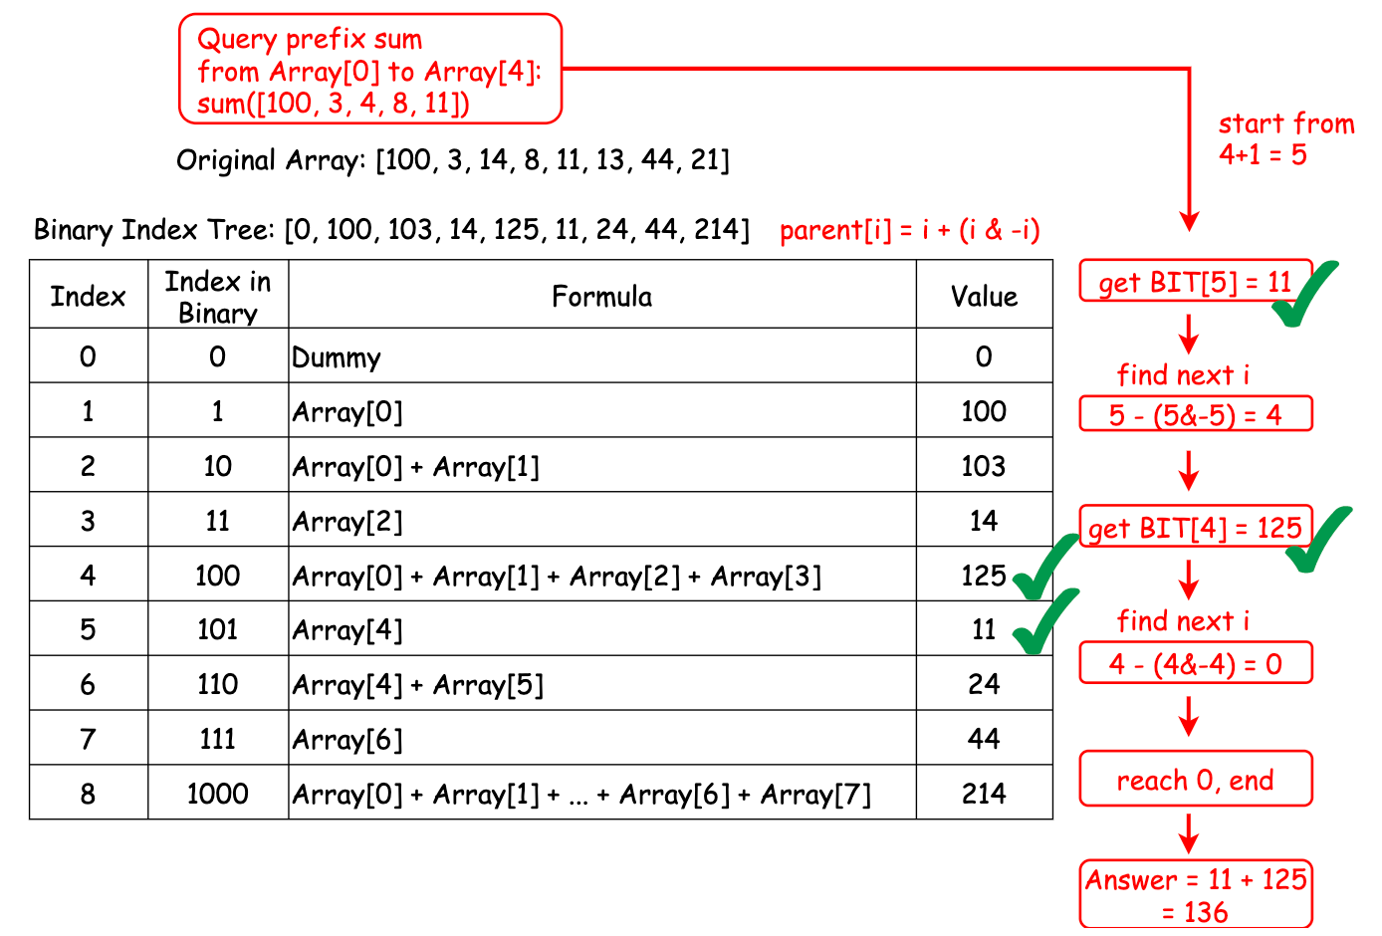

Note that BIT only supports prefix information querying, so we can only query from start to a certain element, not any interval.

OK. Now back to our problem. How can we use BIT to resolve this problem?

Similar to Approach 1, we store the **occurrence number** of values in an array. Then, by querying the interval sum for the current value to the maximum value, we obtain the number of larger elements.

Updating the BIT is also easy. We just need to add 1 to the node of the current element and add other corresponding nodes.

**Algorithm**

Step 1: Implement the Binary Indexed Tree. Since the tree is initialized to all zeros, only update and query is needed to implement.

Step 2: Iterate over instructions. For each element:

* Calculate the left cost (smaller cost) and right cost (larger cost).
* Add the minimal one to the total cost.
* Update the element into the Binary Indexed Tree.

Step 3: Return the total cost after iteration.

Challenge: Can you implement the code yourself without seeing our implementations?

**Implementation**

|  |
| --- |
| class Solution {  public int createSortedArray(int[] instructions) {  int m = 100002;  int[] bit = new int[m];  long cost = 0;  long MOD = 1000000007;  for (int i = 0; i < instructions.length; i++) {  int leftCost = query(instructions[i] - 1, bit);  int rightCost = i - query(instructions[i], bit);  cost += Math.min(leftCost, rightCost);  update(instructions[i], 1, bit, m);  }  return (int) (cost % MOD);  }  // implement Binary Index Tree  private void update(int index, int value, int[] bit, int m) {  index++;  while (index < m) {  bit[index] += value;  index += index & -index;  }  }  private int query(int index, int[] bit) {  index++;  int result = 0;  while (index >= 1) {  result += bit[index];  index -= index & -index;  }  return result;  }  } |

**Complexity Analysis**

Let N*N* be the length of instructions and M*M* be the maximum value in instructions.

* Time Complexity: \mathcal{O}(N\log(M))O(*N*log(*M*)). We need to iterate over instructions, and for each element, the time to find the left cost and right cost is \mathcal{O}(\log(M))O(log(*M*)), and we spend \mathcal{O}(\log(M))O(log(*M*)) inserting the current element into the BIT. In total, we need \mathcal{O}(N \cdot \log(M)) = \mathcal{O}(N\log(M))O(*N*⋅log(*M*))=O(*N*log(*M*)).
* Space Complexity: \mathcal{O}(M)O(*M*), since we need an array of size \mathcal{O}(M)O(*M*) to store BIT.

#### Approach 3: Merge Sort

**Intuition**

In fact, this problem is a kind of extension of the original [Count of Smaller Numbers After Self](https://leetcode.com/problems/count-of-smaller-numbers-after-self/). They are similar except we need both smaller and larger ones on the left.

Inspired from the approach of the original problem, a simple modification of merge sort will help us address this problem. Let's see the idea.

Without loss of generality, consider larger ones on the left first.

If you consider the process of sorting, you will find out a useful insight:

The larger elements on the left of a number are exactly those that **jump from its left to its right** during a stable sort.

For example, consider when instructions = [1, 7, 6, 3, 4] and we want to calculate the number of larger elements on the left of instructions[3] = 3:

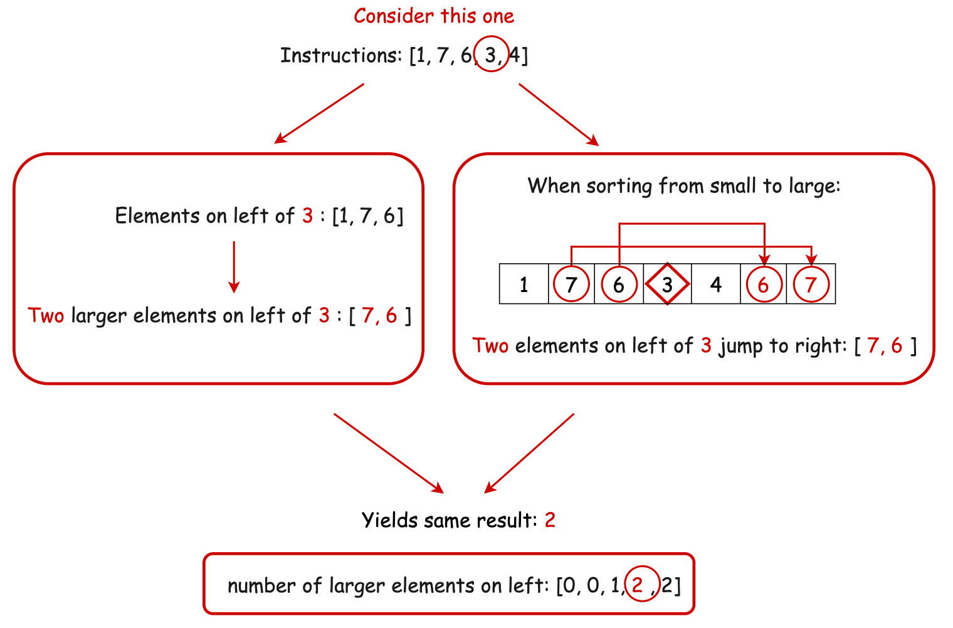

We use the term **stable** sort here since we do not want to count the jumping of adjacent elements with the same values. We want to keep them as what they are.

Therefore, we want to record the jumping numbers when sorting.

But which sorting method? Well, many sorting methods can do it. Here, we pick merge sort for an example.

Merge sort is simple: split the array into two parts, recursively call merge sort on each part, and then merge two parts.

Note that in the "merge" step what we do is exactly deciding which element goes left and which element goes right. We can record the jumping number when merging.

For instance, consider when instructions = [7, 2, 3, 4, 1, 6] and we already have divided it into two parts and sorted them: [2, 3, 7] and [1, 4, 6]. Now we need to merge those two parts:

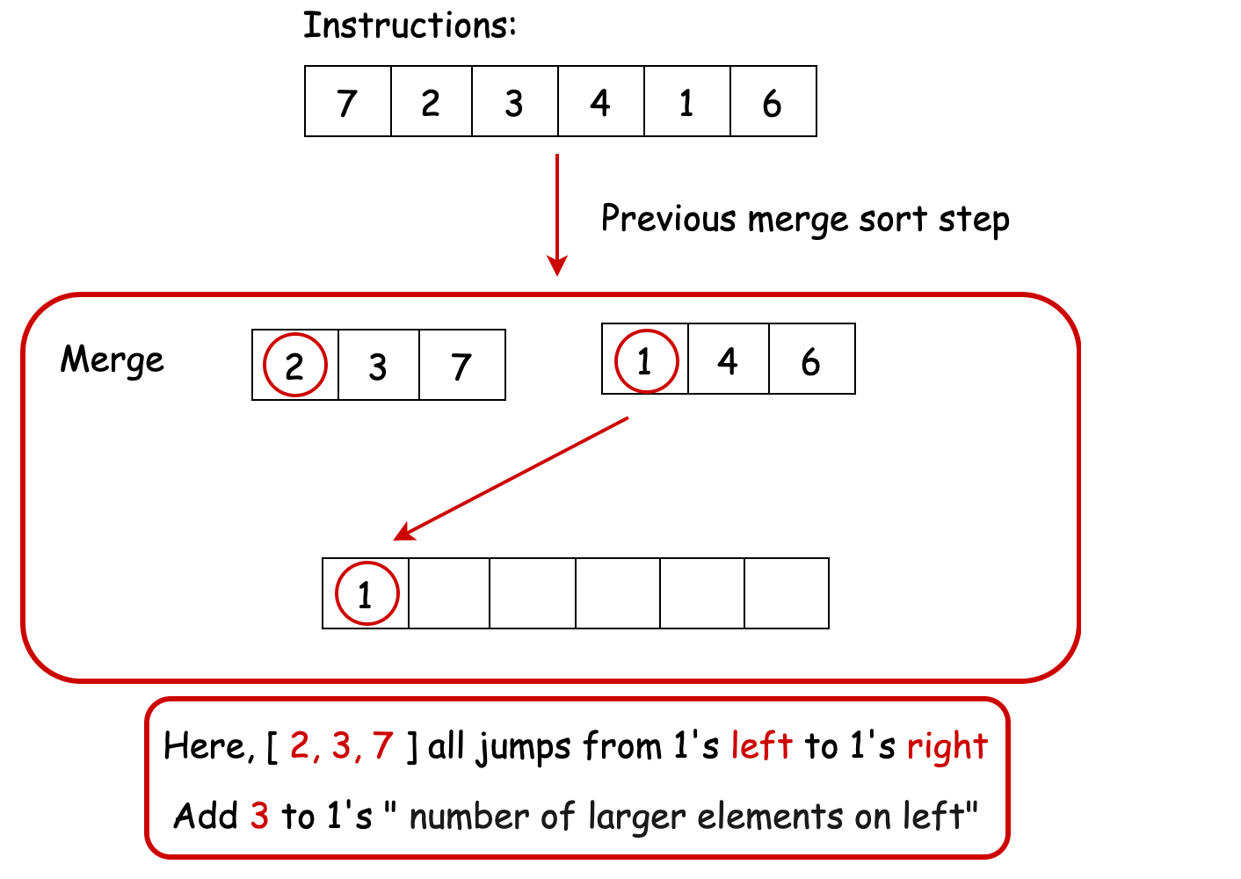

When we decide that we should put the number in the second array, all elements remaining in the first array are jumping from left to right. What we need to do is to add the length of the first array.

The case of smaller ones is similar. We can record the number of elements that **stay** on left after sorting. To avoid counting those with the same value, we need a totally unstable sort here (i.e., adjacent same values become reversed order).

Alternatively, you can stably sort them from large to small, and record those jump from left to right.

However, one should notice that this approach may be slower than previous approaches since we do merge sort twice to solve the larger case and smaller case respectively.

**Algorithm**

Step 1: Initialize larger array and smaller array, which store the number of elements on left strictly larger and smaller than the current element, respectively.

Step 2: Implement two merge sort function: sortLargerand sortSmaller.

* For sortLarger, we perform a stable merge sort. When merging, we record the number of elements jumping from left to right.
* For sortSmaller, we perform a totally unstable merge sort. When merging, we record the number of elements staying on left.

Step 3: Iterate over instructions. For each element:

* Add the minimal of smaller[i] and larger[i] to the total cost.
* Update the element into the Binary Indexed Tree.

Step 3: Return the total cost after iteration.

Challenge: Can you implement the code yourself without seeing our implementations?

**Implementation**

|  |
| --- |
| class Solution {  int[] smaller;  int[] larger;  int[][] temp; // record some temporal information  public int createSortedArray(int[] instructions) {  int n = instructions.length;  smaller = new int[n];  larger = new int[n];  temp = new int[n][];  long cost = 0;  long MOD = 1000000007;  int[][] arrSmaller = new int[n][];  int[][] arrLarger = new int[n][];  for (int i = 0; i < n; i++) {  arrSmaller[i] = new int[] { instructions[i], i };  arrLarger[i] = new int[] { instructions[i], i };  }  sortSmaller(arrSmaller, 0, n - 1);  sortLarger(arrLarger, 0, n - 1);  for (int i = 0; i < n; i++) {  cost += Math.min(smaller[i], larger[i]);  }  return (int) (cost % MOD);  }  private void sortSmaller(int[][] arr, int left, int right) {  if (left == right) {  return;  }  int mid = (left + right) / 2;  sortSmaller(arr, left, mid);  sortSmaller(arr, mid + 1, right);  mergeSmaller(arr, left, right, mid);  }  private void mergeSmaller(int[][] arr, int left, int right, int mid) {  // merge [left, mid] and [mid+1, right]  int i = left;  int j = mid + 1;  int k = left;  // use temp[left...right] to temporarily store sorted array  while (i <= mid && j <= right) {  if (arr[i][0] < arr[j][0]) {  temp[k++] = arr[i];  i++;  } else {  temp[k++] = arr[j];  smaller[arr[j][1]] += i - left;  j++;  }  }  while (i <= mid) {  temp[k++] = arr[i];  i++;  }  while (j <= right) {  temp[k++] = arr[j];  smaller[arr[j][1]] += i - left;  j++;  }  // restore from temp  for (i = left; i <= right; i++) {  arr[i] = temp[i];  }  }  private void sortLarger(int[][] arr, int left, int right) {  if (left == right) {  return;  }  int mid = (left + right) / 2;  sortLarger(arr, left, mid);  sortLarger(arr, mid + 1, right);  mergeLarger(arr, left, right, mid);  }  private void mergeLarger(int[][] arr, int left, int right, int mid) {  // merge [left, mid] and [mid+1, right]  int i = left;  int j = mid + 1;  int k = left;  // use temp[left...right] to temporarily store sorted array  while (i <= mid && j <= right) {  if (arr[i][0] <= arr[j][0]) {  temp[k++] = arr[i];  i++;  } else {  temp[k++] = arr[j];  larger[arr[j][1]] += mid - i + 1;  j++;  }  }  while (i <= mid) {  temp[k++] = arr[i];  i++;  }  while (j <= right) {  temp[k++] = arr[j];  larger[arr[j][1]] += mid - i + 1;  j++;  }  // restore from temp  for (i = left; i <= right; i++) {  arr[i] = temp[i];  }  }  } |

Note:

* In C++ code, we used a raw array instead of vector to avoid TLE. However, in most cases, vector should be preferred since it has more functions and is safer than the array.
* The Python version is likely to yield a TLE since Python itself is slow. This time limit may be extended in the future.

**Complexity Analysis**

Let N*N* be the length of instructions.

* Time Complexity: \mathcal{O}(N\log(N))O(*N*log(*N*)). We need to perform \mathcal{O}(N\log(N))O(*N*log(*N*)) merge sort twice. All other operations take no more than \mathcal{O}(N)O(*N*).
* Space Complexity: \mathcal{O}(N)O(*N*), since we need constant number of arrays of size \mathcal{O}(N)O(*N*).

#### Extra

**1. Order Statistic Tree**

In fact, what we do in Approach 1 and Approach 2 is implementing an [Order Statistic Tree](https://en.wikipedia.org/wiki/Order_statistic_tree) interface with different implementations. The wiki page also gives us another implementation, but that requires extra code and we leave that for interested readers.

**2. The \mathcal{O}(N^2)O(*N*2) Python Approach**

Though Python itself is slow, its many built-in functions are written in C which is fast. As a result, sometimes the built-in functions are faster than our manual implementation, even with larger time complexity.

In this case, maintaining a sorted list with bisect is sometimes faster than the Segment Tree Approach in the current data scale.

|  |
| --- |
| class Solution:  def createSortedArray(self, instructions: List[int]) -> int:  MOD = 10**9+7  current = []  cost = 0  for x in instructions:  left_cost = bisect.bisect_left(current, x)  right_cost = len(current) - bisect.bisect_right(current, x)  cost += min(left_cost, right_cost)  bisect.insort(current, x)  cost %= MOD  return cost % MOD |

**3. The \mathcal{O}(N\log(N))O(*N*log(*N*)) built-in Python Approach**

Python is an interesting language with many useful libraries. In a third-party library sortedcontainers, we have a SortedList that supports update in \mathcal{O}(\log(N))O(log(*N*)), given that N*N* is the length of the sorted list.

You can check the implementation detail in its [official docs](http://www.grantjenks.com/docs/sortedcontainers/implementation.html). In short, it implements a Segment-Tree-like structure.

|  |
| --- |
| from sortedcontainers import SortedList  class Solution:  def createSortedArray(self, instructions: List[int]) -> int:  sorted_list = SortedList()  MOD = 10**9+7  cost = 0  size = len(instructions)  for i in range(size):  left_cost = sorted_list.bisect_left(instructions[i])  right_cost = i - sorted_list.bisect_right(instructions[i])  cost += min(left_cost, right_cost)  sorted_list.add(instructions[i])  return cost % MOD |

**4. The \mathcal{O}(N\sqrt{N})O(*NN*​) Approach**

Though with larger time complexity, this approach can be solved with Sqrt Decomposition. We will not introduce it in detail since it yields TLE for this problem.

Generally speaking, what we do is to split the sorted list into \mathcal{O}(\sqrt{N})O(*N*​) sublists of size \mathcal{O}(\sqrt{N})O(*N*​), and we only need to spend \mathcal{O}(\sqrt{N})O(*N*​) on insertion. Interested readers can check [Range Sum Query - Mutable](https://leetcode.com/problems/range-sum-query-mutable/solution/) for some idea.

**Boats to Save People**

You are given an array people where people[i] is the weight of the ith person, and an **infinite number of boats** where each boat can carry a maximum weight of limit. Each boat carries at most two people at the same time, provided the sum of the weight of those people is at most limit.

Return the minimum number of boats to carry every given person.

**Example 1:**

**Input:** people = [1,2], limit = 3

**Output:** 1

**Explanation:** 1 boat (1, 2)

**Example 2:**

**Input:** people = [3,2,2,1], limit = 3

**Output:** 3

**Explanation:** 3 boats (1, 2), (2) and (3)

**Example 3:**

**Input:** people = [3,5,3,4], limit = 5

**Output:** 4

**Explanation:** 4 boats (3), (3), (4), (5)

**Constraints:**

* 1 <= people.length <= 5 * 104
* 1 <= people[i] <= limit <= 3 * 104

## Solution

#### Approach 1: Greedy (Two Pointer)

**Intuition**

If the heaviest person can share a boat with the lightest person, then do so. Otherwise, the heaviest person can't pair with anyone, so they get their own boat.

The reason this works is because if the lightest person can pair with anyone, they might as well pair with the heaviest person.

**Algorithm**

Let people[i] to the currently lightest person, and people[j] to the heaviest.

Then, as described above, if the heaviest person can share a boat with the lightest person (if people[j] + people[i] <= limit) then do so; otherwise, the heaviest person sits in their own boat.

|  |
| --- |
| class Solution {  public int numRescueBoats(int[] people, int limit) {  Arrays.sort(people);  int i = 0, j = people.length - 1;  int ans = 0;  while (i <= j) {  ans++;  if (people[i] + people[j] <= limit)  i++;  j--;  }  return ans;  }  } |

**Complexity Analysis**

* Time Complexity: O(N \log N)*O*(*N*log*N*), where N*N* is the length of people.
* Space Complexity: O(N)*O*(*N*).

**Minimum Operations to Reduce X to Zero**

You are given an integer array nums and an integer x. In one operation, you can either remove the leftmost or the rightmost element from the array nums and subtract its value from x. Note that this **modifies** the array for future operations.

Return the ***minimum number*** of operations to reduce x to ***exactly*** 0 if it's possible, otherwise, return -1.

**Example 1:**

**Input:** nums = [1,1,4,2,3], x = 5

**Output:** 2

**Explanation:** The optimal solution is to remove the last two elements to reduce x to zero.

**Example 2:**

**Input:** nums = [5,6,7,8,9], x = 4

**Output:** -1

**Example 3:**

**Input:** nums = [3,2,20,1,1,3], x = 10

**Output:** 5

**Explanation:** The optimal solution is to remove the last three elements and the first two elements (5 operations in total) to reduce x to zero.

**Constraints:**

* 1 <= nums.length <= 105
* 1 <= nums[i] <= 104
* 1 <= x <= 109

   Hide Hint #1

Think in reverse; instead of finding the minimum prefix + suffix, find the maximum subarray.

   Hide Hint #2

Finding the maximum subarray is standard and can be done greedily.

## Solution

#### Overview

This problem is closely related to [Maximum Size Subarray Sum Equals k](https://leetcode.com/problems/maximum-size-subarray-sum-equals-k/). The key difference is that the input array for this problem only contains positive integers, whereas for [Maximum Size Subarray Sum Equals k](https://leetcode.com/problems/maximum-size-subarray-sum-equals-k/), it can contain both positive and negative integers.

One way of solving this problem is to firstly transform it into a [Maximum Size Subarray Sum Equals k](https://leetcode.com/problems/maximum-size-subarray-sum-equals-k/) problem. Then, any algorithm that solves [Maximum Size Subarray Sum Equals k](https://leetcode.com/problems/maximum-size-subarray-sum-equals-k/) will also solve this problem.

**Warning**: The converse is not true. Because the input array for [Maximum Size Subarray Sum Equals k](https://leetcode.com/problems/maximum-size-subarray-sum-equals-k/) can contain both positive and negative integers, algorithms that only work for positive integers will work for this problem, but not [Maximum Size Subarray Sum Equals k](https://leetcode.com/problems/maximum-size-subarray-sum-equals-k/).

The downside of doing this is that the algorithms for [Maximum Size Subarray Sum Equals k](https://leetcode.com/problems/maximum-size-subarray-sum-equals-k/) are more complicated than what is necessary for this problem, so in this article, we're going to focus on approaches that only work with positive integers.

Below, we will discuss two methods: Two Pointers (Indirectly) and Two Pointers (Directly). Their implementations are almost the same, but their perspectives on the problem are different.

#### Approach 1: Two Pointers (Indirectly)

**Intuition**

The indirect approach determines which values will remain in the array, as opposed to which values should be removed from the array.

Let total be the sum of elements in nums.

An insight is that:

To find the **shortest** required operations that sum up to x is to find the **longest** subarray that sums up to total - x.

For example:

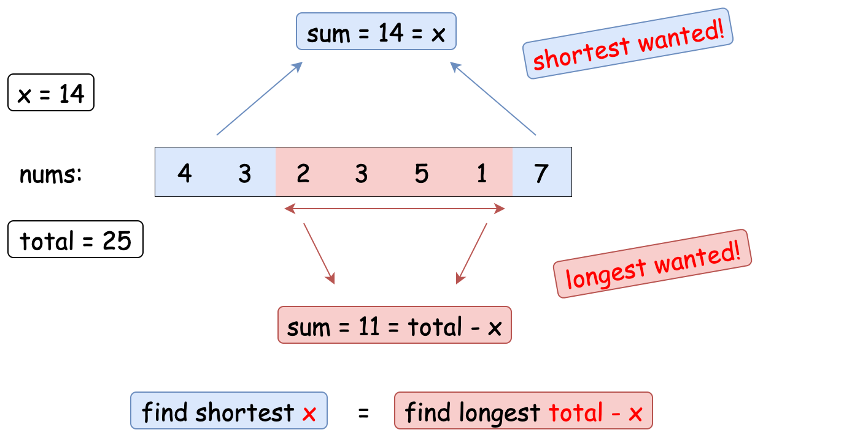

In this case, nums = [4, 3, 2, 3, 5, 1, 7]. To sum to x = 14, the shortest operations are taking [4, 3] on left and [7] on right. This is the same as finding the longest subarray that sums up to total - x = 11: what we need is the remaining subarray: [2, 3, 5, 1].

In this way, we've changed the problem into finding the maximum sized subarray with sum equals total - x".

What we can do is to use two pointers to solve it.

We initialize two pointers left and right. Iterate right pointer from the start to the end of nums. In each position of right pointer, we move left pointer as left as possible until the subarray sum is equal to or less than the required total - x.

With this moving method, we can find the subarray [left, ..., right] whose sum is **closest** to total - x for each right (but not greater than).

Take nums = [1, 3, 2, 3, 5, 1, 7] and x = 14 for example.

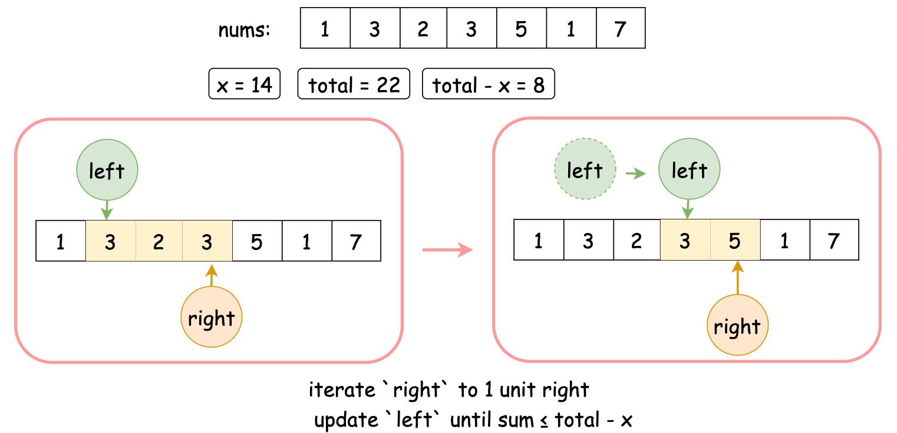

When left = 1 and right =3, currently the subarray sum is 3 + 2 + 3 = 8. The current sum is closest to total - x = 8 (In fact, they are the same!).

If we want to move right to one unit right, the sum becomes 3 + 2 + 3 + 5 = 13 > 8. Then we need to move left to let sum as close to total - x as possible.

Moving left one unit right yields 2 + 3 + 5 = 10 > 8. One more unit right gives 3 + 5 = 8 = total - x. Here we stop moving left since it is equal to the required total - x. In this case, we found the subarray whose sum is **closest** to 8 and ends at right.

With those two pointers, we can find all subarray whose sum is total - x. What we need to do is to record the maximum length of those subarrays.

Finally, calculate the remaining number of elements in nums and that is the final answer.

**Algorithm**

Step 1: Calculate the total sum of nums. Mark as total.

Step 2: Initialize two pointers left and right to 0. Initialize an integer current to represent the sum from nums[left] to nums[right], inclusively. Initialize an integer maxi to record the maximum length that sums up to total - x.

Step 3: Iterate right form 0 to the end of nums. In each iteration:

* Update current.
* If current is greater than total - x, move left to left.
* If current is equal to total - x, update the maximum length.

Step 4: Return the result.

**Implementation**

|  |
| --- |
| class Solution {  public int minOperations(int[] nums, int x) {  int total = 0;  for (int num : nums) {  total += num;  }  int n = nums.length;  int maxi = -1;  int left = 0;  int current = 0;  for (int right = 0; right < n; right++) {  // sum([left ,..., right]) = total - x  current += nums[right];  // if larger, move `left` to left  while (current > total - x && left <= right) {  current -= nums[left];  left += 1;  }  // check if equal  if (current == total - x) {  maxi = Math.max(maxi, right - left + 1);  }  }  return maxi != -1 ? n - maxi : -1;  }  } |

**Complexity Analysis**

Let N*N* be the length of nums.

* Time Complexity: \mathcal{O}(N)O(*N*), since each element is accessed at most twice, once by left and once by right.
* Space Complexity: \mathcal{O}(1)O(1), since no additional data structure is allocated.

#### Approach 2: Two Pointers (Directly)

**Intuition**

In the previous approach, we transformed the problem into finding the longest subarray with a sum of total - x. A natural question that begs to be asked is, "Can we solve it directly without transformation?".

Yes, we can. Let's have a try.

Similarly, we would like to continue using two pointers.

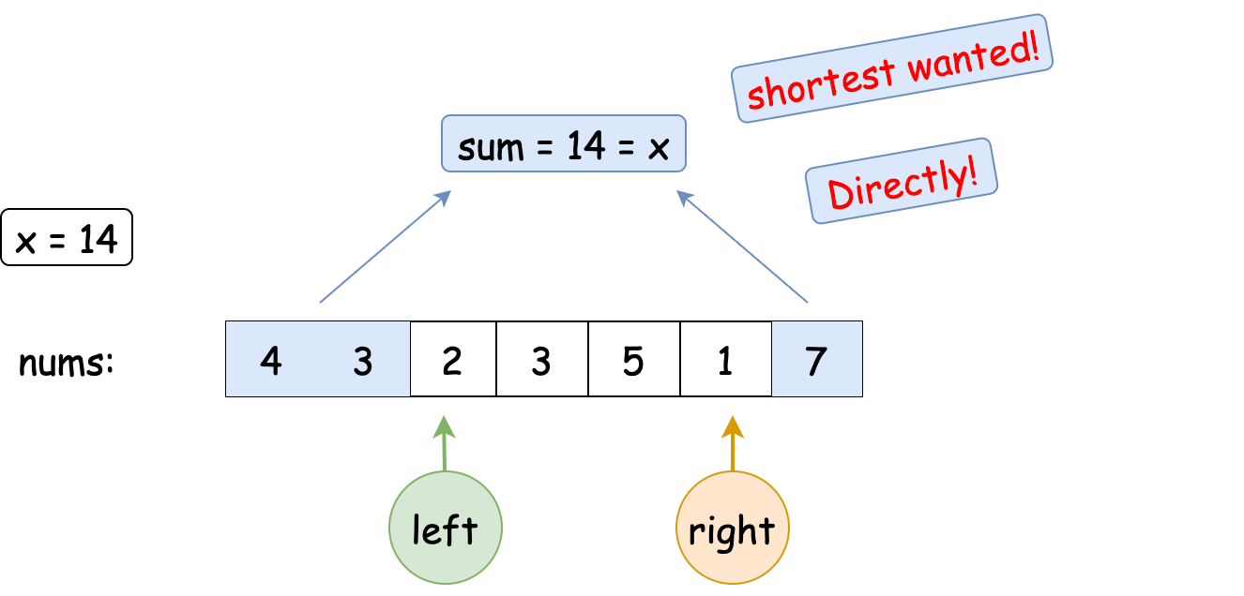

This time, we mark sum as the sum of the left part from left and the right part from right, not including left and right. Of course, you can include them with a few modifications to the code.

Still, we need to iterate right from the start to the end of nums and move left correspondingly. Here, we choose to move left to left until sum is greater than or equals to x.

We still take nums = [1, 3, 2, 3, 5, 1, 7] and x = 14 for example.

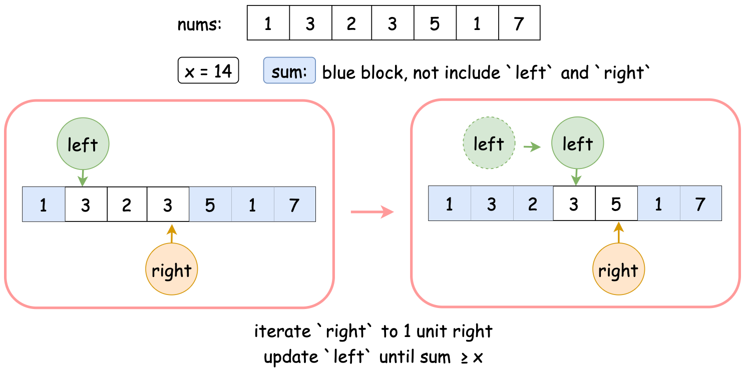

When left = 1 and right = 3, currently the sum is 1 + 5 + 1 + 7 = 14, which is closest to x = 14 (In fact, they are the same!). If we want to move right pointer by one unit towards right, the sum becomes 1 + 1 + 7 = 9 < 14. Then we need to move left to let sum as close to x as possible.

Moving left pointer one unit towards right yields 1 + 3 + 1 + 7 = 12 < 14. One more unit towards right gives 1 + 3 + 2+ 1 + 7 = 14 = x. Here we stop moving left pointer since it is equal to x.

With those two pointers, we can find all operations whose sum is x. What we need to do is to record the minimal length and return it.

However, it is needed to point out that the difference between Approach 1 and Approach 2 is not that huge. Their codes are similar but differ in the perspectives of the problem.

**Algorithm**

Step 1: Calculate the total sum of nums.

Step 2: Initialize two pointers left and right to 0. Initialize an integer current to represent the sum from nums[0] to nums[left-1] and from nums[right+1] to nums[last]. Initialize an integer mini to record the minimum length that sums up to x

Step 3: Iterate right form 0 to the end of nums. In each iteration:

* Update current.
* If current is smaller than x, move left to left.
* If current is equal to x, update the maximum length.

Step 4: Return the result.

**Implementation**

|  |
| --- |
| class Solution {  public int minOperations(int[] nums, int x) {  int current = 0;  for (int num : nums) {  current += num;  }  int n = nums.length;  int mini = Integer.MAX_VALUE;  int left = 0;  for (int right = 0; right < n; right++) {  // sum([0,..,left) + (right,...,n-1]) = x  current -= nums[right];  // if smaller, move `left` to left  while (current < x && left <= right) {  current += nums[left];  left += 1;  }  // check if equal  if (current == x) {  mini = Math.min(mini, (n-1-right)+left);  }  }  return mini != Integer.MAX_VALUE ? mini : -1;  }  } |

**Complexity Analysis**

Let N*N* be the length of nums.

* Time Complexity: \mathcal{O}(N)O(*N*), since each element is accessed at most twice, once by left pointer and once by right pointer.
* Space Complexity: \mathcal{O}(1)O(1), since no additional data structure is allocated.

**Get Maximum in Generated Array**

You are given an integer n. An array nums of length n + 1 is generated in the following way:

* nums[0] = 0
* nums[1] = 1
* nums[2 * i] = nums[i] when 2 <= 2 * i <= n
* nums[2 * i + 1] = nums[i] + nums[i + 1] when 2 <= 2 * i + 1 <= n

Returnthe ***maximum*** integer in the array nums​​​.

**Example 1:**

**Input:** n = 7

**Output:** 3

**Explanation:** According to the given rules:

nums[0] = 0

nums[1] = 1

nums[(1 * 2) = 2] = nums[1] = 1

nums[(1 * 2) + 1 = 3] = nums[1] + nums[2] = 1 + 1 = 2

nums[(2 * 2) = 4] = nums[2] = 1

nums[(2 * 2) + 1 = 5] = nums[2] + nums[3] = 1 + 2 = 3

nums[(3 * 2) = 6] = nums[3] = 2

nums[(3 * 2) + 1 = 7] = nums[3] + nums[4] = 2 + 1 = 3

Hence, nums = [0,1,1,2,1,3,2,3], and the maximum is 3.

**Example 2:**

**Input:** n = 2

**Output:** 1

**Explanation:** According to the given rules, the maximum between nums[0], nums[1], and nums[2] is 1.

**Example 3:**

**Input:** n = 3

**Output:** 2

**Explanation:** According to the given rules, the maximum between nums[0], nums[1], nums[2], and nums[3] is 2.

**Constraints:**

* 0 <= n <= 100

   Hide Hint #1

Try generating the array.

   Hide Hint #2

Make sure not to fall in the base case of 0.

## Solution

#### Overview

The problem is quite simple.For a given n*n*, we have to build an array of size n+1*n*+1 using a particular sequence generation pattern which is called [Stern's Diatomic Sequence](https://en.wikipedia.org/wiki/Calkin%E2%80%93Wilf_tree#Stern's_diatomic_sequence). According to the given array generation rules, we could use the values at position i*i* and i+1*i*+1 in array, to calculate the values for positions (i*2)(*i*∗2) and (i*2+1)(*i*∗2+1). The following figure illustrates the idea.

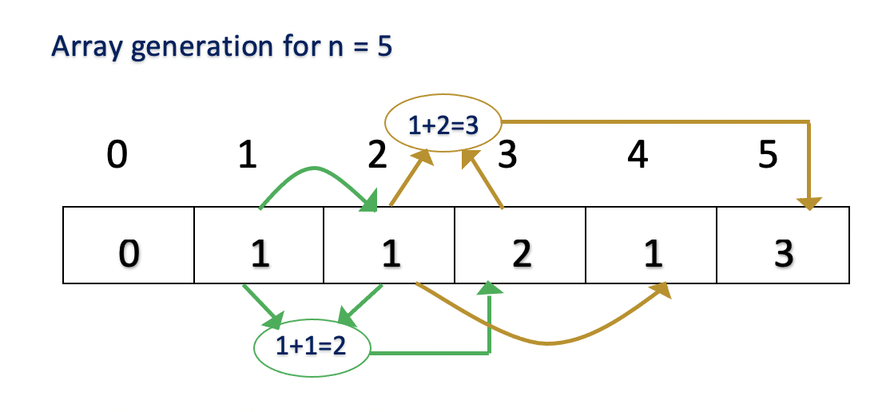

Thus, we could build the array by sequentially traversing the array from index 11 to index n*n* and use the values at the current index to calculate the next values. Once the array is generated, we have to return the maximum value.

Let's look at the approaches in detail.

#### Approach 1: Naive Solution

**Intuition**

The straightforward solution is to generate the array of size n+1*n*+1 using the given generation pattern and keep track of the maximum element in the array. For every array element in array nums at index i with value nums[i], we must calculate the value at next positions as follows,

* nums[i*2] would be equal to value of nums[i].
* nums[i*2+1] would be equal to the value of nums[i] + nums[i+1].

The figure illustrates the array generated for a value of n*n* as 88.

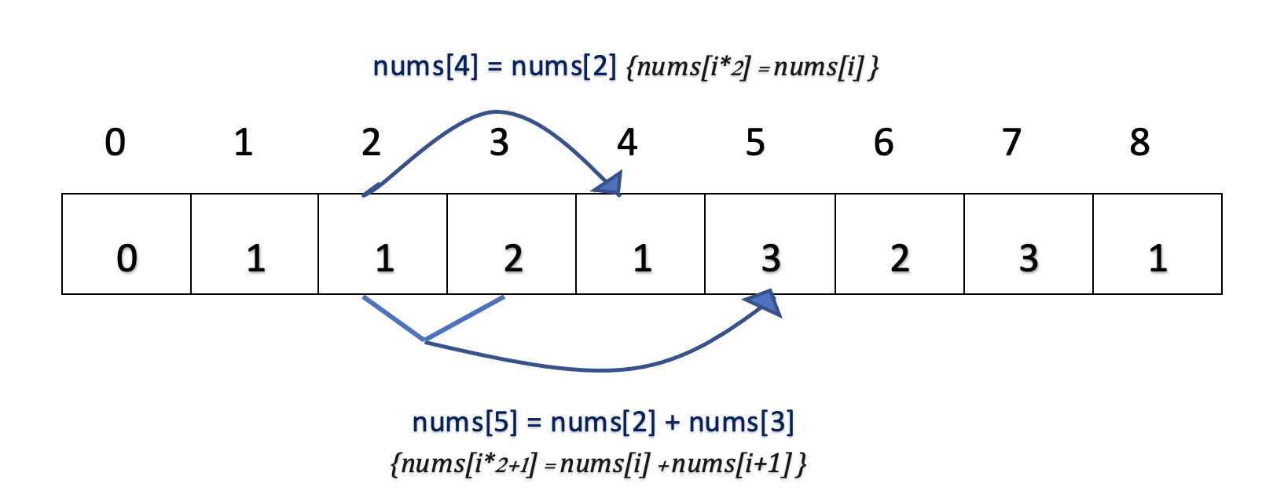

Using the value at index 22, we could calculate value at index 44 and using value at index 22 and 33, we could calculate the value at index 55.

**Algorithm**

* Build an array nums of size n+1.
* Initialize nums[1] as 1 as specified in the problem statement.
* Iterate from 1 to n where i is the current index of array nums. As we iterate over each array element, calculate the value of positions i*2 and i*2+1.
* Update the maximum value generated so far by comparing it with the value at the current index.

**Implementation**

|  |
| --- |
| class Solution {  public int getMaximumGenerated(int n) {  if (n == 0) {  return 0;  }  int[] nums = new int[n + 1];  int maximumValue = 1;  nums[1] = 1;  for (int i = 1; i <= n; i++) {  if (i * 2 <= n) {  nums[i * 2] = nums[i];  }  if (i * 2 + 1 <= n) {  nums[i * 2 + 1] = nums[i] + nums[i + 1];  }  maximumValue = Math.max(maximumValue, nums[i]);  }  return maximumValue;  }  } |

**Complexity Analysis**

* Time Complexity : \mathcal{O}(n)O(*n*), as we iterate n*n* times to build the array.
* Space Complexity: \mathcal{O}(n)O(*n*), as we use an array \text{nums}nums of size n*n*.

#### Approach 2: Optimized Solution

**Intuition**

We aim to find the maximum value in the array. We make the following observation of the array generation algorithm,

* Using every array index i, we are finding the values for i*2 and i*2+1 positions. Hence, we could stop our traversal when the current index is equal to n/2, as n/2 * 2 would be the last index (n) of the array and there is no point in going further as we have calculated all the results at this point.

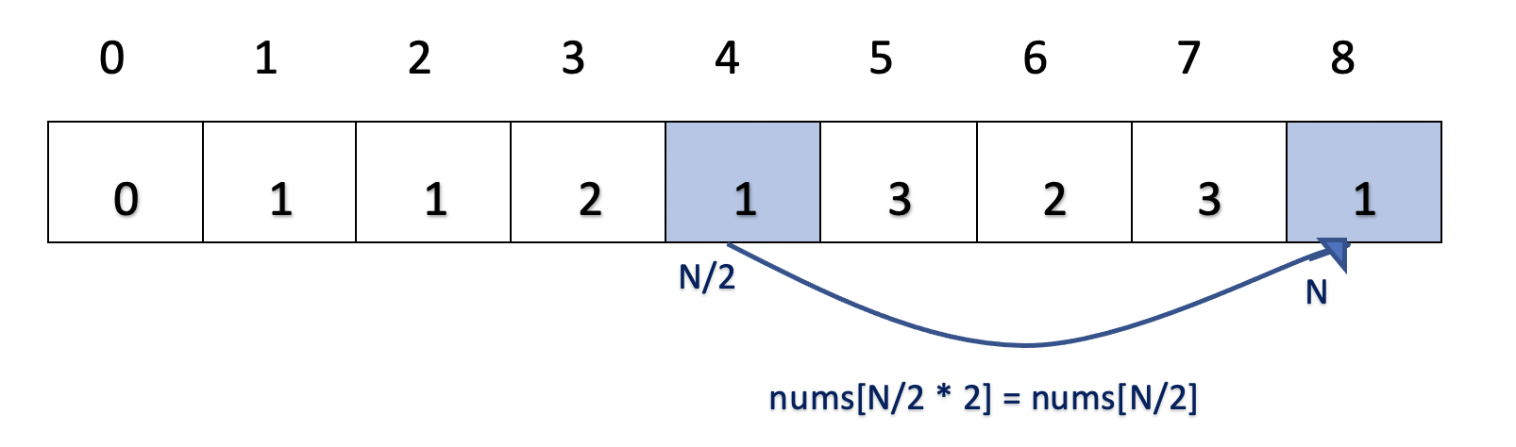

* If we are at index i and the maximum value calculated so far is maximumValue, the next maximum value could only be at the position i*2+1. Since the value at index i*2 is always equal to the value at index i, we know that it would never be greater than the already calculated maximumValue value.

**Algorithm**

* Build an array nums of size n+1 using the array generation rules as in Approach 1.
* The maximum value would only be updated if the value at position nums[i*2+1] is greater than the current maximum value. As the value gets incremented at that position, there is a chance of finding a new maximum value.
* We must iterate from index 1 to n/2. Since at n/2 index, we have already calculated the values of all the elements till n index.

**Implementation**

|  |
| --- |
| class Solution {  public int getMaximumGenerated(int n) {  if (n == 0) {  return 0;  }  int[] nums = new int[n + 1];  int maximumValue = 1;  nums[1] = 1;  for (int i = 1; i <= n / 2; i++) {  nums[i * 2] = nums[i];  if (i * 2 + 1 <= n) {  nums[i * 2 + 1] = nums[i] + nums[i + 1];  maximumValue = Math.max(maximumValue, nums[i * 2 + 1]);  }  }  return maximumValue;  }  } |

**Complexity Analysis**

* Time Complexity : \mathcal{O}(n)O(*n*), as we iterate n/2*n*/2 times, the time complexity would be \mathcal{O}(n)O(*n*).
* Space Complexity: \mathcal{O}(n)O(*n*), as we use an array \text{nums}nums of size n*n*.

#### Approach 3: Using Division

**Intuition**

There is another way of solving this problem. Instead of generating the next values based on the current value (using multiplication), we could generate current value based on previous values (using division). Let's look at the array generation rules,

* nums[i*2] is equal to the value of nums[i].

This could be written as, if i is even,nums[i] is equal to the value of nums[i/2]

* nums[i*2+1] is equal to the value of nums[i] + nums[i+1].

This could be written as, if i is odd,nums[i] is equal to value of nums[i/2] + nums[i/2+1]

**Algorithm**

* Build an array nums of size n+1 using the array generation rules.
* Iterate from 1 to n where i is the current index of array nums. As we iterate over each array element, calculate the value of current position nums[i] as follows,
  + If current index i is even, the value of nums[i] is equal to nums[i/2].
  + Else, the value of nums[i] is equal to nums[i/2] + nums[i/2+1].
* The maximum value would only be updated if the value at the current position nums[i] is greater than the maximum value calculated so far.

**Implementation**

|  |
| --- |
| class Solution {  public int getMaximumGenerated(int n) {  if (n == 0) {  return 0;  }  int[] nums = new int[n + 1];  int maximumValue = 1;  nums[1] = 1;  for (int i = 2; i <= n; i++) {  if (i % 2 == 0)  nums[i] = nums[i / 2];  else  nums[i] = nums[i / 2] + nums[i / 2 + 1];  maximumValue = Math.max(maximumValue, nums[i]);  }  return maximumValue;  }  } |

* Time Complexity : \mathcal{O}(n)O(*n*), as we iterate n*n* times to build the array.
* Space Complexity: O(*n*), as we use an array \text{nums}nums of size n*n*.

**Count Sorted Vowel Strings**

Given an integer n, return the number of strings of length n that consist only of vowels (a, e, i, o, u) and are ***lexicographically sorted***.

A string s is **lexicographically sorted** if for all valid i, s[i] is the same as or comes before s[i+1] in the alphabet.

**Example 1:**

**Input:** n = 1

**Output:** 5

**Explanation:** The 5 sorted strings that consist of vowels only are ["a","e","i","o","u"].

**Example 2:**

**Input:** n = 2

**Output:** 15

**Explanation:** The 15 sorted strings that consist of vowels only are

["aa","ae","ai","ao","au","ee","ei","eo","eu","ii","io","iu","oo","ou","uu"].

Note that "ea" is not a valid string since 'e' comes after 'a' in the alphabet.

**Example 3:**

**Input:** n = 33

**Output:** 66045

**Constraints:**

* 1 <= n <= 50

   Hide Hint #1

For each character, its possible values will depend on the value of its previous character, because it needs to be not smaller than it.

   Hide Hint #2

Think backtracking. Build a recursive function count(n, last_character) that counts the number of valid strings of length n and whose first characters are not less than last_character.

   Hide Hint #3

In this recursive function, iterate on the possible characters for the first character, which will be all the vowels not less than last_character, and for each possible value c, increase the answer by count(n-1, c).

## Solution

#### Overview

The problem is to build all the string combinations of given length n*n* using 5 vowels(a, e ,i ,o ,u) in sorted order. If you have solved the common backtracking problems before like [Combination Sum](https://leetcode.com/problems/combination-sum/) or [Combinations](https://leetcode.com/problems/combinations/), it is easier to come up with the Backtracking solution with few changes. However, there are also other interesting ways to solve the problem.

Let's look at the different approaches in detail.

#### Approach 1: Brute Force Using Backtracking

**Intuition**

[Backtracking](https://en.wikipedia.org/wiki/Backtracking) is a general approach that works by identifying potential candidates and incrementally builds the solution using depth first search. Once the required goal is reached, we backtrack to explore another potential candidate.

The backtracking solution for the given problem would be, to begin with, the first vowel character, continue using the same vowel until we build a string of length n*n*. Post that, backtrack and use the next character.

As we are picking up each vowel character in alphabetically sorted order (first a, then e, then i, and so on), we know that the resultant string is always lexicographically sorted.

Example, For n = 3, pick the first vowel a, continue picking up the same vowel until we reach n*n*. The resultant string would be aaa. Now that we have found our first combination, backtrack and pick up the next character e. Our next string would be aae. The process continues until all the vowel characters are explored.

**Algorithm**

* As we start with the first vowel a then e and so on, we need a way to determine the current vowel in a recursive function. We use an integer variable vowel for that purpose, where 1 denotes a, 2 denotes e, and so on.
* We begin with n*n* positions and first vowel a(1) and use method countVowelStringUtil to recursively compute all the combinations.
* On every recursion, we decrement n by 1 as we have used up that position and continue passing the same vowel. On the backtrack, we move on to the next vowel.

Base Case

If n = 0*n*=0, we have reached the end of the string and found one combination. Hence, we return 1 and backtrack.

|  |
| --- |
| class Solution {  public int countVowelStrings(int n) {  return countVowelStringUtil(n, 1);  }  int countVowelStringUtil(int n, int vowels) {  if (n == 0)  return 1;  int result = 0;  for (int i = vowels; i <= 5; i++) {  result += countVowelStringUtil(n - 1, i);  }  return result;  }  } |

**Complexity Analysis**

* Time Complexity : \mathcal{O}(n^{5})O(*n*5). We have to calculate the size of the recursion tree. Let's analyze the number of nodes generated at each level. The following figure illustrates the number of enumerations at level 22.

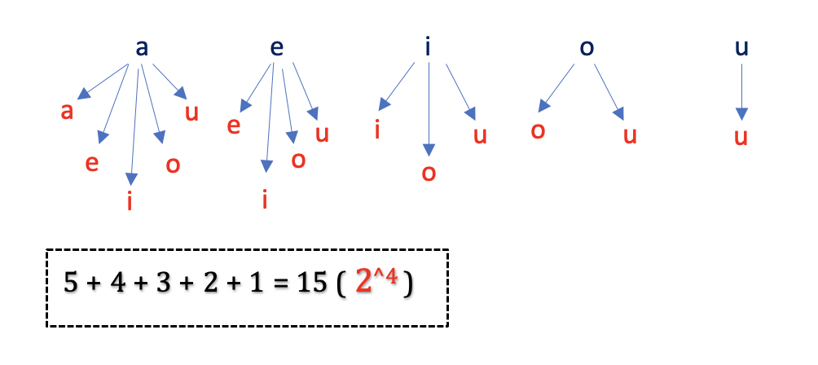

Mathematically, the total number of enumerations at each level can be analyzed as follows,

1. If we choose vowel a for i^{th}*ith* position, we have i-1*i*−1 positions left and we could choose from one of the 55 vowels (a, e, i, o, u) as next vowel character.

Thus, from 55 vowels, we could choose i-1*i*−1 vowels with repetitions ([K - Combinations With Repetitions](https://en.wikipedia.org/wiki/Combination#Number_of_combinations_with_repetition)), which can be written as,

\left(\!\!{5\choose i-1}\!\!\right)((*i*−15​)) = \frac{(5 + (i - 1)-1)}{(5-1)! \cdot (i-1)!} = \frac{(i)\cdot (i+1) \cdot (i+2) \cdot (i+3)}{24}=(5−1)!⋅(*i*−1)!(5+(*i*−1)−1)​=24(*i*)⋅(*i*+1)⋅(*i*+2)⋅(*i*+3)​

1. If we choose vowel e for i^{th}*ith* position, we have i-1*i*−1 positions left and we could choose from one of the 44 vowels (e, i, o, u) as next vowel character.

\left(\!\!{4\choose i-1}\!\!\right)((*i*−14​)) = \frac{(4 + (i - 1)-1)!}{(4-1)! \cdot (i-1)!} = \frac{(i)\cdot (i+1) \cdot (i+2)}{6}=(4−1)!⋅(*i*−1)!(4+(*i*−1)−1)!​=6(*i*)⋅(*i*+1)⋅(*i*+2)​

1. Similarly, if we choose vowel i for i^{th}*ith* position, we are left with 3 vowels (i, o, u) for i-1*i*−1 positions.

\left(\!\!{3\choose i-1}\!\!\right)((*i*−13​)) = \frac{(3 + (i - 1)-1)!}{(3-1)! \cdot (i-1)!} = \frac{(i)\cdot (i+1)}{2}=(3−1)!⋅(*i*−1)!(3+(*i*−1)−1)!​=2(*i*)⋅(*i*+1)​

1. Similarly, if we choose vowel o for i^{th}*ith* position, we are left with 2 vowels (o, u) for i-1*i*−1 positions.

\left(\!\!{2\choose i-1}\!\!\right)((*i*−12​)) = \frac{(2 + (i - 1)-1)!}{(2-1)! \cdot (i-1)!} = i=(2−1)!⋅(*i*−1)!(2+(*i*−1)−1)!​=*i*

1. Lastly, if we choose vowel u for i^{th}*ith* position, we are left with only one vowel (u) for i-1*i*−1 positions.

\left(\!\!{1\choose i-1}\!\!\right)((*i*−11​)) = \frac{(1 + (i - 1)-1)!}{(1-1)! \cdot (i-1)!} = 1=(1−1)!⋅(*i*−1)!(1+(*i*−1)−1)!​=1

Adding above equations we get, \frac{(i)\cdot (i+1) \cdot (i+2) \cdot (i+3)}{24} + \frac{(i)\cdot (i+1) \cdot (i+2)}{6} +\frac{(i)\cdot (i+1)}{2} + i + 124(*i*)⋅(*i*+1)⋅(*i*+2)⋅(*i*+3)​+6(*i*)⋅(*i*+1)⋅(*i*+2)​+2(*i*)⋅(*i*+1)​+*i*+1.

Thus, we could say that at each level i*i*, there would be roughly i^{4}*i*4 possible branches in the recursion tree. Since, the maximum depth of recursion would be n*n*, the total number of nodes can be calculated as,

\sum\limits_{i=1}^n i^4 = \mathcal{O}(n^{4+1}) = \mathcal{O}(n^5)*i*=1∑*n*​*i*4=O(*n*4+1)=O(*n*5).

This gives us total time complexity as \mathcal{O}(n^{5})O(*n*5).

* Space Complexity: \mathcal{O}(n)O(*n*). This space will be used to store the recursion stack. We can’t have more than n*n* recursive calls on the call stack at any time.

#### Approach 2: Decoding the Pattern, Using Recursion

**Intuition**

If we observe, the problem follows a specific pattern. For any given n*n* and number of \text{vowels}vowels , the number of combinations is always equal to the sum of following,

* Number of combinations for previous n*n* i.e n-1*n*−1 and same number of vowels*vowels*
* Number of combinations for vowels-1*vowels*−1 and same n*n*.

The following figure illustrates this idea using an example.

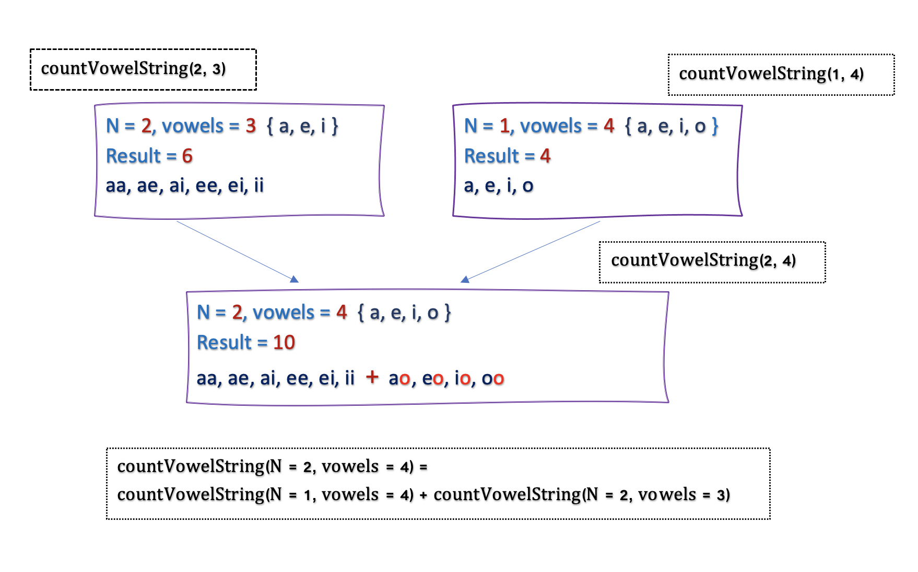

Thus, the recurrence relation can be written as,

countVowelStrings (n, vowels) = isSum(n - 1, vowels) + isSum(n, vowels - 1)

**Algorithm**

* We start with given n*n* and vowels as 55. {a, e, i, o, u}.
* Recursively calculate the result for every n*n* and \text{vowels}vowels using above recurrence relation.
* We must backtrack on the following base cases,
  + If n = 1*n*=1, we have only one position left. Here, we must return the current number of vowels.

Example, if n = 1*n*=1 and \text{vowels} = 3vowels=3. As there could be 3 combinations a, e, i, the result would be 3.

* + If \text{vowels} = 1vowels=1, we must return 11.

Example, if n=3*n*=3, and only 1 vowel u is left, there could be only one combination uuu.

**Implementation**

|  |
| --- |
| class Solution {  public int countVowelStrings(int n) {  return countVowelStringUtil(n, 5);  }  int countVowelStringUtil(int n, int vowels) {  if (n == 1)  return vowels;  if (vowels == 1)  return 1;  return countVowelStringUtil(n - 1, vowels) +  countVowelStringUtil(n, vowels - 1);  }  } |

**Complexity Analysis**

* Time Complexity : \mathcal{O}(n^{5})O(*n*5), as for a given n*n* and 55 vowels (a, e, i, o, u), there are roughly n^{5}*n*5 possible candidates (Refer time complexity of Approach 1).This gives us time complexity as \mathcal{O}(n^{5})O(*n*5).
* Space Complexity: \mathcal{O}(n)O(*n*). This space will be used to store the recursion stack. As the maximum depth of recursion would be \max(n,5)max(*n*,5), the space required for internal call stack would roughly \mathcal{O}(n)O(*n*).

#### Approach 3: Using Recursion + Memoization, Top Down Dynamic Programming

**Intuition**

If you have solved problems on [Dynamic Programming](https://en.wikipedia.org/wiki/Dynamic_programming) before, it is pretty easy to optimize the Approach 2 using Memoization. In the above approach, the problem can be broken down into subproblems. On drawing the recursion tree, it is evident that the same subproblems are computed multiple times.

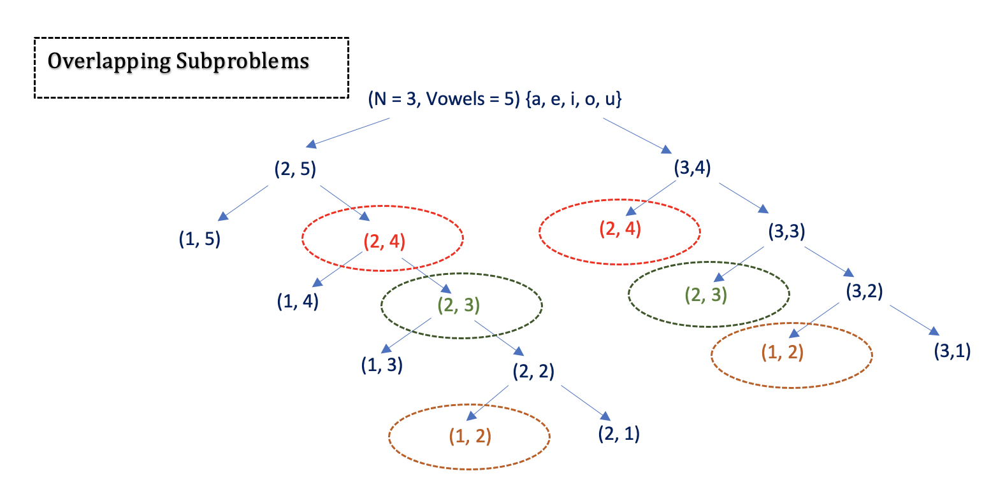

In the above recursion tree, we could see that subproblems (2, 4), (2, 3) and (1, 2) are computed multiple times and the result would be always the same. The problem has [Overlapping Subproblem](https://en.wikipedia.org/wiki/Overlapping_subproblems) and can be solved using Dynamic Programming.

**Algorithm**

We could have stored the results of our computation for the first time and used it later. This technique of computing once and returning the stored value is called [Memoization](https://en.wikipedia.org/wiki/Memoization).

As we must store results for every n*n* and \text{vowels}vowels, we use a two dimensional array \text{memo}memo of size n \cdot 5*n*⋅5 and follow the following steps for each recursive call :

* Check in the memo if we have already calculated results for a given n*n* and \text{vowels}vowels and return the result stored in the memo.
* Save the results of any calculations to \text{memo}memo.

Since arrays are 0-indexed, we initialize the array of size (n + 1, 5 + 1) and use the range 1..n and 1..5 for easier understanding and keeping it consistent with the previous approach.

**Implementation**

|  |
| --- |
| class Solution {  public int countVowelStrings(int n) {  int memo[][] = new int[n + 1][6];  return countVowelStringUtil(n, 5, memo);  }  int countVowelStringUtil(int n, int vowels, int memo[][]) {  if (n == 1)  return vowels;  if (vowels == 1)  return 1;  if (memo[n][vowels] != 0)  return memo[n][vowels];  int res = countVowelStringUtil(n - 1, vowels, memo) +  countVowelStringUtil(n, vowels - 1, memo);  memo[n][vowels] = res;  return res;  }  } |

**Complexity Analysis**

* Time Complexity : \mathcal{O}(n)O(*n*), as for every n*n* and \text{vowels}vowels we calculate result only once, the total number of nodes in the recursion tree would be n \cdot 5*n*⋅5, which is roughly equal to n*n*.
* Space Complexity : \mathcal{O}(n)O(*n*), as we use a 2D array \text{memo}memo of size n \cdot 5*n*⋅5 and the size of internal call stack would also be n*n* (As explained in Approach 2), the space complexity would be \mathcal{O}(n+n) = \mathcal{O}(n+n)O(*n*+*n*)=O(*n*+*n*).

#### Approach 4: Bottom Up Dynamic Programming, Tabulation

**Intuition**

This is another approach to solve the Dynamic Programming problems. We use the iterative approach and store the result of subproblems in bottom-up fashion also known as Tabulation. We store the results of previous computations in tabular format and use those results for the next computations.

**Algorithm**

We maintain a 2D array , \text{dp}dp of size n \cdot 5*n*⋅5 where, \text{dp[n][vowels]}dp[n][vowels] denotes the total number of combinations for given n*n* and number of \text{vowels}vowels. Using the recurrence relation established in Approach 2, we could iteratively calculate the value for \text{dp[n][vowels]}dp[n][vowels] as,

dp[n][vowels] = dp[n - 1][vowels] + dp[n][vowels - 1]

As this is the Bottom Up approach to solve the problem, we must initialize the table for the base cases. The base cases are the same as in Approach 2.

* If n = 1*n*=1, the number of combinations are always equal to number of \text{vowels}vowels. Hence, we initialize all the values of \text{dp[1][vowels]}dp[1][vowels] with \text{vowels}vowels.
* If vowels = 1*vowels*=1, the number of combinations are always equal to 1. Hence, we initialize all the values of \text{dp[n][1]}dp[n][1] with 11.

**Implementation**

|  |
| --- |
| class Solution {  public int countVowelStrings(int n) {  int[][] dp = new int[n + 1][6];  for (int vowels = 1; vowels <= 5; vowels++)  dp[1][vowels] = vowels;  for (int nValue = 2; nValue <= n; nValue++) {  dp[nValue][1] = 1;  for (int vowels = 2; vowels <= 5; vowels++) {  dp[nValue][vowels] = dp[nValue][vowels - 1] + dp[nValue - 1][vowels];  }  }  return dp[n][5];  }  } |

**Complexity Analysis**

* Time Complexity : \mathcal{O}(n)O(*n*), as we iterate 5 \cdot n5⋅*n* times to fill the \text{dp}dp array, the time complexity is approximately \mathcal{O}(5 \cdot n) =\mathcal{O}(n)O(5⋅*n*)=O(*n*).
* Space Complexity : \mathcal{O}(n)O(*n*), as we use a 2D array of size n \cdot 5*n*⋅5, the space complexity would be \mathcal{O}(n)O(*n*).

#### Approach 5: Math

**Intuition and Algorithm**

The problem is a variant of finding [Combinations](https://en.wikipedia.org/wiki/Combination). Mathematically, the problem can be described as, given 5 vowels (let k = 5*k*=5), we want to find the number of combinations using only n*n* vowels. Also, we can repeat each of those vowels multiple times.

In other words, from k*k* vowels (k = 5*k*=5), we can choose n*n* vowels with repetition. Denoted as \left(\!\!{k \choose n}\!\!\right)((*nk*​)), the formulae for [Combination with Repetition](https://en.wikipedia.org/wiki/Combination#Number_of_combinations_with_repetition)is given by,

\left(\!\!{k \choose n}\!\!\right)((*nk*​)) = \frac{(k + n - 1)!}{ (k - 1)! n!}=(*k*−1)!*n*!(*k*+*n*−1)!​

We know that the k*k* value is 55 as there are always 55 vowels to choose from. Substituting k*k* as 55 in above formulae,

\left(\!\!{5\choose n}\!\!\right)((*n*5​)) = \frac{(n+4) \cdot (n+3) \cdot (n+2) \cdot (n+1)}{24}=24(*n*+4)⋅(*n*+3)⋅(*n*+2)⋅(*n*+1)​

The derivation can be illustrated as follows.

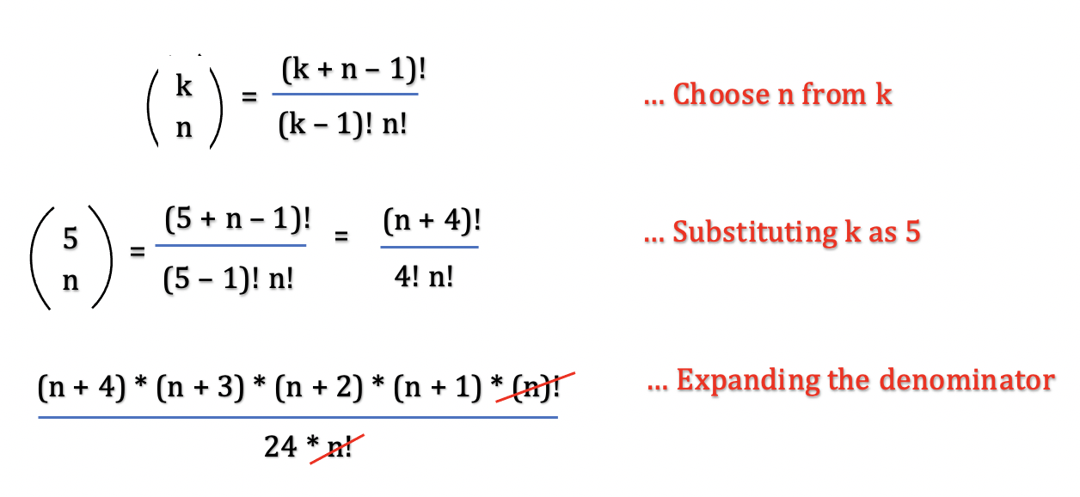

**Implementation**

|  |
| --- |
| class Solution {  public int countVowelStrings(int n) {  return (n + 4) * (n + 3) * (n + 2) * (n + 1) / 24;  }  } |

**Complexity Analysis**

* Time Complexity: \mathcal{O}(1)O(1), as the approach runs in constant time.
* Space Complexity: \mathcal{O}(1)O(1), as the approach uses constant extra space.

**Max Number of K-Sum Pairs**

You are given an integer array nums and an integer k.

In one operation, you can pick two numbers from the array whose sum equals k and remove them from the array.

Return *the maximum number of operations you can perform on the array*.

**Example 1:**

**Input:** nums = [1,2,3,4], k = 5

**Output:** 2

**Explanation:** Starting with nums = [1,2,3,4]:

- Remove numbers 1 and 4, then nums = [2,3]

- Remove numbers 2 and 3, then nums = []

There are no more pairs that sum up to 5, hence a total of 2 operations.

**Example 2:**

**Input:** nums = [3,1,3,4,3], k = 6

**Output:** 1

**Explanation:** Starting with nums = [3,1,3,4,3]:

- Remove the first two 3's, then nums = [1,4,3]

There are no more pairs that sum up to 6, hence a total of 1 operation.

**Constraints:**

* 1 <= nums.length <= 105
* 1 <= nums[i] <= 109
* 1 <= k <= 109

   Hide Hint #1

The abstract problem asks to count the number of disjoint pairs with a given sum k.

   Hide Hint #2

For each possible value x, it can be paired up with k - x.

   Hide Hint #3

The number of such pairs equals to min(count(x), count(k-x)), unless that x = k / 2, where the number of such pairs will be floor(count(x) / 2).

## Solution

#### Overview

The problem is to find the number of pairs in a given array nums such that the sum of each pair is k. Every element can be paired with any other element only once. For example, if nums = [3,4,3] and k = 7, we have to choose a pair in array nums with sum equal to 7. Now if we pair element 44 with element 33 at 0^{th}0*th* index to form sum 77, then we cannot again pair the same element 44 with element 33 at 2^{nd}2*nd* index.

This problem is similar to one of the popular array problem [Two Sum](https://leetcode.com/problems/two-sum). The difference is that instead of finding indexes of the first pair with sum equal to a given value, we have to find the count of all the pairs with sum equal to a given value. Since we don't have to retain the original indexes of elements, it could be an advantage for us. We could reorder or shuffle the array elements and try to solve the problem more efficiently. (In _Approach 4, we are going to sort the array in increasing order).

This is an interesting problem that can be implemented in various ways. Let's look at the different approaches in detail.

#### Approach 1: Brute Force

**Intuition**

The naive solution we could think of would be to pick an element from the array nums, then try to pair it with all the other elements in the array such that the sum of the pair formed is equal to k.

Once we find a matching pair, we could remove both elements from the array. However, removing the elements from an array could be costly, since an array stores element in a contiguous form, we could simply mark the array element to 00 value. Thus, in our case 00 value denotes that the element is already taken up or paired up with some other element.

We could begin by picking up the first element at the 0^{th}0*th* index and find it's pair by iterating over all the elements beginning from the element at 1^{st}1*st* index until we reach the end of the array. Thus, we could repeat the process until all the elements in the array are picked.

**Algorithm**

* To implement the intuition, we would use a nested for loop. The outer loop would choose the first element of the pair using a pointer first and iterate from the 0^{th}0*th* index to the end of the array. The inner loop would choose the second element of the pair using a pointer second and iterate from the first+1 index to the end of the array.
* We would also need to maintain a variable count which would be incremented every time we find a pair with sum equal to k.
* Now, that we have 2 elements to form a pair, pointed by first and second pointers, we would check if the value of each pair sums up to k. If the sum is k, we need to do 2 things,
  + Increment the variable count to count the current pair found.
  + Update the value of array positions pointed by first and second pointer to 00. This is used to indicate that these elements are already taken up to form a pair.
* The process would continue until all the elements are traversed.

**Implementation**

|  |
| --- |
| class Solution {  public int maxOperations(int[] nums, int k) {  int count = 0;  for (int first = 0; first < nums.length; first++) {  // check if element pointed by first is already taken up  if (nums[first] == 0) continue;  for (int second = first + 1; second < nums.length; second++) {  // check if element pointed by second is already taken up  if (nums[second] == 0) continue;  if (nums[first] + nums[second] == k) {  nums[first] = nums[second] = 0;  count++;  break;  }  }  }  return count;  }  } |

**Complexity Analysis**

* Time Complexity : \mathcal{O}(n^{2})O(*n*2), where n*n* is the length of array nums. We are using a nested for loop and pairing up every single element with every other element in the array. Thus, the time complexity of this approach would be \mathcal{O}(n^{2})O(*n*2).

This approach is exhaustive and results in Time Limit Exceeded (TLE)

* Space Complexity: \mathcal{O}(1)O(1), as we are using constant extra space to store the variable count and maintain pointers, first and second.

#### Approach 2: Using Hashmap - Two Pass

**Intuition**

In the previous approach, for every element in the array, we had to find it's pair. Let's the first element of the pair be x. Now, we have to find the second element, say y, such that the sum of x and y is k. Instead of traversing the entire array to find a suitable pair y for every element x, can we do it in optimal time?

Hint: We can try to find if the Complement of current element x with respect to k is present in the array or not in constant time.

If the first element in the pair is x, we know that the other element y must be equal to k - x such that their sum is k. (x + k - x = k). In other words, if the current element has the value x, we want to know if there is an element in the array with the value k - x.

The first data structure that comes to our mind is a Set. We could maintain a Hash Set that contains all the elements in the array and we could search if there is an element with a particular value (i.e k - x) in a Hash Set in constant time.

But, the input array may contain duplicates as well. Since there could be more than one element with a particular value, we must also store the count of the number of times each value is present in the array. We could build a HashMap for that with key-value pair. The key would the element present in the array and its value would the number of times the value occurs in the array.

Now that we have a hash map that stores the elements present in the array with its count, we could simply traverse the given array nums. For every element x we could query hashmap to know if k - x exists or not.

It must be noted that, once we find a pair with sum equal to k, we must decrement the count of occurrence of those 2 elements from the map so that they aren't used again.

Based on the insight, let's implement the algorithm.

**Algorithm**

* Build a hashmap map where the key is the value of elements in the array and value is the count of the number of times that value is present in the array.
* Iterate over every element in the array nums. Let current be the element currently being traversed. Find the complement of the current element with respect to k, complement = current - k. The complement is a pair of current element that we are trying to find.
* However, it is possible that the current element is also taken before and paired with some other element. Hence, we check if both elements of the pair, current and complement are present in the map. If yes, we form the pair and remove those elements from the map.

Instead of removing the elements from the map, we could simply decrement its count by 11. An element with a count of 00 is as good as being non-existent in the map.

Is there any other case where our algorithm may fail?

* If the value of the current element and complement element is the same, we need at least 22 occurrences of that element to be present in the array, otherwise, we cannot form a pair.

For example, if k = 6 and the value of the current element is 3, the complement must be 3 as well. In this case, there must be 22 elements in the array with the value 3 to form a pair.

* Every time we find a suitable pair of 2 elements with sum equal to k, increment the variable count. At the end, return the total number of pairs, count found in the array.

The following animation illustrates the idea with nums = [3, 1, 3, 4, 3, 2, 4] and k = 6.



|  |
| --- |
| class Solution {  public int maxOperations(int[] nums, int k) {  HashMap<Integer, Integer> map = new HashMap<>();  int count = 0;  // build the hashmap with count of occurence of every element in array  for (int i = 0; i < nums.length; i++) {  map.put(nums[i], map.getOrDefault(nums[i], 0) + 1);  }  for (int i = 0; i < nums.length; i++) {  int current = nums[i];  int complement = k - nums[i];  if (map.getOrDefault(current, 0) > 0  && map.getOrDefault(complement, 0) > 0) {  if ((current == complement) && map.get(current) < 2)  continue;  map.put(current, map.get(current) - 1);  map.put(complement, map.get(complement) - 1);  count++;  }  }  return count;  }  } |

**Complexity Analysis**

* Time Complexity : \mathcal{O}(n)O(*n*), where n*n* is the length of array nums. We iterate over an element in the array twice which takes \mathcal{O}(n)O(*n*) time. First, to build a map from the array. Second, to find a pair for every element in the array. Also, to add or update an element in a hashmap takes constant time. This gives us total time complexity as \mathcal{O}(n)O(*n*).
* Space Complexity: \mathcal{O}(n)O(*n*), where n*n* is the length of array nums. We use an unordered map to store the values of the array with their count of occurrence. In the worst case, if every element in the array is unique, the maximum size of the map would grow up to n*n*.

#### Approach 3: Using Hashmap - Single Pass

**Intuition**

In the previous approach, we iterated over the array twice. In the first pass, we were just building the hashmap. In the second pass, we found a pair for every element. Can we do the same in a single pass?

For every element current, we must first try to find if it's pair,complement exists in the map. If it does, there is no need to add the current element to the map and we could simply remove the complement element from the map. If the complement element does not exist in the map, we could add the current element to the map.

In this approach, the hashmap would only hold those array elements for which we have not yet found a suitable pair so far with sum equal to k. As and when the elements are paired up, we remove them from the map.

Thus, in a single pass, we can build the map as well as find the matching pair of every element. Let's look at the algorithm in detail.

**Algorithm**

* Initialize a hashmap map to store the elements that are traversed till now and not paired up with any element so far.
* A variable count would be initialized to 00 and store the total number of pairs we find in the array.
* Iterate over each element in the array nums. For every traversed element current, calculate the complement value with respect to k. complement = k - current. Now check if the complement value exists in the map.
  + If the complement value exists in the map, simply remove it from the map. Note that, we would not add the current element in the map here, since it is already paired with complement.
  + Otherwise, add the current element to the map, so that it can be paired with some other array element in the future.

**Implementation**

|  |
| --- |
| class Solution {  public int maxOperations(int[] nums, int k) {  HashMap<Integer, Integer> map = new HashMap<>();  int count = 0;  for (int i = 0; i < nums.length; i++) {  int current = nums[i];  int complement = k - current;  if (map.getOrDefault(complement, 0) > 0) {  // remove complement from the map  map.put(complement, map.get(complement) - 1);  count++;  } else {  // add current element in the map  map.put(current, map.getOrDefault(current, 0) + 1);  }  }  return count;  }  } |

**Complexity Analysis**

* Time Complexity : \mathcal{O}(n)O(*n*), where n*n* is the length of array nums. We iterate over every element only once. Besides, checking or updating the value of a particular key element in the hashmap takes constant time. This gives us total time complexity as \mathcal{O}(n)O(*n*).
* Space Complexity: \mathcal{O}(n)O(*n*), where n*n* is the length of array nums. We use an unordered map to store the values of the array with their count of occurrence. In the worst case, if we do not find a complement pair of any current element, we would end up adding all the elements in the map and the maximum size of the map would grow up to n*n*.

#### Approach 4: Two Pointer Approach Using Sort

**Intuition**

There is another approach to solve the problem. What if we sort the elements in an array in increasing order? Can we take advantage of this sorted order to find the pairs quickly?

In sorted array, we know that for every i^{th}*ith* element, the value of (i+1)^{th}(*i*+1)*th* element would always be greater than or equal it's own value. Similarly, the value of (i-1)^{th}(*i*−1)*th* element would be less than or equal to its value.

We can use 22 pointers, the first pointer left, is positioned at 0^{th}0*th* index of the array, and the second pointer right is positioned at n^{th}*nth* index of the array. (where n is the size of array nums). Let's add the values of elements pointed by left and right, given by sum.

The value of the variable sum can be used to determine where a possible pair could lie,

* If the value of sum is less than the value of k, we know that we want a larger value. We also know that left is pointing to the smallest value in the array, hence we can increment the left pointer by 11 to get a little larger value.
* Similarly, if the value of sum is greater than the value of k, we know that we want a smaller value. We also know that right is pointing to the largest value in the array, hence we can decrement the right pointer by 11 to get a little smaller value.
* Otherwise, the value of sum must be equal to k and we have found one pair of elements pointed by left and right pointers respectively. We can increment the left pointer and decrement right pointer to find the next pair.

In other words, we could say that, if the left pointer is pointing to the current element, we must adjust the right pointer to point to its complement and vice versa.

The following example illustrates the idea with nums = [3, 1, 9, 3, 2, 2, 4] and k = 6.

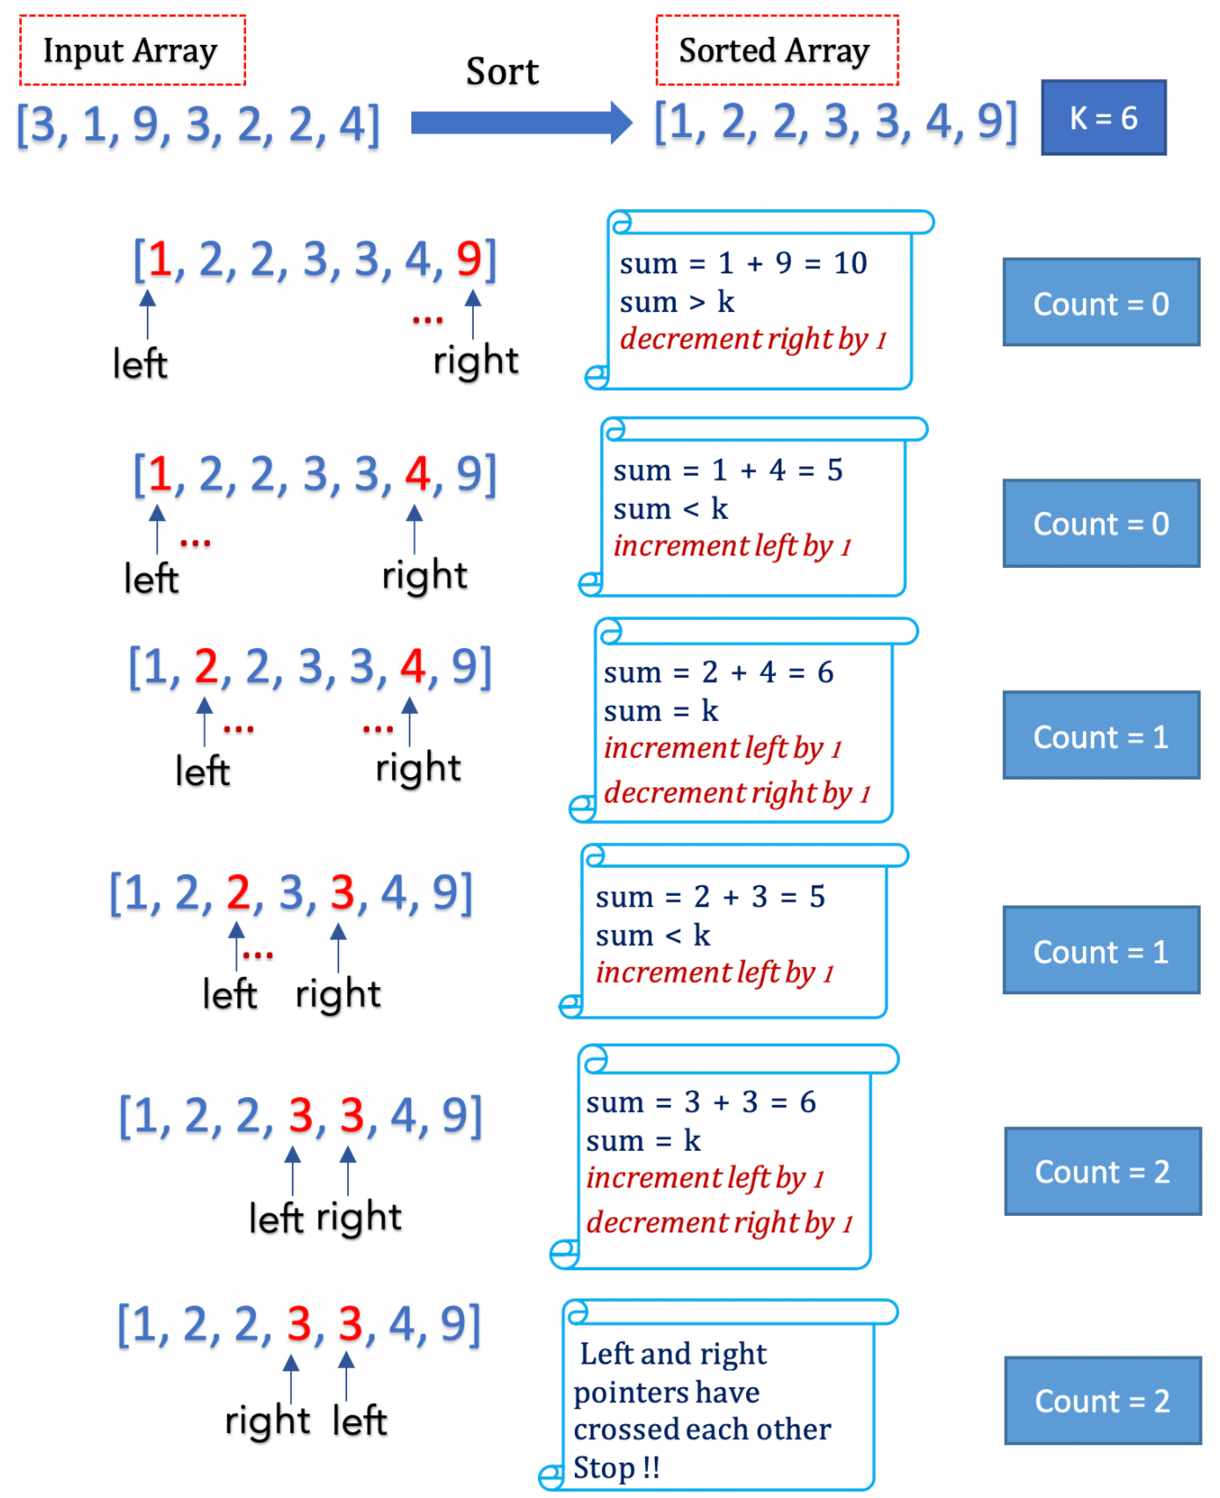

Let's look at the algorithm in detail.

**Algorithm**

* Sort the nums array in increasing i.e ascending order. We can use the built-in sort function.
* Initialize the left pointer to point at the 0^{th}0*th* index and the right pointer to point to the last index of the nums array. We could say that the left pointer points to the smallest element in the array, and the right points to the largest element.
* Add the values of array elements pointed by left and right pointer given by sum.
  + If the value of sum is less than k, increment left pointer.
  + If the value of sum is greater than k, increment the right pointer.
  + Otherwise, we have found one pair with a sum equal to k. Increment left pointer and decrement right pointer so that we can go ahead and find another pair.
* The process would continue until the left pointer is less than the right pointer. Once the left and right pointer cross each other, we know that we have traversed all the elements and cannot find any other pair. Hence, we stop at that point.

**Implementation**

|  |
| --- |
| class Solution {  public int maxOperations(int[] nums, int k) {  Arrays.sort(nums);  int count = 0;  int left = 0;  int right = nums.length - 1;  while (left < right) {  if (nums[left] + nums[right] < k) {  left++;  } else if (nums[left] + nums[right] > k) {  right--;  } else {  left++;  right--;  count++;  }  }  return count;  }  } |

**Complexity Analysis**

* Time Complexity : \mathcal{O}(n \log n)O(*n*log*n*), where n*n* is the length of array nums.

The sort operation on the array takes \mathcal{O}(n \log n)O(*n*log*n*) time.

Each element is traversed only once, either by the left pointer or by the right pointer, depending on the fact that which pointer reaches that element first. Thus, traversing array takes \mathcal{O}(n)O(*n*) time.

This gives us total time complexity as \mathcal{O}(n \log n)O(*n*log*n*) + \mathcal{O}(n)O(*n*) = \mathcal{O}(n \log n)O(*n*log*n*).

* Space Complexity: \mathcal{O}(1)O(1). We use constant extra space to track the count variable and maintain left,right pointers.
* Space complexity : \mathcal{O}(N)O(*N*) or \mathcal{O}(\log{N})O(log*N*)
  + The space complexity of the sorting algorithm depends on the implementation of each program language.
  + For instance, the std::sort() function in C++ is implemented with the [Introsort](https://en.wikipedia.org/wiki/Introsort) algorithm whose space complexity is \mathcal{O}(N)O(*N*).
  + In Java, the [Arrays.sort()](https://docs.oracle.com/javase/8/docs/api/java/util/Arrays.html#sort-byte:A-) is implemented as a variant of quicksort algorithm whose space complexity is \mathcal{O}(\log{N})O(log*N*).

**Find the Most Competitive Subsequence**

Given an integer array nums and a positive integer k, return *the most****competitive****subsequence of*nums *of size*k.

An array's subsequence is a resulting sequence obtained by erasing some (possibly zero) elements from the array.

We define that a subsequence a is more **competitive** than a subsequence b (of the same length) if in the first position where a and b differ, subsequence a has a number **less** than the corresponding number in b. For example, [1,3,4] is more competitive than [1,3,5] because the first position they differ is at the final number, and 4 is less than 5.

**Example 1:**

**Input:** nums = [3,5,2,6], k = 2

**Output:** [2,6]

**Explanation:** Among the set of every possible subsequence: {[3,5], [3,2], [3,6], [5,2], [5,6], [2,6]}, [2,6] is the most competitive.

**Example 2:**

**Input:** nums = [2,4,3,3,5,4,9,6], k = 4

**Output:** [2,3,3,4]

**Constraints:**

* 1 <= nums.length <= 105
* 0 <= nums[i] <= 109
* 1 <= k <= nums.length

Hide Hint #1

In lexicographical order, the elements to the left have higher priority than those that come after. Can you think of a strategy that incrementally builds the answer from left to right?

## Solution

#### Overview

The problem is to build the most competitive subsequence of size k*k* for a given array \text{nums}nums.

A subsequence is different from a subarray. Unlike subarray, which contains only contiguous array elements, in subsequence of an array, we can skip any number of elements given that the ordering of elements is maintained.

For array = [2,3,5,6,7,8],[5,6,7] is subarray as well as subsequence. Whereas, [5,6,8] is a subsequence but not a subarray.

For the given array, we have to generate all its subsequences with size k*k* and then find the one which satisfies the criteria of being most competitive. Now, what are the criteria for being the most competitive subsequence?

The most competitive subsequence is the one in which the value of the element at every position/index is smallest among values of all the subsequences at that position. Let's understand with an example.

Let nums = [2, 3, 4] and k = 2.

We could generate three subsequences of size 33 from the given nums array, seq1:[2, 3], seq2:[2, 4], seq3:[3, 4].

* Let's compare all the subsequences at index 00. seq1 and seq2 has element 22 at 0^{th}0*th* position. Whereas, seq3 has an element 33 which is greater than 22. Considering index 00, seq1 and seq2 can be the most competitive sequence as the value at 0^{th}0*th* index is smallest among other subsequences.
* Now, let's compare the remaining subsequences at index 11. seq1 has value 33 at 1^{st}1*st* index which is smaller than value 44 at 1^{st}1*st* index in seq2.

This gives us subsequence seq1:[2, 3] as the most competitive sequence among all.

Based on these insights, let's implement the solution.

#### Approach 1: Using Double-Ended Queue

**Intuition**

We have to choose elements for our subsequence such that every element is the smallest possible value for that array position.

The naive solution would be to generate all the possible subsequences of an array and compare the element at every position to find the most competitive subsequence. This approach is too exhaustive. What could be a better way to implement the solution?

Instead of building all the subsequences and then finding the one matching the criteria, we could scan the array and build the required subsequence. We would choose the elements for every position/index for the resultant subsequence that would be the most competitive element for that position.

For 1^{st}1*st* position in the resultant subsequence, we would try to choose the smallest possible value in the array, the next smaller element for the 2^{nd}2*nd* position, and so on. In other words, we could say that we would try to build the subsequence in Increasing Order. Any element that does not follow the order would be ignored or dropped. Let's understand all possible cases with an example.

Example, if nums = [3, 2, 5, 4] and k = 3.

We have to build the most competitive subsequence of size 33. Let's scan the array from left to right and build the result.

* index = 0 , element = 3.

We start by choosing element 33 for the 1^{st}1*st* position in result, result = [3, _ , _ ].

* index = 1 , element = 2.

We find that the next element is 22, which is smaller than last chosen element 33, hence we can drop or remove 33 and replace it by 22 at 1^{st}1*st* position in result, result = [2, _ , _ ].

* index = 2 , element = 5.

Now, the current element 55 is greater than than last chosen element 22 in result, thus we could choose 55 for 2^{nd}2*nd* position in result, result = [2, 5, _ ].

* index = 3 , element = 4.

Again, the current element 44 is smaller than the last chosen element 55, but this time we cannot replace 55 with 44. Because we have to build a result of size 33 and this is the last element we have. If we remove 55 at 2^{nd}2*nd* position in result and replace it with 44, we won't be able to find another element for 3^{rd}3*rd* position. Hence, we must keep 55 at the 2^{nd}2*nd* position and add 44 at the 3^{rd}3*rd* position in the result. result = [2, 5, 4].

With the above example, we can state that to build the most competitive subsequence,

* We must try to choose the smallest possible element for every position.
* We have to choose at least k*k* elements.

Let's understand how we can implement the intuition in detail.

**Algorithm**

To implement the solution discussed above, we need 2 things,

* First, we need a data structure that could hold the chosen elements for the resultant subsequence. We should be able to add or remove any number of elements from the end of the subsequence, as well as read elements at the beginning of the subsequence. The data structure that comes in our mind is [Double-Ended Queue](https://en.wikipedia.org/wiki/Double-ended_queue).
* Second, we need a way to know the number of elements we could drop from the array nums to build the resultant subsequence.

For example, if nums = [3, 4, 1] and k = 3, we know that we cannot drop any element from the array, and the result would be [3, 4, 1]. Hence, there are 00 elements that can be dropped.

If nums = [3, 4, 1, 5] and k = 3, we know that we can drop 11 element from the array as we need only 33 elements in the resultant subsequence.

Let \text{additionalCount}additionalCount be the number of elements that we can drop from the array nums to build the result. Initially, \text{additionalCount}additionalCount would be initialized to ( length of nums array - k )

Steps:

* Build a double-ended queue, named queue that holds the chosen subsequence at any given point.
* Iterate over array nums, choose the most competitive elements and add it to the queue.
* Compare the last element of the queue (last chosen element for the resultant subsequence) with the current element.
  + Until the last element of the queue is greater than the current element and \text{additionalCount}additionalCount is greater than 00, we know that we can remove the last chosen element from the queue and replace it with the current element which is smaller and hence a better candidate. Every time an element is removed from queue, decrement the \text{additionalCount}additionalCount by 11.
  + Otherwise, simply add the current element at the end of the queue.
* In the end, we have the most suitable candidates in the queue. Get the first k*k* elements from the queue and build the resultant array.

The following figure illustrates the idea for nums = [3, 6, 4, 2, 1] and k = 3.

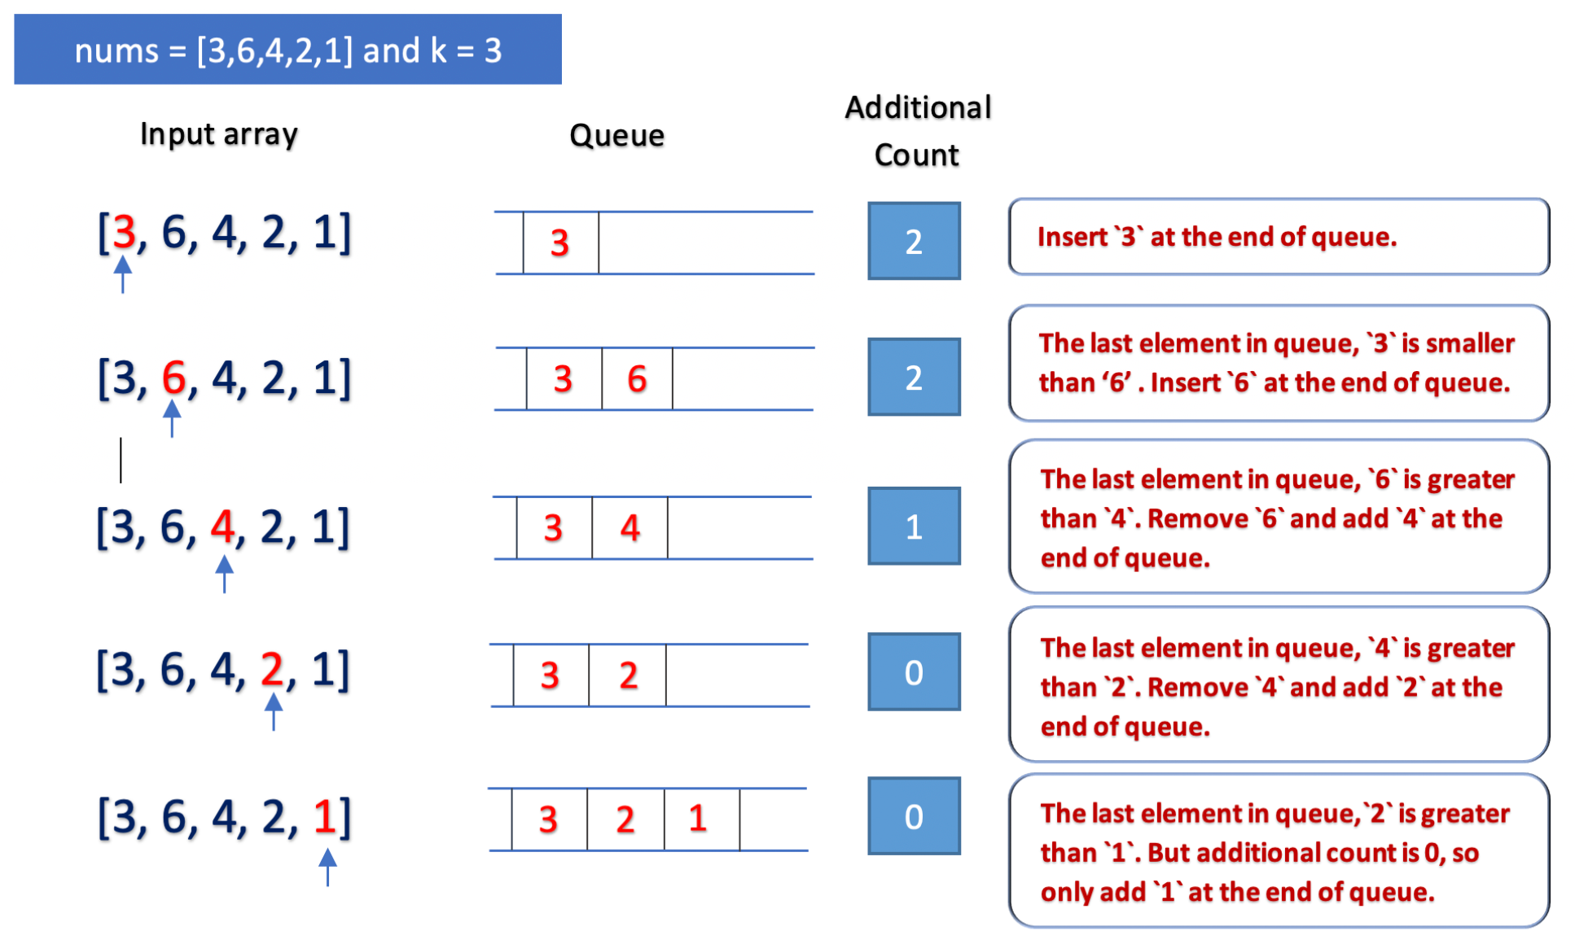

**Implementation**

|  |
| --- |
| class Solution {  public int[] mostCompetitive(int[] nums, int k) {  Deque<Integer> queue = new ArrayDeque<Integer>();  int additionalCount = nums.length - k;  for (int i = 0; i < nums.length; i++) {  while (!queue.isEmpty() && queue.peekLast() > nums[i] && additionalCount > 0) {  queue.pollLast();  additionalCount--;  }  queue.addLast(nums[i]);  }  int[] result = new int[k];  for (int i = 0; i < k; i++) {  result[i] = queue.pollFirst();  }  return result;  }  } |

* Time Complexity: \mathcal{O}(n)O(*n*), where n*n* is the size of array nums. We iterate over the array nums. In the worst case, we would iterate over every element at most twice. First, to add it to the queue, and second to remove it from the queue. This gives us time complexity as \mathcal{O}(n)O(*n*).
* Space Complexity: \mathcal{O}(n)O(*n*), where n*n* is the size of array nums. In the worst case, all the elements of array nums may be added to the queue. Hence, the maximum size of the queue can grow up to n*n*.

**Determine if Two Strings Are Close**

Two strings are considered **close** if you can attain one from the other using the following operations:

* Operation 1: Swap any two **existing** characters.
  + For example, abcde -> aecdb
* Operation 2: Transform **every** occurrence of one **existing** character into another **existing** character, and do the same with the other character.
  + For example, aacabb -> bbcbaa (all a's turn into b's, and all b's turn into a's)

You can use the operations on either string as many times as necessary.

Given two strings, word1 and word2, return true*if*word1*and*word2*are****close****, and*false*otherwise.*

**Example 1:**

**Input:** word1 = "abc", word2 = "bca"

**Output:** true

**Explanation:** You can attain word2 from word1 in 2 operations.

Apply Operation 1: "abc" -> "acb"

Apply Operation 1: "acb" -> "bca"

**Example 2:**

**Input:** word1 = "a", word2 = "aa"

**Output:** false

**Explanation:** It is impossible to attain word2 from word1, or vice versa, in any number of operations.

**Example 3:**

**Input:** word1 = "cabbba", word2 = "abbccc"

**Output:** true

**Explanation:** You can attain word2 from word1 in 3 operations.

Apply Operation 1: "cabbba" -> "caabbb"

Apply Operation 2: "caabbb" -> "baaccc"

Apply Operation 2: "baaccc" -> "abbccc"

**Example 4:**

**Input:** word1 = "cabbba", word2 = "aabbss"

**Output:** false

**Explanation:** It is impossible to attain word2 from word1, or vice versa, in any amount of operations.

**Constraints:**

* 1 <= word1.length, word2.length <= 105
* word1 and word2 contain only lowercase English letters.

   Hide Hint #1

Operation 1 allows you to freely reorder the string.

   Hide Hint #2

Operation 2 allows you to freely reassign the letters' frequencies.

## Solution

#### Overview

Our aim is to determine if the given 2 strings are close. The problem states that the strings are close if we could perform certain operations on either one string or both strings any number of times and make those strings equal. We could perform the following transformations,

Operation 1 : Swapping any 2 characters (a**a**b**c** -> a**c**b**a**).

Operation 2 : Exchanging the occurrence of any 2 characters (**aa**b**cc** -> **cc**b**aa** OR **a**b**cc** -> **cc**b**a**).

Now, performing these 2 operations for every 2 characters in strings and determining the closeness after every operation would be costly. How can we optimize it?

From the given operations, we could observe that if any 2 strings are close, they always satisfy follow conditions,

**Condition 1**: Every character that exists in word1 must exist in word2 as well, irrespective of the frequency.

Let's understand this condition with an example. The following figure illustrates the valid transformations of a string uua on applying operations 1 and 2.

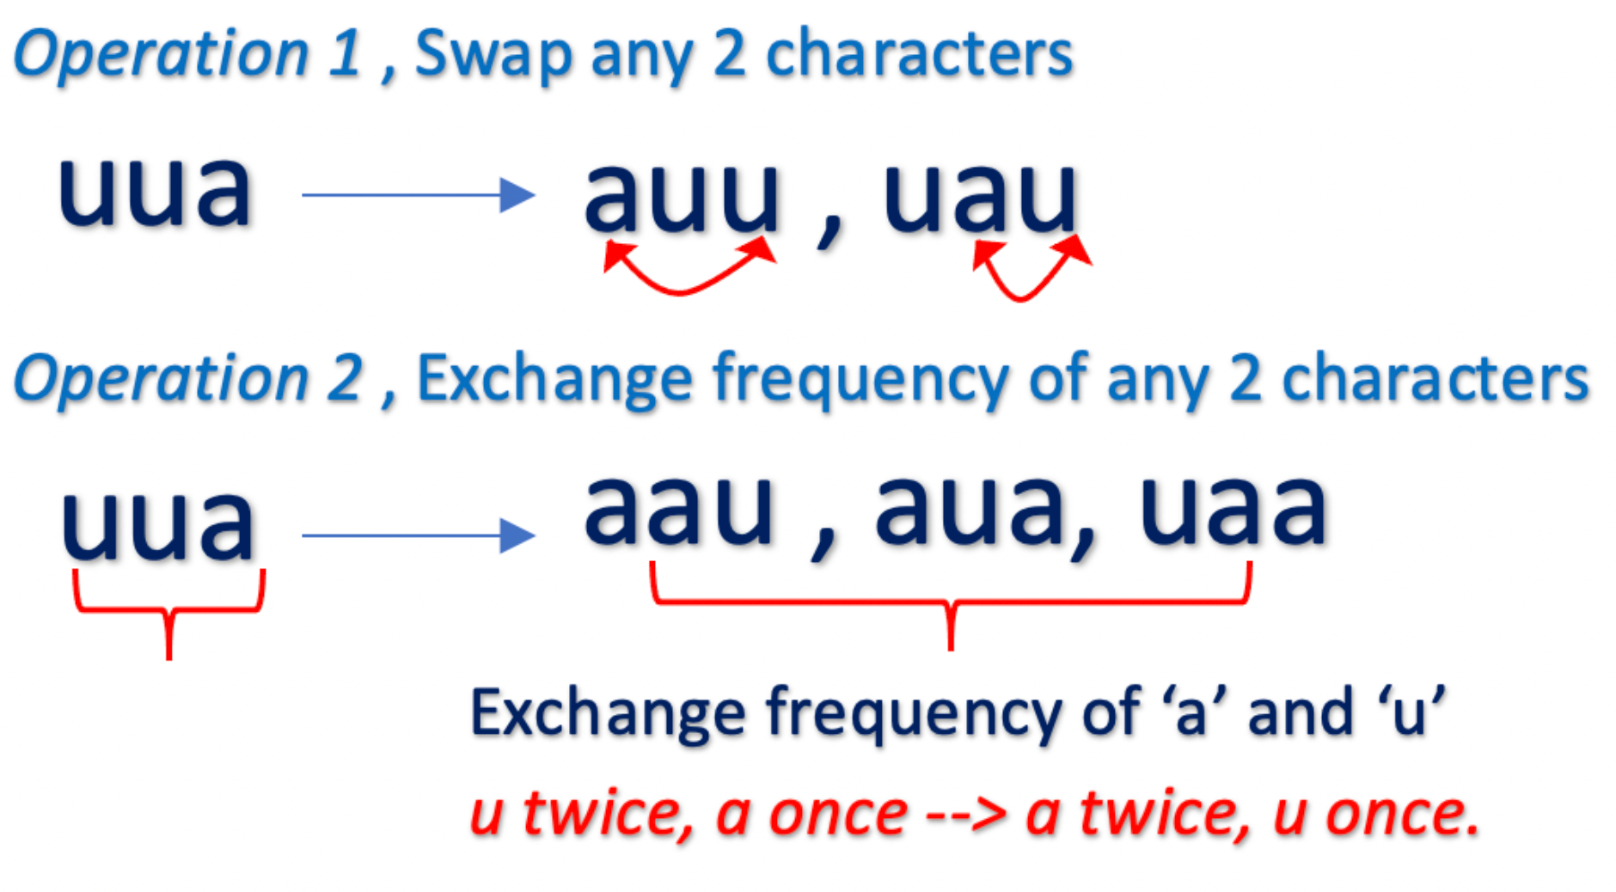

In all the transformations of string uua, the character u and a are always present. Thus, if any string is close to uua it must contain the characters u and a.

**Condition 2**: The frequency of all the characters is always the same. In the above example for string uua, regardless of the operation, following condition always holds :

There exists 1 character that occurs once (frequency = 1) and 1 character that occurs twice (frequency = 2)

The following figure illustrates that all the transformations of uua follows this condition.

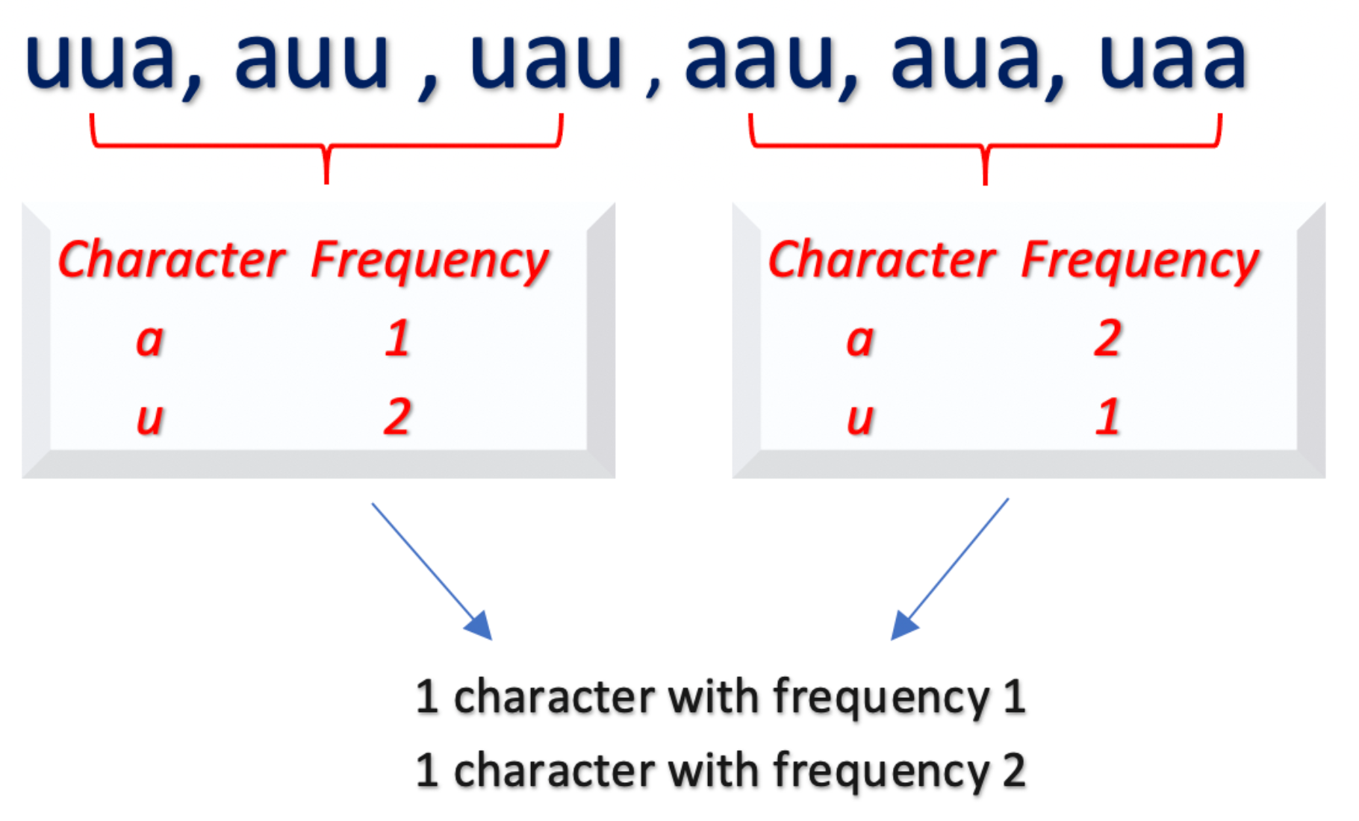

Based on these insights, let's implement the solution using different approaches.

#### Approach 1: Using HashMap

**Intuition**

As discussed above, we have to check for the following conditions to determine if given strings word1 and word1 are close:

* The strings word1 and word2 must have the same characters (Condition 1).

We can build a set that contains the characters in word1 and word2 and check if both sets are equal.

* The occurrence or frequency of characters in word1 and word2 must be the same. (Condition 2).

One way to get the frequency of each character in a string is to use a hashmap. We could build a hashmap with each character as a key and it's frequency as a value of hashmap. Now, we have to verify if there are equal number of characters with a particular frequency. For this, we can sort the frequency values in the hashmap and check for equality.

Instead of building a separate set to check for Condition 1, we can only build one hashmap and check if the keys (that represent each character in the string) are present in both maps.

**Algorithm**

* Initialize hashmaps word1Map and word2Map for strings word1 and word2 respectively.
* Iterate over each word and build its hashmap where the key is the individual character of the word and value is the frequency of that character.
* To check if characters in word1 and word2 are the same, we must check if the key values of hashmaps word1Map and word2Map are the same.
* Now, to check the occurrence, we must sort the values of both hashmaps in increasing order and check for equality.

**Implementation**

|  |
| --- |
| class Solution {  public boolean closeStrings(String word1, String word2) {  if (word1.length() != word2.length()) {  return false;  }  Map<Character, Integer> word1Map = new HashMap<>();  Map<Character, Integer> word2Map = new HashMap<>();  for (char c : word1.toCharArray()) {  word1Map.put(c, word1Map.getOrDefault(c, 0) + 1);  }  for (char c : word2.toCharArray()) {  word2Map.put(c, word2Map.getOrDefault(c, 0) + 1);  }  if (!word1Map.keySet().equals(word2Map.keySet())) {  return false;  }  List<Integer> word1FrequencyList = new ArrayList<>(word1Map.values());  List<Integer> word2FrequencyList = new ArrayList<>(word2Map.values());  Collections.sort(word1FrequencyList);  Collections.sort(word2FrequencyList);  return word1FrequencyList.equals(word2FrequencyList);  }  } |

**Complexity Analysis**

* Time Complexity: \mathcal{O}(n)O(*n*). We iterate over each word to build the hashmap which would take \mathcal{O}(n)O(*n*) time. Further, we sort the character keys and frequency values of each hashmap. The maximum size of hashmap would be 2626, as we store each character a-z only once. In the worst case, all the sort operations would take \mathcal{O}(26 \log 26)O(26log26) time to sort those frequency values. This gives us total time complexity as \mathcal{O}(n)O(*n*).
* Space Complexity: \mathcal{O}(1)O(1), as the maximum size of each hashmap would be 2626, we are using constant extra space.

#### Approach 2: Using Frequency Array Map

**Intuition**

We know that the string contains all the lowercase characters (a-z) only. So, instead of using a hashmap to track the frequency of characters, we could build an array of size 2626 as a frequency map, where each array element represents a character's frequency (0th index = a, 1st index = b and so on). In order to check if all characters exist in both words, we could simply iterate over the fixed size frequency map.

**Algorithm**

* Build arrays word1Map and word2Map of size 2626 to store the frequencies of each character (a-z).
* For the first condition, we must check if the characters in word1 and word2 are the same. There could be multiple ways to implement this. One way is to iterate over each frequency map of size 2626 and ensure if a character does not exist in word1Map, then it must not exist in word2Map as well and vice versa. If the condition is not satisfied for any of the characters, return false.
* For the second condition, we could simply sort the array in increasing order and return true if arrays are equal, otherwise return false.

**Implementation**

|  |
| --- |
| class Solution {  public boolean closeStrings(String word1, String word2) {  if (word1.length() != word2.length()) {  return false;  }  int word1Map[] = new int[26];  int word2Map[] = new int[26];  for (char c : word1.toCharArray()) {  word1Map[c - 'a']++;  }  for (char c : word2.toCharArray()) {  word2Map[c - 'a']++;  }  for (int i = 0; i < 26; i++) {  if ((word1Map[i] == 0 && word2Map[i] > 0) ||  (word2Map[i] == 0 && word1Map[i] > 0)) {  return false;  }  }  Arrays.sort(word1Map);  Arrays.sort(word2Map);  return Arrays.equals(word1Map, word2Map);  }  } |

**Complexity Analysis**

* Time Complexity : \mathcal{O}(n)O(*n*), where n*n* is the length of word.

We iterate over words of size n*n* to build the frequency map which takes \mathcal{O}(n)O(*n*). To check if both words have the same characters and frequency, we iterate over a fixed-size array of size 2626 which takes constant time. The sort operation on the array also takes constant time, as the array is of size 2626.

This gives us time complexity of \mathcal{O}(n) + \mathcal{O}(1) + \mathcal{O}(1) = \mathcal{O}(n)O(*n*)+O(1)+O(1)=O(*n*)

* Space Complexity: \mathcal{O}(1)O(1), as we use constant extra space of size 2626 to store the frequency map.

#### Approach 3: Using Bitwise Operation and Frequency Array Map

**Intuition**

The previous approach iterates over the map of size 2626 to check if the word1 and word2 have the same characters (Condition 1). However, there is another efficient way to implement this.

We just want a way to know if a character exists in a word or not. Instead of iterating over a frequency map to check this condition, we could simply store this information in a single integer. This could be done by making use of Bitwise Operators.

We could use a integer \text{wordBit}wordBit, where each bit in the \text{wordBit}wordBit stores the information about each of the 26 characters (a-z). The rightmost bit represents the character a, the next left bit would represent character b and so on.

A character exists in the word if it's a corresponding bit is set to 11. The following figure illustrates this idea.

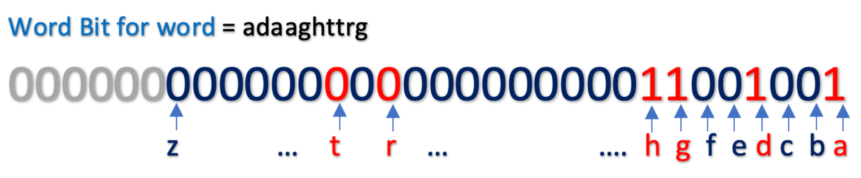

To set a bit represented by a character we must use the bitwise OR operator. Example,

\text{wordBit } | \text{ wordBit << 2}wordBit ∣ wordBit << 2, sets the 2^{nd}2*nd* bit, \text{wordBit} = 100wordBit=100.

\text{wordBit } | \text{ wordBit << 5}wordBit ∣ wordBit << 5, sets the 5^{th}5*th* bit, \text{wordBit} = 100100wordBit=100100.

It must be noted that this approach works because the size of the integer is 3232 bits (In Java and C++) and we only need to 2626 bits to store our information.

**Algorithm**

* Build arrays word1Map and word2Map of size 26 to store the frequencies of each character (a-z) as in Approach 2.
* For the first condition, we must check if the characters in word1 and word2 are the same. We use word1Bit and word2Bit to store the bit information of word1 and word2 respectively. While building the frequency map, we update the word bits as well to mark the occurrence of a character.
* For the second condition, we could simply sort the array in increasing order and return true if arrays are equal, otherwise return false.

**Implementation**

|  |
| --- |
| class Solution {  public boolean closeStrings(String word1, String word2) {  if (word1.length() != word2.length()) {  return false;  }  int word1Map[] = new int[26];  int word2Map[] = new int[26];  int word1Bit = 0;  int word2Bit = 0;  for (char c : word1.toCharArray()) {  word1Map[c - 'a']++;  word1Bit = word1Bit | (1 << (c - 'a'));  }  for (char c : word2.toCharArray()) {  word2Map[c - 'a']++;  word2Bit = word2Bit | (1 << (c - 'a'));  }  if (word1Bit != word2Bit) {  return false;  }  Arrays.sort(word1Map);  Arrays.sort(word2Map);  for (int i = 0; i < 26; i++) {  if (word1Map[i] != word2Map[i]) {  return false;  }  }  return true;  }  } |

* Time Complexity : \mathcal{O}(n)O(*n*), where n*n* is the length of the word. The complexity is similar to *Approach 2*.
* Space Complexity: \mathcal{O}(1)O(1), as we use constant extra space, frequency map of size 2626 and word bits of type integer.

**Sort the Matrix Diagonally**

A **matrix diagonal** is a diagonal line of cells starting from some cell in either the topmost row or leftmost column and going in the bottom-right direction until reaching the matrix's end. For example, the **matrix diagonal** starting from mat[2][0], where mat is a 6 x 3 matrix, includes cells mat[2][0], mat[3][1], and mat[4][2].

Given an m x n matrix mat of integers, sort each **matrix diagonal** in ascending order and return *the resulting matrix*.

**Example 1:**

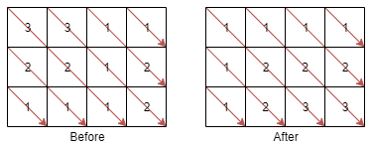

**Input:** mat = [[3,3,1,1],[2,2,1,2],[1,1,1,2]]

**Output:** [[1,1,1,1],[1,2,2,2],[1,2,3,3]]

**Example 2:**

**Input:** mat = [[11,25,66,1,69,7],[23,55,17,45,15,52],[75,31,36,44,58,8],[22,27,33,25,68,4],[84,28,14,11,5,50]]

**Output:** [[5,17,4,1,52,7],[11,11,25,45,8,69],[14,23,25,44,58,15],[22,27,31,36,50,66],[84,28,75,33,55,68]]

**Constraints:**

* m == mat.length
* n == mat[i].length
* 1 <= m, n <= 100
* 1 <= mat[i][j] <= 100

   Hide Hint #1

Use a data structure to store all values of each diagonal.

   Hide Hint #2

How to index the data structure with the id of the diagonal?

   Hide Hint #3

All cells in the same diagonal (i,j) have the same difference so we can get the diagonal of a cell using the difference i-j.

## Solution Article

#### Approach 1: Hash Table of Heaps

The most straightforward idea is to create a **hash table of heaps** to store the diagonals. This way, the diagonals are automatically sorted, and one has nothing to do but to push these sorted diagonals back into the matrix.

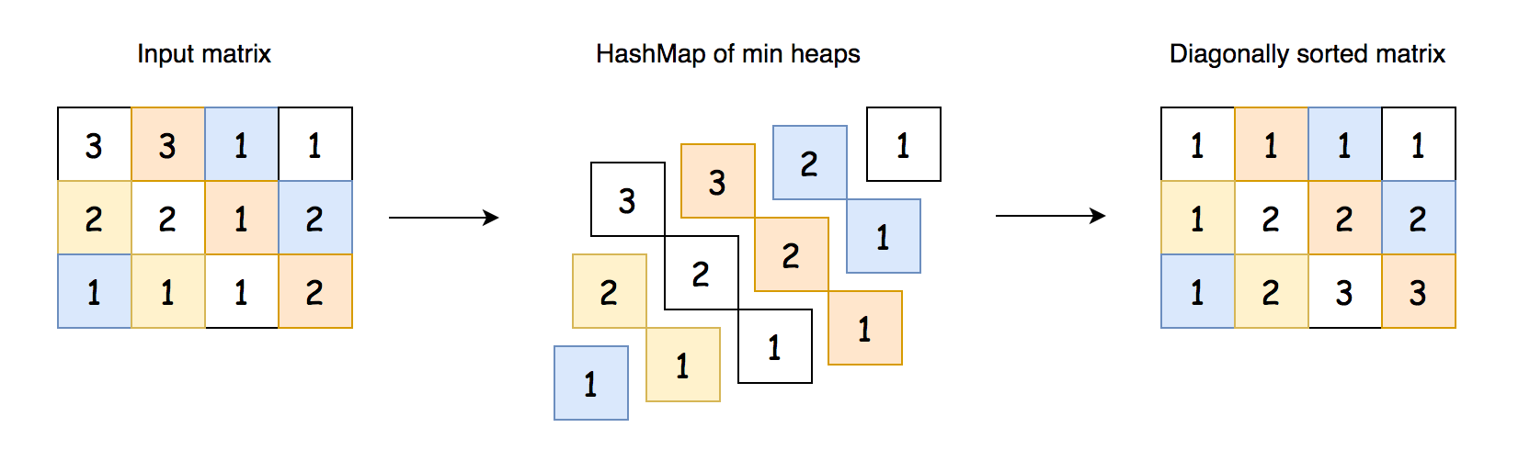 Fig 1. Approach 1: HashMap of Heaps.

**Implementation**

|  |
| --- |
| class Solution {  public int[][] diagonalSort(int[][] mat) {  // Store the matrix dimensions  int m = mat.length;  int n = mat[0].length;    // Data structure to store the diagonals.  Map<Integer, Queue<Integer>> diagonals = new HashMap<>();    // Insert values into the HashMap.  for (int row = 0; row < m; row++) {  for (int col = 0; col < n; col++) {  diagonals.putIfAbsent(row - col, new PriorityQueue<>());  diagonals.get(row - col).add(mat[row][col]);  }  }  // Take values back out of the HashMap.  for (int row = 0; row < m; row++) {  for (int col = 0; col < n; col++) {  mat[row][col] = diagonals.get(row - col).remove();  }  }    return mat;  }  } |

**Complexity Analysis**

Let M*M* be the number of rows, and N*N* be the number of columns.

* Time complexity: \mathcal{O}\Big(N \times M \times \log \big(\min(N, M)\big)\Big)O(*N*×*M*×log(min(*N*,*M*))).

We perform N \times M*N*×*M* operations in two nested loops. At each iteration, we push an element into a heap that contains the current diagonal. The longest diagonal contains \min(N, M)min(*N*,*M*) element, and so pushing an element to a heap has a cost of \mathcal{O}\Big(\log\big(\min(N, M)\big)\Big)O(log(min(*N*,*M*))). Multiplying these together, we get a time complexity of \mathcal{O}\Big(N \times M \times \log \big(\min(N, M)\big)\Big)O(*N*×*M*×log(min(*N*,*M*)))

* Space complexity: \mathcal{O}(M \times N)O(*M*×*N*).

The diagonals Hash Map has to store each element in the input matrix.

#### Approach 2: Sort Diagonals One by One Using Heap

To optimize the space, we could sort diagonals one by one. That would decrease the space complexity from \mathcal{O}(N \times M)O(*N*×*M*) down to \mathcal{O}(\min(N, M))O(min(*N*,*M*)).

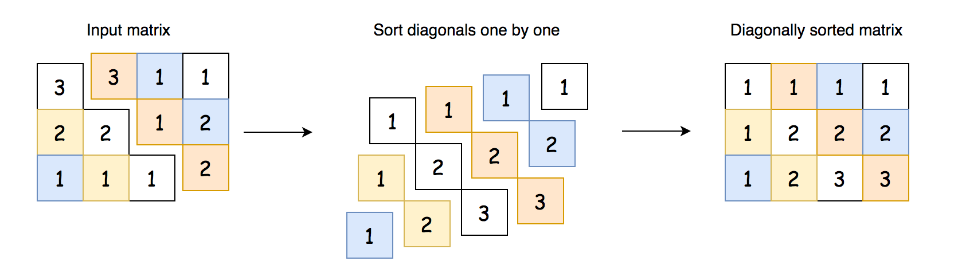 Fig 2. Approach 2: Sort Diagonals One by One Using Heap.

**Implementation**

|  |
| --- |
| class Solution {    public int[][] diagonalSort(int[][] mat) {  // Store the matrix dimensions.  int m = mat.length;  int n = mat[0].length;    // Sort each diagonal that starts on a row.  for (int row = 0; row < m; row++) {  sortDiagonal(row, 0, mat);  }  // Sort each diagonal that starts on a col.  // Note that we've already sorted the one starting  // at col = 0; this is the same as the one starting  // at row = 0.  for (int col = 1; col < n; col++) {  sortDiagonal(0, col, mat);  }    return mat;  }  private void sortDiagonal(int row, int col, int[][] mat) {  int m = mat.length;  int n = mat[0].length;  Queue<Integer> diagonal = new PriorityQueue<>();    int diagonalLength = Math.min(m - row, n - col);  // Put values on this diagonal into the heap.  for (int i = 0; i < diagonalLength; i++) {  diagonal.add(mat[row + i][col + i]);  }  // Put values on heap back into this diagonal  for (int i = 0; i < diagonalLength; i++) {  mat[row + i][col + i] = diagonal.remove();  }  }  } |

**Complexity Analysis**

Let M*M* be the number of rows, and N*N* be the number of columns.

* Time complexity: \mathcal{O}\Big(N \times M \times \log \big(\min(N, M)\big)\Big)O(*N*×*M*×log(min(*N*,*M*))).

We perform N \times M*N*×*M* operations in two nested loops. At each iteration, we push an element into a heap that contains the current diagonal. The longest diagonal contains \min(N, M)min(*N*,*M*) element, and so pushing an element to a heap has a cost of \mathcal{O}\Big(\log\big(\min(N, M)\big)\Big)O(log(min(*N*,*M*))). Multiplying these together, we get a time complexity of \mathcal{O}\Big(N \times M \times \log \big(\min(N, M)\big)\Big)O(*N*×*M*×log(min(*N*,*M*)))

* Space complexity: \mathcal{O}(\min(N, M))O(min(*N*,*M*)).

The space is used by the heap with diagonal elements, and the longest diagonal contains \min(N, M)min(*N*,*M*) elements.

#### Approach 3: Sort Diagonals One by One Using Counting Sort

**Intuition**

Instead of using a heap, we could put each diagonal into a list and then sort it using built-in sorting functions. This would achieve the same time and space complexity as the previous approach.

But can we do better on the time complexity? Yes, we can! Instead of using heaps or built-in sort, we could implement a [counting sort](https://en.wikipedia.org/wiki/Counting_sort). Recall that counting sort runs in \mathcal{O}(A + B)O(*A*+*B*) time, where A*A* is the number of items to be sorted, and B*B* is the difference between the smallest and largest element.

 Fig 3. Approach 3: Sort Diagonals One by One Using Sort.

**Interview Tip**: A somewhat popular follow-up question for "sorting" problems goes something like this. Assume that the maximum value in the data to be sorted is x, where x is small compared to the number of elements to be sorted. Assuming that the number of values to be sorted is n*n*, can you come up with a solution that runs in O(x \cdot n)*O*(*x*⋅*n*) time, as opposed to O(n \log n)*O*(*n*log*n*) time?

The solution to this is to use counting sort. It is important to practice implementing counting sort so that you can confidently tackle this common follow-up question.

|  |
| --- |
| class Solution {    public int[][] diagonalSort(int[][] mat) {  int m = mat.length;  int n = mat[0].length;  for (int row = 0; row < m; row++) {  sortDiagonal(row, 0, mat);  }  for (int col = 1; col < n; col++) {  sortDiagonal(0, col, mat);  }  return mat;  }  private List<Integer> countingSort(List<Integer> nums) {  // The problem constraints allow us to assume that  // 1 <= mat[i][j] <= 100.  // You should, however, confirm with the interviewer  // that it is OK to hardcode values like this.  int min = 1; // You could also use: Collections.min(nums);  int max = 100; // You could also use: Collections.max(nums);    // Calculate the range of values, and then create a list  // of the size of the range.  int len = max - min + 1;  int[] count = new int[len];  // Tally up the values in nums.  for (int num : nums) {  count[num - min]++;  }  // Flatten the list of counts into a sorted list.  List<Integer> sortedNums = new ArrayList<>();  for (int i = 0; i < len; i++) {  for (int times = count[i]; times > 0; times--) {  sortedNums.add(i + min);  }  }  return sortedNums;  }  private void sortDiagonal(int row, int col, int[][] mat) {  int m = mat.length;  int n = mat[0].length;  List<Integer> diagonal = new ArrayList<>();  int diagonalLength = Math.min(m - row, n - col);  for (int i = 0; i < diagonalLength; i++) {  diagonal.add(mat[row + i][col + i]);  }  // Sort the diagonal using our counting sort method.  diagonal = countingSort(diagonal);  for (int i = 0; i < diagonalLength; i++) {  mat[row + i][col + i] = diagonal.remove(0);  }  }  } |

**Complexity Analysis**

Let M*M* be the number of rows, N*N* the number of columns, and V*V* the range of values in the matrix.

The time complexity is dependent on whether we're treating V*V* as a variable or a constant. In the code above, we treated it as a constant; we simply set the minimum and maximum for the range to min = 0 and max = 100, which would give a fixed-size range of V = 100. Alternatively, if we'd done min = min value in diagonal and max = max value in diagonal, then this would make it a variable.

* Time complexity (Treating V*V* as a variable): \mathcal{O}\big((V \times M) + (V \times N) + (M \times N)\big)O((*V*×*M*)+(*V*×*N*)+(*M*×*N*)).

The best way of analyzing the time complexity for this approach is to summarise all of the steps as follows.

* + Each of the M \times N*M*×*N* elements is getting taken out of the matrix *once*.
  + Each of the M \times N*M*×*N* elements is getting returned to the matrix *once*.
  + Each of the M \times N*M*×*N* elements is getting inserted into an array (direct access) *once*.
  + Each of the M \times N*M*×*N* elements is getting removed from an array *once*. The total cost for these 44 operations is \mathcal{O}(4 \times M \times N) = \mathcal{O}(M \times N)O(4×*M*×*N*)=O(*M*×*N*).

We're not quite done though, we also need to consider the cost of creating and traversing the counts arrays.

* + There are a total of M + N - 1*M*+*N*−1 diagonals, and for each diagonal, an array of length V*V* is created.
  + Each of the M + N - 1*M*+*N*−1 arrays of length V*V* are traversed once. The total cost for these 22 operations is \mathcal{O}(2 \times V \times (M + N - 1))O(2×*V*×(*M*+*N*−1)). Dropping the constants, we get \mathcal{O}\big(V \times (M + N)\big)O(*V*×(*M*+*N*)) and expanding the brackets gives \mathcal{O}\big((V \times M) + (V \times N)\big)O((*V*×*M*)+(*V*×*N*)).

Combining the two parts, we get a final result of \mathcal{O}\big((V \times M) + (V \times N) + (M \times N)\big)O((*V*×*M*)+(*V*×*N*)+(*M*×*N*)).

* Time complexity (Treating V*V* as a constant): \mathcal{O}(N \times M)O(*N*×*M*).

Each of the M \times N*M*×*N* values in the matrix is being put into a bucket of a fixed-size array. Putting a value has a cost of O(1)*O*(1), as does iterating over the buckets. Therefore, we're only left with the cost of iterating the matrix.

* Space complexity: \mathcal{O}\big(\min(N, M)\big)O(min(*N*,*M*)).

We use additional space for the current diagonal we're processing. The maximum possible diagonal size is \min(N, M)min(*N*,*M*).

**Further Thoughts: A slippery slope for arbitrary constants**

The "constant range" way of implementing and analyzing counting sort is popular, but not without its issues. If, for example, the range was the size of a 32-bit integer, then the constant would be over 4 billion - and would no doubt lead to a TLE if you tried to run it here on LeetCode! Also, it leads to another compelling question: Why is it OK to treat the range as a constant, but not the array length? We could easily write some code that hardcodes the maximum array size, and then simply skips all out-of-bounds indexes. This, technically, would allow us to iterate an array, up to a size big enough to solve the problem, in O(1)*O*(1) time. And why stop there? By hardcoding high enough values, we could, in theory, solve every problem on LeetCode in O(1)*O*(1) time. This all seems pretty silly, so the moral of the story is: we need to be very careful about hardcoding *any* problem constraints.

In an interview, you should be careful to explain and justify whether or not you're treating the number range as a constant.

**Check If All 1's Are at Least Length K Places Away**

Given an array nums of 0s and 1s and an integer k, return True if all 1's are at least k places away from each other, otherwise return False.

**Example 1:**

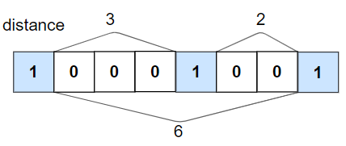

**Input:** nums = [1,0,0,0,1,0,0,1], k = 2

**Output:** true

**Explanation:** Each of the 1s are at least 2 places away from each other.

**Example 2:**

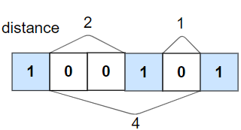

**Input:** nums = [1,0,0,1,0,1], k = 2

**Output:** false

**Explanation:** The second 1 and third 1 are only one apart from each other.

**Example 3:**

**Input:** nums = [1,1,1,1,1], k = 0

**Output:** true

**Example 4:**

**Input:** nums = [0,1,0,1], k = 1

**Output:** true

**Constraints:**

* 1 <= nums.length <= 105
* 0 <= k <= nums.length
* nums[i] is 0 or 1

Hide Hint #1

Each time you find a number 1, check whether or not it is K or more places away from the next one. If it's not, return false.

## Solution

#### Approach 1: One Pass + Count

Let's first implement a pretty straightforward one-pass idea: to iterate over the array and count the number of zeros in-between the "neighbor" 1s. Each two neighbor 1s should have at least k*k* zeros in-between. If it's not the case, return false.

 Fig 1. One pass: count the number of zeros in-between the "neighbour" *1*s.

**Implementation**

|  |
| --- |
| class Solution {  public boolean kLengthApart(int[] nums, int k) {  // initialize the counter of zeros to k  // to pass the first 1 in nums  int count = k;    for (int num : nums) {  // if the current integer is 1  if (num == 1) {  // check that number of zeros in-between 1s  // is greater than or equal to k  if (count < k) {  return false;  }  // reinitialize counter  count = 0;    // if the current integer is 0  } else {  // increase the counter  ++count;  }  }  return true;  }  } |

**Complexity Analysis**

* Time complexity: \mathcal{O}(N)O(*N*) to parse an array of N*N* elements.
* Space complexity: \mathcal{O}(1)O(1) since we don't allocate any additional data structures here.

#### Approach 2: Bit Manipulation

This approach would be more suitable for the Facebook variation of this problem, when the input is not a binary array but an integer.

In this situation, the problem could be solved with the bitwise trick to remove trailing zeros in the binary representation:

|  |
| --- |
| // remove trailing zeros  while ((x & 1) == 0) {  x = x >> 1;  } |

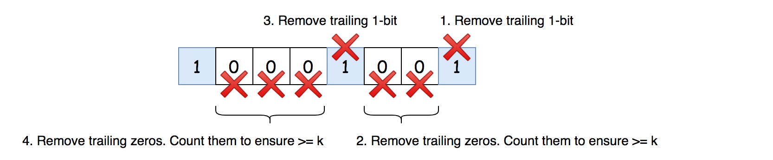 *Fig 2. Approach 2: use bit manipulations to work with the binary representation of the integer.*

**Algorithm**

* Convert binary array into integer x. Note that this conversion always works fine in Python where there is no limit on the value of integers. In Java, the usage of this approach is limited by the integer capacity.
* Consider the base cases: return true if x == 0 or k == 0.
* Remove trailing zeros in the binary representation of x. That ensures that the last bit of x is 1-bit.
* While x is greater than 1:
  + Remove trailing 1-bit with the right shift: x >>= 1.
  + Remove trailing zeros one by one, and count them using counter count. The number of zeros in-between 1-bits should be greater or equal to k. Hence, return false if count < k.
* We're here because all 1-bits are separated by more than k zeros. Return true.

**Implementation**

|  |
| --- |
| class Solution {  public boolean kLengthApart(int[] nums, int k) {  // convert binary array into int  int x = 0;  for (int num : nums) {  x = (x << 1) | num;  }    // base case  if (x == 0 || k == 0) {  return true;  }    // remove trailing zeros  while ((x & 1) == 0) {  x = x >> 1;  }    while (x != 1) {  // remove trailing 1-bit  x = x >> 1;    // count trailing zeros  int count = 0;  while ((x & 1) == 0) {  x = x >> 1;  ++count;  }    // number of zeros in-between 1-bits  // should be greater than or equal to k  if (count < k) {  return false;  }  }  return true;  }  } |

**Complexity Analysis**

* Time complexity: \mathcal{O}(N)O(*N*) to parse an array of N*N* elements.
* Space complexity: \mathcal{O}(1)O(1) since we don't allocate any additional data structures here.

**Path With Minimum Effort**

You are a hiker preparing for an upcoming hike. You are given heights, a 2D array of size rows x columns, where heights[row][col] represents the height of cell (row, col). You are situated in the top-left cell, (0, 0), and you hope to travel to the bottom-right cell, (rows-1, columns-1) (i.e., **0-indexed**). You can move **up**, **down**, **left**, or **right**, and you wish to find a route that requires the minimum **effort**.

A route's **effort** is the **maximum absolute difference**in heights between two consecutive cells of the route.

Return *the minimum****effort****required to travel from the top-left cell to the bottom-right cell.*

**Example 1:**

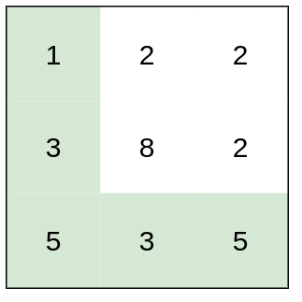

**Input:** heights = [[1,2,2],[3,8,2],[5,3,5]]

**Output:** 2

**Explanation:** The route of [1,3,5,3,5] has a maximum absolute difference of 2 in consecutive cells.

This is better than the route of [1,2,2,2,5], where the maximum absolute difference is 3.

**Example 2:**

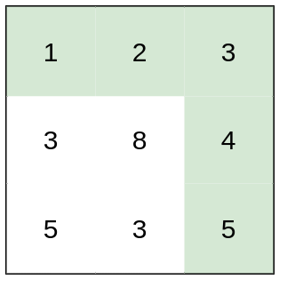

**Input:** heights = [[1,2,3],[3,8,4],[5,3,5]]

**Output:** 1

**Explanation:** The route of [1,2,3,4,5] has a maximum absolute difference of 1 in consecutive cells, which is better than route [1,3,5,3,5].

**Example 3:**

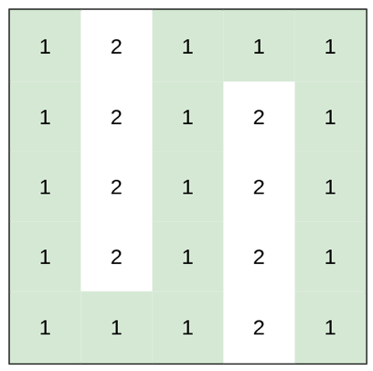

**Input:** heights = [[1,2,1,1,1],[1,2,1,2,1],[1,2,1,2,1],[1,2,1,2,1],[1,1,1,2,1]]

**Output:** 0

**Explanation:** This route does not require any effort.

**Constraints:**

* rows == heights.length
* columns == heights[i].length
* 1 <= rows, columns <= 100
* 1 <= heights[i][j] <= 106

   Hide Hint #1

Consider the grid as a graph, where adjacent cells have an edge with cost of the difference between the cells.

   Hide Hint #2

If you are given threshold k, check if it is possible to go from (0, 0) to (n-1, m-1) using only edges of ≤ k cost.

   Hide Hint #3

Binary search the k value.

## Solution

#### Overview

The problem is that given a 2D matrix \text{heights}heights of size \text{row} \cdot \text{col}row⋅col representing the height of each cell, we have travel from top right corner (0, 0) to bottom right corner (row-1, col-1) of the matrix and find a path with minimum effort. The effort to move from one cell to another is the absolute difference in the heights of those cells.

The following example illustrates the effort required to travel from cell A to all the neighboring cells B,C, D, and F. The first matrix represents the heights of each cell and the second represents the absolute difference from cell A to all the adjacent cells. The path with minimum effort is from cell A to cell E.

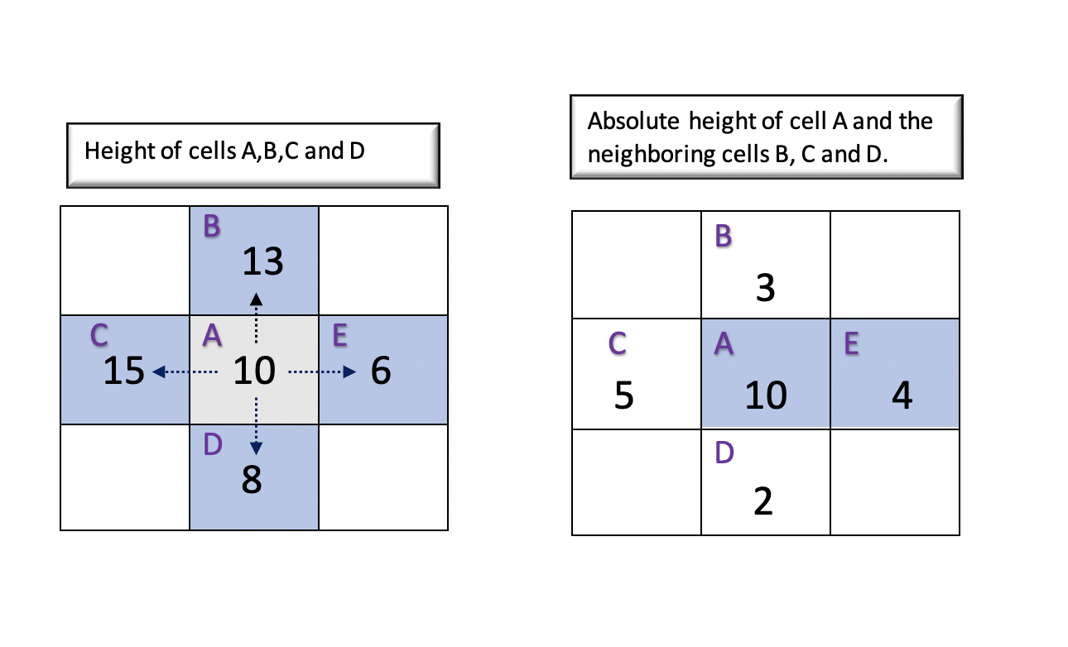

Let's understand the different approaches to implement the solution in detail.

#### Approach 1: Brute Force using Backtracking

**Intuition**

The brute force approach would be to traverse all the possible paths from the source cell to the destination cell and track the path with minimum efforts. To try all possible paths, the first thing that comes in our mind is [Backtracking](https://leetcode.com/explore/learn/card/recursion-ii/472/backtracking/2654/). Backtracking incrementally builds the candidates for a solution using depth first search and discards the candidates (backtrack) if it doesn't satisfy the condition.

The backtracking algorithms consists of the following steps,

* Choose: Choose the potential candidate. For any given cell A, we must choose the adjacent cells in all 4 directions (up, down, left, right) as a potential candidate.
* Constraint: Define a constraint that must be satisfied by the chosen candidate. In this case, a chosen cell is valid if it is within the boundaries of the matrix and it is not visited before.
* Goal: We must define the goal that determines if we have found the required solution and we must backtrack. Here, our goal is achieved once we have reached the destination cell. On reaching the destination cell, we must track the maximum absolute difference in that path and backtrack.

To make the algorithm more efficient, once we find any path from source to destination, we track the maximum absolute difference of all adjacent cells in that path in a variable \text{maxSoFar}maxSoFar. With this, we can avoid going into other paths in the future where effort is greater than or equal to \text{maxSoFar}maxSoFar.

In other words, if we have already found a path to reach the destination cell with \text{maxSoFar}maxSoFar, then, we would only explore other paths if it takes efforts less than \text{maxSoFar}maxSoFar.

**Algorithm**

We must begin the Depth First Search traversal from source cell (x = 0 and y = 0). Using the intuition discussed above, we must explore all the potential paths using the following steps,

* For a given cell (x, y), explore the adjacent cells in all the 4 directions defined by directions and choose the one with minimum effort.
* The maxDifference keeps track of the maximum absolute difference seen so far in the current path. On every move to the adjacent cell, we must update the maxDifference if it is lesser than the currentDifference (The absolute difference between current cell(x, y) and adjacent cell(adjacentX, adjacentY)).
* We must backtrack from the depth first search traversal once we reach the destination cell (row-1) and (col-1) and return the maximum absolute difference of the current path.

Thus, for each cell, we recursively calculate the effort required to reach the destination cell from all the adjacent cells and find the minimum effort.

**Note**

It must be noted that we mark the current cell as visited by setting the height of the current cell (x,y) as 0. We must update the height back to the previous value once we backtrack from the current path. This is necessary because the cell must be visited again for other paths.

**Implementation**

|  |
| --- |
| class Solution {  public int minimumEffortPath(int[][] heights) {  return backtrack(0, 0, heights, heights.length, heights[0].length, 0);  }  int directions[][] = {{0, 1}, {1, 0}, {0, -1}, {-1, 0}};  int maxSoFar = Integer.MAX_VALUE;  int backtrack(int x, int y, int[][] heights, int row, int col, int maxDifference) {  if (x == row - 1 && y == col - 1) {  maxSoFar = Math.min(maxSoFar, maxDifference);  return maxDifference;  }  int currentHeight = heights[x][y];  heights[x][y] = 0;  int minEffort = Integer.MAX_VALUE;  for (int i = 0; i < 4; i++) {  int adjacentX = x + directions[i][0];  int adjacentY = y + directions[i][1];  if (isValidCell(adjacentX, adjacentY, row, col) && heights[adjacentX][adjacentY] != 0) {  int currentDifference = Math.abs(heights[adjacentX][adjacentY] - currentHeight);  int maxCurrentDifference = Math.max(maxDifference, currentDifference);  if (maxCurrentDifference < maxSoFar) {  int result = backtrack(adjacentX, adjacentY, heights, row, col, maxCurrentDifference);  minEffort = Math.min(minEffort, result);  }  }  }  heights[x][y] = currentHeight;  return minEffort;  }  boolean isValidCell(int x, int y, int row, int col) {  return x >= 0 && x <= row - 1 && y >= 0 && y <= col - 1;  }  } |

**Complexity Analysis**

Let m*m* be the number of rows and n*n* be the number of columns in the matrix \text{heights}heights.

* Time Complexity : \mathcal{O}(3^{m \cdot n})O(3*m*⋅*n*). The total number of cells in the matrix is given by m \cdot n*m*⋅*n*. For the backtracking, there are at most 4 possible directions to explore, but further, the choices are reduced to 3 (since we won't go back to where we come from). Thus, considering 3 possibilities for every cell in the matrix the time complexity would be \mathcal{O}(3^{m \cdot n})O(3*m*⋅*n*).

The time complexity is exponential, hence this approach is exhaustive and results in Time Limit Exceeded (TLE).

* Space Complexity: \mathcal{O}(m \cdot n)O(*m*⋅*n*) This space will be used to store the recursion stack. As we recursively move to the adjacent cells, in the worst case there could be m \cdot n*m*⋅*n* cells in the recursive call stack.

#### Approach 2: Variations of Dijkstra's Algorithm

**Intuition**

The previous approach is exhaustive as it traverses all the paths. If we observe, the problem is similar to finding the shortest path from a source cell to a destination cell. Here, the shortest path is the one with **minimum absolute difference** between every adjacent cells in that path. Also, since there is height associated with each cell, simple BFS traversal won't be sufficient.

The absolute difference between adjacent cells A and B can be perceived as the weight of an edge from cell A to cell B. Thus, we could use [Dijkstra's Algorithm](https://en.wikipedia.org/wiki/Dijkstra%27s_algorithm) which is used to find the shortest path in a weighted graph with a slight modification of criteria for the shortest path.

Let's look at the algorithm in detail.

**Algorithm**

* We use a differenceMatrix of size \text{row} \cdot \text{col}row⋅col where each cell represents the minimum effort required to reach that cell from all the possible paths. Also, initialize we all the cells in the differenceMatrix to infinity \text{(MAX\_INT)}(MAX_INT) since none of the cells are reachable initially.
* As we start visiting each cell, all the adjacent cells are now reachable. We update the absolute difference between the current cell and adjacent cells in the differenceMatrix. At the same time, we also push all the adjacent cells in a priority queue. The priority queue holds all the reachable cells sorted by its value in differenceMatrix, i.e the cell with minimum absolute difference with its adjacent cells would be at the top of the queue.
* We begin by adding the source cell (x=0, y=0) in the queue. Now, until we have visited the destination cell or the queue is not empty, we visit each cell in the queue sorted in the order of priority. The less is the difference value(absolute difference with adjacent cell) of a cell, the higher is its priority.
  + Get the cell from the top of the queue curr and visit the current cell.
  + For each of the 4 cells adjacent to the current cell, calculate the maxDifference which is the maximum absolute difference to reach the adjacent cell (adjacentX, adjacentY) from current cell (curr.x, curr.y).
  + If the current value of the adjacent cell (adjacentX, adjacentY) in the difference matrix is greater than the maxDifference, we must update that value with maxDifference. In other words, we have found that the path from the current cell to the adjacent cell takes lesser efforts than the other paths that have reached the adjacent cell so far. Also, we must add this updated difference value in the queue.

Ideally, for updating the priority queue, we must delete the old value and reinsert with the new maxDifference value. But, as we know that the updated maximum value is always lesser than the old value and would be popped from the queue and visited before the old value, we could save time and avoid removing the old value from the queue.

* At the end, the value at differenceMatrix[row - 1][col - 1] is the minimum effort required to reach the destination cell (row-1,col-1).



|  |
| --- |
| class Solution {  int directions[][] = {{0, 1}, {1, 0}, {0, -1}, {-1, 0}};  public int minimumEffortPath(int[][] heights) {  int row = heights.length;  int col = heights[0].length;  int[][] differenceMatrix = new int[row][col];  for (int[] eachRow : differenceMatrix)  Arrays.fill(eachRow, Integer.MAX_VALUE);  differenceMatrix[0][0] = 0;  PriorityQueue<Cell> queue = new PriorityQueue<Cell>((a, b) -> (a.difference.compareTo(b.difference)));  boolean[][] visited = new boolean[row][col];  queue.add(new Cell(0, 0, differenceMatrix[0][0]));  while (!queue.isEmpty()) {  Cell curr = queue.poll();  visited[curr.x][curr.y] = true;  if (curr.x == row - 1 && curr.y == col - 1)  return curr.difference;  for (int[] direction : directions) {  int adjacentX = curr.x + direction[0];  int adjacentY = curr.y + direction[1];  if (isValidCell(adjacentX, adjacentY, row, col) && !visited[adjacentX][adjacentY]) {  int currentDifference = Math.abs(heights[adjacentX][adjacentY] - heights[curr.x][curr.y]);  int maxDifference = Math.max(currentDifference, differenceMatrix[curr.x][curr.y]);  if (differenceMatrix[adjacentX][adjacentY] > maxDifference) {  differenceMatrix[adjacentX][adjacentY] = maxDifference;  queue.add(new Cell(adjacentX, adjacentY, maxDifference));  }  }  }  }  return differenceMatrix[row - 1][col - 1];  }  boolean isValidCell(int x, int y, int row, int col) {  return x >= 0 && x <= row - 1 && y >= 0 && y <= col - 1;  }  }  class Cell {  int x;  int y;  Integer difference;  Cell(int x, int y, Integer difference) {  this.x = x;  this.y = y;  this.difference = difference;  }  } |

**Complexity Analysis**

* Time Complexity : \mathcal{O}(m \cdot n \log (m \cdot n))O(*m*⋅*n*log(*m*⋅*n*)), where m*m* is the number of rows and n*n* is the number of columns in matrix \text{heights}heights. It will take \mathcal{O}(m \cdot n)O(*m*⋅*n*) time to visit every cell in the matrix. The priority queue will contain at most m \cdot n*m*⋅*n* cells, so it will take \mathcal{O}(\log (m \cdot n))O(log(*m*⋅*n*)) time to re-sort the queue after every adjacent cell is added to the queue. This given as total time complexiy as \mathcal{O}(m \cdot n \log(m \cdot n))O(*m*⋅*n*log(*m*⋅*n*)).
* Space Complexity: \mathcal{O}(m \cdot n)O(*m*⋅*n*), where m*m* is the number of rows and n*n* is the number of columns in matrix \text{heights}heights. The maximum queue size is equal to the total number of cells in the matrix \text{height}height which is given by m \cdot n*m*⋅*n*. Also, we use a difference matrix of size m \cdot n*m*⋅*n*. This gives as time complexity as \mathcal{O}(m \cdot n + m \cdot n)O(*m*⋅*n*+*m*⋅*n*) = \mathcal{O}(m \cdot n)O(*m*⋅*n*)

#### Approach 3: Union Find - Disjoint Set

**Intuition**

Using [Disjoint Set](https://en.wikipedia.org/wiki/Disjoint-set_data_structure) is another intuitive way to solve the problem. Each cell in the matrix is a single node/component in a graph. The path from the current cell to adjacent cells is an edge connecting the 2 cells. Using this intuition, we could use Union Find algorithm to form a connected component from the source cell to the destination cell.

Initially, every cell is a disconnected component and we aim to form a single connected component that connects the source cell to the destination cell. Each connected component connects multiple cells and is identified by a parent. We must continue connecting components until the source cell and destination cell shares the same parent.

The union find algorithm performs 2 operations,

Find(x): Returns the parent of the connected component to which x belongs.

Union(x, y): Merges the two disconnected components to which x and y belongs.

To efficiently implement the above operations, we could use Union By Rank and Path Compression strategy.

**Algorithm**

* Initially, each cell is a disconnected component, so we initialize each cell as a parent of itself. Also we flatten a 2D matrix into a 1D matrix of size row * col and each cell (currentRow, currentCol) in a 2D matrix can be stored at (currentRow * col + currentCol) in a 1D matrix. The below figure illustrates this idea.

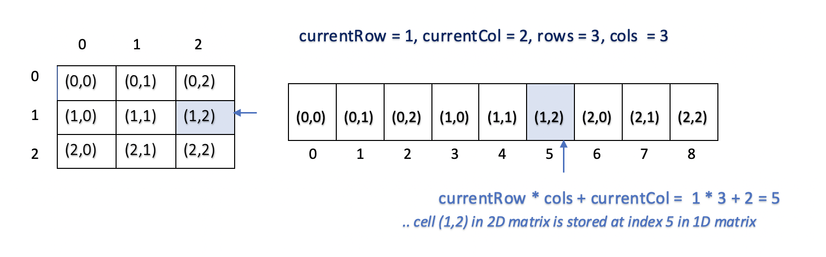

* We also build an edgeList which consists of the absolute difference between every adjacent cell in the matrix. We also sort the edge list in non-decreasing order of difference. The below example illustrates the edge list of given heights matrix [[1,2,2],[3,8,2],[5,3,5]] sorted by difference.

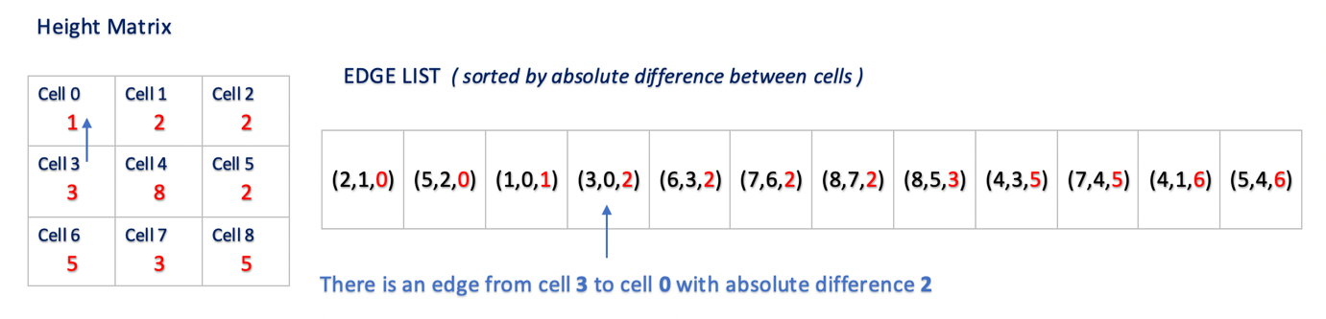

* Start iterating over the sorted edge list and connect each edge to form a connected component using Union Find Algorithm.
* After every union, check if the source cell (0) and destination cell (row * col - 1) are connected. If yes, the absolute difference between the current edge is our result. Since we access the edges in increasing order of difference, and the current edge connected the source and destination cell, we are sure that the current difference is the maximum absolute difference in our path with minimum efforts.

**Implementation**

|  |
| --- |
| class Solution {  public int minimumEffortPath(int[][] heights) {  int row = heights.length;  int col = heights[0].length;  if (row == 1 && col == 1) return 0;  UnionFind unionFind = new UnionFind(heights);  List<Edge> edgeList = unionFind.edgeList;  Collections.sort(edgeList, (e1, e2) -> e1.difference - e2.difference);  for (int i = 0; i < edgeList.size(); i++) {  int x = edgeList.get(i).x;  int y = edgeList.get(i).y;  unionFind.union(x, y);  if (unionFind.find(0) == unionFind.find(row * col - 1)) return edgeList.get(i).difference;  }  return -1;  }  }  class UnionFind {  int[] parent;  int[] rank;  List<Edge> edgeList;  public UnionFind(int[][] heights) {  int row = heights.length;  int col = heights[0].length;  parent = new int[row * col];  edgeList = new ArrayList<>();  rank = new int[row * col];  for (int currentRow = 0; currentRow < row; currentRow++) {  for (int currentCol = 0; currentCol < col; currentCol++) {  if (currentRow > 0) {  edgeList.add(new Edge(currentRow * col + currentCol,  (currentRow - 1) * col + currentCol,  Math.abs(heights[currentRow][currentCol] - heights[currentRow - 1][currentCol]))  );  }  if (currentCol > 0) {  edgeList.add(new Edge(currentRow * col + currentCol,  currentRow * col + currentCol - 1,  Math.abs(heights[currentRow][currentCol] - heights[currentRow][currentCol - 1]))  );  }  parent[currentRow * col + currentCol] = currentRow * col + currentCol;  }  }  }  int find(int x) {  if (parent[x] != x) parent[x] = find(parent[x]);  return parent[x];  }  void union(int x, int y) {  int parentX = find(x);  int parentY = find(y);  if (parentX != parentY) {  if (rank[parentX] > rank[parentY]) parent[parentY] = parentX;  else if (rank[parentX] < rank[parentY]) parent[parentX] = parentY;  else {  parent[parentY] = parentX;  rank[parentX] += 1;  }  }  }  }  class Edge {  int x;  int y;  int difference;  Edge(int x, int y, int difference) {  this.x = x;  this.y = y;  this.difference = difference;  }  } |

**Complexity Analysis**

Let m*m* be the number of rows and n*n* be the number of columns of the matrix \text{height}height.

* Time Complexity : \mathcal{O}(m\cdot n(\log(m\cdot n)))O(*m*⋅*n*(log(*m*⋅*n*))). We iterate each edge in the matrix. From the above example, it is evident that for a matrix of size 3 \cdot33⋅3, the total number of edges are 1212. Thus, for a m \cdot n*m*⋅*n* matrix, the total number of edges could be given by (m\cdot n \cdot 2)-(m+n)(*m*⋅*n*⋅2)−(*m*+*n*) (3*3*2) - (3+3)), which is roughly equivalent to m \cdot n*m*⋅*n*.

For every edge, we find the parent of each cell and perform the union (Union Find). For n*n* elements, the time complexity of Union Find is \log nlog*n*. (Refer [Proof Of Time Complexity Of Union Find](https://en.wikipedia.org/wiki/Proof_of_O(log*n)_time_complexity_of_union%E2%80%93find)). Thus for m \cdot n*m*⋅*n* cells, the time taken to perform Union Find would be \log m \cdot nlog*m*⋅*n*. This gives us total time complexity as, \mathcal{O}(m\cdot n(\log(m\cdot n)))O(*m*⋅*n*(log(*m*⋅*n*))).

* Space Complexity : \mathcal{O}(m \cdot n)O(*m*⋅*n*) , we use arrays edgeList, parent, and rank of size m \cdot n*m*⋅*n*.

#### Approach 4: Binary Search Using BFS

**Intuition**

Our aim to find the minimum effort required to travel from source cell to destination cell. We know from the given constraints that the maximum height could be 10^6 (1000000)106(1000000). So we know that our required absolute difference values would between 00 and 10^6106. We could use [Binary Search](https://leetcode.com/explore/learn/card/binary-search/) and reduce our search space by half.

Given the lower bound as 00 and upper bound as 10^6106, we could repeatedly calculate the middle value. Let this middle value be mid. We could divide our search space based on the following condition,

* If there exists a path from the source cell to the destination cell with the effort less than the value mid, we know that the required minimum effort value lies between lower bound 00 and mid.
* Similarly, if there doesn't exist any path from a source cell to destination cell with the effort less than the value mid, we know that the required minimum effort value lies between mid and upper bound 10^6106 .

To find if there exists a path from the source cell to the destination cell for a given mid value, we could use simple graph traversal. In this approach, we use [Breath First Search](https://leetcode.com/explore/learn/card/queue-stack/231/practical-application-queue/1376/) traversal.

**Algorithm**

* Intialize the lower bound left as 00 and upper bound right as 10^6106. Calculate the middle value mid of the left and right value.
* Using Breath First Search, check if there exists a path from source cell (x=0, y=0) to destination cell (x=row-1, y=column-1) with effort less than or equal to mid using method canReachDestination which returns a boolean value.
* If there exists a path from the source cell to the destination cell, we must update the result value as a minimum of the current result and mid and continue the search in the range between left and mid-1. For this, we must update the value of right to mid-1.

Otherwise, we must search in the range between mid+1 and right and update left to mid+1.

**Implementation**

|  |
| --- |
| class Solution {  public int minimumEffortPath(int[][] heights) {  int left = 0;  int right = 1000000;  int result = right;  while (left <= right) {  int mid = (left + right) / 2;  if (canReachDestinaton(heights, mid)) {  result = Math.min(result, mid);  right = mid - 1;  } else {  left = mid + 1;  }  }  return result;  }  int[][] directions = {{1, 0}, {-1, 0}, {0, 1}, {0, -1}};  // use bfs to check if we can reach destination with max absolute difference k  boolean canReachDestinaton(int[][] heights, int k) {  int row = heights.length;  int col = heights[0].length;  Deque<Cell> queue = new ArrayDeque<>();  boolean[][] visited = new boolean[heights.length][heights[0].length];  queue.addLast(new Cell(0, 0));  visited[0][0] = true;  while (!queue.isEmpty()) {  Cell curr = queue.removeFirst();  if(curr.x == row - 1 && curr.y == col - 1) {  return true;  }  for (int[] direction : directions) {  int adjacentX = curr.x + direction[0];  int adjacentY = curr.y + direction[1];  if (isValidCell(adjacentX, adjacentY, row, col) && !visited[adjacentX][adjacentY]) {  int currentDifference = Math.abs(heights[adjacentX][adjacentY] - heights[curr.x][curr.y]);  if (currentDifference <= k) {  visited[adjacentX][adjacentY] = true;  queue.addLast(new Cell(adjacentX, adjacentY));  }  }  }  }  return false;  }  boolean isValidCell(int x, int y, int row, int col) {  return x >= 0 && x <= row - 1 && y >= 0 && y <= col - 1;  }  }  class Cell {  int x;  int y;  Cell(int x, int y) {  this.x = x;  this.y = y;  }  } |

**Complexity Analysis**

Let m*m* be the number of rows and n*n* be the number of columns for the matrix \text{height}height.

* Time Complexity : \mathcal{O}(m \cdot n)O(*m*⋅*n*). We do a binary search to calculate the mid values and then do Breadth First Search on the matrix for each of those values.

Binary Search:To perform Binary search on numbers in range (0.. 10^{6})(0..106), the time taken would be \mathcal{O}(\log 10^{6})O(log106).

Breath First Search: The time complexity for the Breadth First Search for vertices V and edges E is \mathcal{O}(V+E)O(*V*+*E*) ([See our Explore Card on BFS](https://leetcode.com/explore/learn/card/queue-stack/231/practical-application-queue/1376/)) Thus, in the matrix of size m \cdot n*m*⋅*n*, with m \cdot n*m*⋅*n* vertices and m \cdot n*m*⋅*n* edges (Refer time complexity of Approach 3), the time complexity to perform Breath First Search would be \mathcal{O}(m \cdot n + m \cdot n)O(*m*⋅*n*+*m*⋅*n*) = \mathcal{O}(m \cdot n)O(*m*⋅*n*).

This gives us total time complexity as \mathcal{O}(\log10^{6}\cdot(m \cdot n))O(log106⋅(*m*⋅*n*)) which is equivalent to \mathcal{O}(m \cdot n)O(*m*⋅*n*).

* Space Complexity: \mathcal{O}(m \cdot n)O(*m*⋅*n*), as we use a queue and visited array of size m \cdot n*m*⋅*n*

#### Approach 5: Binary Search Using DFS

**Intuition and Algorithm**

The solution is similar to Approach 4. Except that, here, we use a Depth First Search traversal to find if there exists a path from the source cell to destination cell for a given value middle value mid.

**Implementation**

|  |
| --- |
| class Solution {  public int minimumEffortPath(int[][] heights) {  int left = 0;  int right = 1000000;  int result = right;  while (left <= right) {  int mid = (left + right) / 2;  if (dfsUtil(heights, mid)) {  result = Math.min(result, mid);  right = mid - 1;  } else {  left = mid + 1;  }  }  return result;  }  int[][] directions = {{1, 0}, {-1, 0}, {0, 1}, {0, -1}};  boolean dfsUtil(int[][] heights, int mid) {  int row = heights.length;  int col = heights[0].length;  boolean visited[][] = new boolean[row][col];  return canReachDestinaton(0, 0, heights, visited, row, col, mid);  }  boolean canReachDestinaton(int x, int y, int[][] heights,  boolean[][] visited, int row, int col, int mid) {  if (x == row - 1 && y == col - 1) {  return true;  }  visited[x][y] = true;  for (int[] direction : directions) {  int adjacentX = x + direction[0];  int adjacentY = y + direction[1];  if (isValidCell(adjacentX, adjacentY, row, col) && !visited[adjacentX][adjacentY]) {  int currentDifference = Math.abs(heights[adjacentX][adjacentY] - heights[x][y]);  if (currentDifference <= mid) {  if (canReachDestinaton(adjacentX, adjacentY, heights, visited, row, col, mid))  return true;  }  }  }  return false;  }  boolean isValidCell(int x, int y, int row, int col) {  return x >= 0 && x <= row - 1 && y >= 0 && y <= col - 1;  }  } |

**Complexity Analysis**

* Time Complexity : \mathcal{O}(m \cdot n)O(*m*⋅*n*). As in *Approach 4*. The only difference is that we are using Depth First Search instead of Breadth First Search and have similar time complexity.
* Space Complexity: \mathcal{O}(m \cdot n)O(*m*⋅*n*), As in *Approach 4*. In Depth First Search, we use the internal call stack (instead of the queue in Breadth First Search).

**Concatenation of Consecutive Binary Numbers**

Given an integer n, return *the****decimal value****of the binary string formed by concatenating the binary representations of*1*to*n*in order,****modulo***109+ 7.

**Example 1:**

**Input:** n = 1

**Output:** 1

**Explanation:** "1" in binary corresponds to the decimal value 1.

**Example 2:**

**Input:** n = 3

**Output:** 27

**Explanation:** In binary, 1, 2, and 3 corresponds to "1", "10", and "11".

After concatenating them, we have "11011", which corresponds to the decimal value 27.

**Example 3:**

**Input:** n = 12

**Output:** 505379714

**Explanation**: The concatenation results in "1101110010111011110001001101010111100".

The decimal value of that is 118505380540.

After modulo 109 + 7, the result is 505379714.

**Constraints:**

* 1 <= n <= 105

   Hide Hint #1

Express the nth number value in a recursion formula and think about how we can do a fast evaluation.

## Solution

#### Overview

The sequence described in the problem is [A047778](https://oeis.org/A047778), and you can check the first few terms [here](https://oeis.org/A047778/list). As we see, the number grows rapidly.

Below, we will discuss three approaches: Change to Binary String, Math, and Math (Bitwise Operation).

Generally, we recommend the third approach since it has fast performance and low space usage.

#### Approach 1: Change to Binary String

**Intuition**

The problem requires us to do three things:

1. Transform numbers from 11 to n*n* into binary.

This step is similar to [Convert a Number to Hexadecimal](https://leetcode.com/problems/convert-a-number-to-hexadecimal/). All we need to do is keep dividing by 22 and collecting the remainders. Also, many programming languages have built-in APIs.

1. Concatenate binarys.

It is simple since we always have a built-in API.

1. Transform the concatenation into decimal.

The third step is similar to [Convert Binary Number in a Linked List to Integer](https://leetcode.com/problems/convert-binary-number-in-a-linked-list-to-integer/). We need to iterate each element, and for each element, we multiply the current result by 22 and add the element to the result.

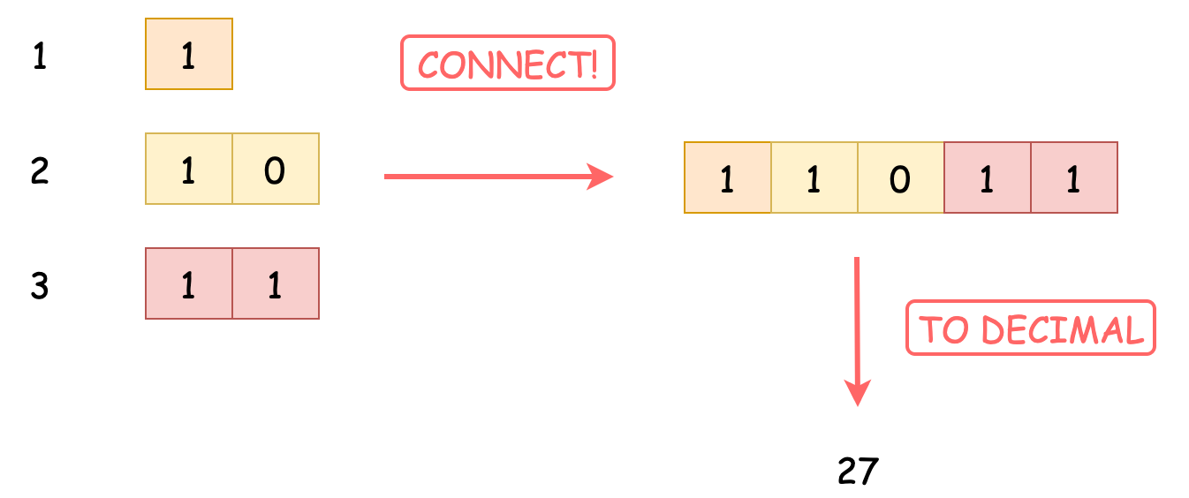

If you are unclear about the detail, please check the problem linked above.

However, if we directly combine those three steps, we probably meet Time Limit Exceed. This is because the second step, concatenation, takes a long time since it needs to generate a new string after each connection or to reallocate itself. Of course, in some programming languages such as Python, it is fast enough to pass, but for some others, optimizations are needed.

Luckily, if we dig into those three steps, we will find that the concatenation is **not** necessary. When we transform the binary into the decimal, we only need the **next** element when iterating. Therefore, we can transform the next number into binary when we need the next element.

For example, if n == 3, and we have calculated the binary form of 1 (binary: 1) and 2 (binary: 10), and the current result is 110 (binary) = 6 (decimal). Now we want to include 3. We can transform 3 into 11 (binary) and then add to the result. There is no need for concatenation.

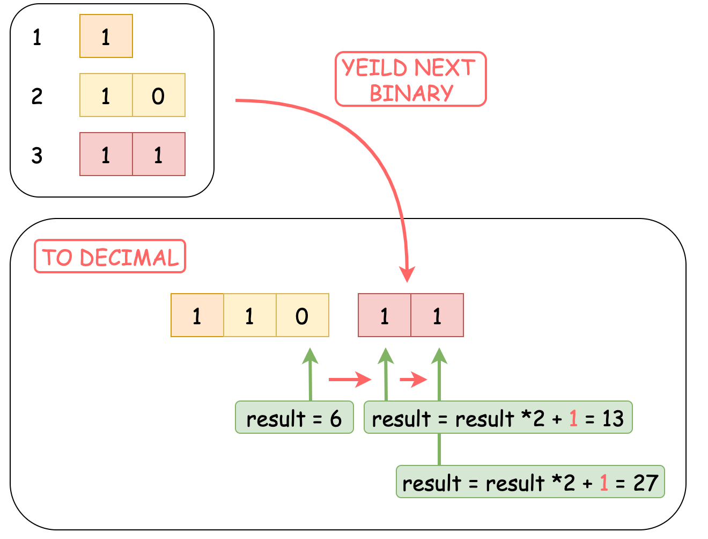

**Algorithm**

Step 1: Initialize an integer result to store the final result.

Step 2: Iterate from 1 to n. For each number:

* Convert the number into binary form.
* Iterate the binary string. For each element (0 or 1), update result to 2*result + element.

Step 3: Return result.

Challenge: Can you implement the code yourself without seeing our implementations?

**Implementation**

|  |
| --- |
| class Solution {  public int concatenatedBinary(int n) {  final int MOD = 1000000007;  int result = 0;  for (int i = 1; i <= n; i++) {  String binary = Integer.toBinaryString(i);  for (int j = 0; j < binary.length(); j++) {  result = (result * 2 + (binary.charAt(j) - '0')) % MOD;  }  }  return result;  }  } |

Note: Due to the convenient API and big integer characteristics in Python, we can directly **concatenate** strings together and make it into decimal at once. Though it requires extra space but is easier to implement.

**Complexity Analysis**

* Time Complexity: \mathcal{O}(n\log(n))O(*n*log(*n*)). We iterate n*n* numbers, and for each number we spend \mathcal{O}(\log(n))O(log(*n*)) to transform it into the binary form and add it to the final result.
* Space Complexity: Depends on the implementation. In Python, we firstly concatenate all string together, so the total space usage is \mathcal{O}(n\log(n))O(*n*log(*n*)). While in Java and C++, we add the string into the final result immediately without concatenating, so the space complexity is \mathcal{O}(n)O(*n*). Of course, you can implement the immediately adding version in Python, but that requires extra codes.

#### Approach 2: Math

**Intuition**

Recall the last example in Approach 1. Let's dig into what happens when we add 3 (binary: 11) to previous result 110 (binary, concatenated by 1 and 10) (decimal: 6).

What we do indeed is shift 110 (binary) two units left and then add 3.

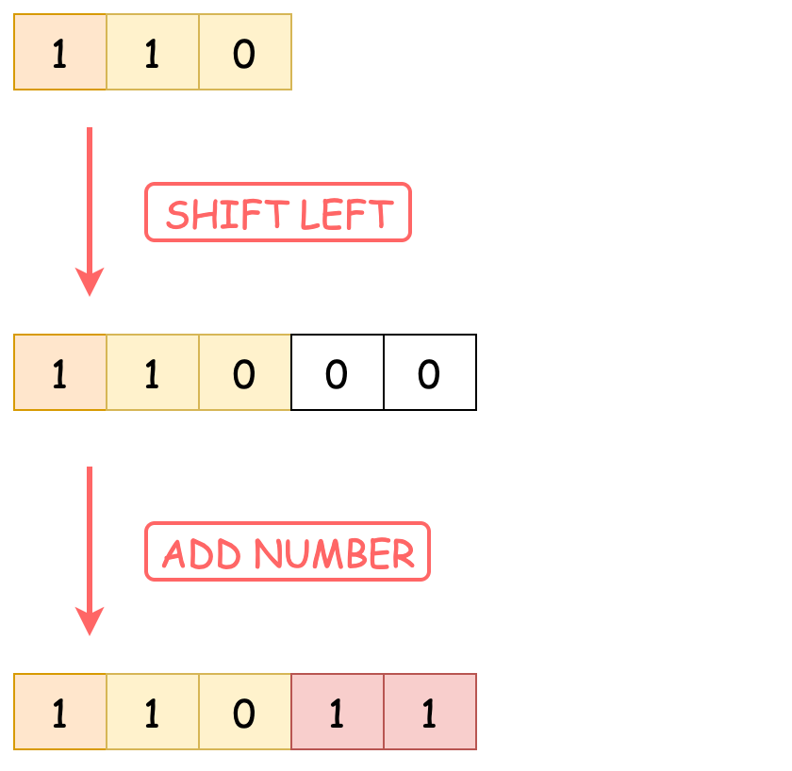

Moving "two" units left is because 11 (binary) has a length of 22.

To find out the length of the binary representation of a number, we can use \loglog with base 22. Alternatively, we can record the current length, and increase it when we meet a power of 22.

In conclusion, we can multiply the previous result by some power of 22 to shift it to the left, and add the number to get the next result.

This process does not involve anything related to the binary transformation!

**Algorithm**

*Step 1:* Initialize an integer result to store the final result.

*Step 2:* Iterate from 1 to n. For each number i:

* Find the length of the binary representation of the number. Denote by length.
* Update result to \text{result} \cdot 2^{\text{length}} + iresult⋅2length+*i*.

*Step 3:* Return result.

Challenge: Can you implement the code yourself without seeing our implementations?

**Implementation**

|  |
| --- |
| class Solution {  public int concatenatedBinary(int n) {  final int MOD = 1000000007;  int length = 0; // bit length of addends  long result = 0; // long accumulator  for (int i = 1; i <= n; i++) {  // when meets power of 2, increase the bit length  if (Math.pow(2, (int) (Math.log(i) / Math.log(2))) == i) {  length++;  }  result = ((result * (int) Math.pow(2, length)) + i) % MOD;  }  return (int) result;  }  } |

**Complexity Analysis**

* Time Complexity: \mathcal{O}(n\log(n))O(*n*log(*n*)). We iterate n*n* numbers, and for each number we spend \mathcal{O}(\log(n))O(log(*n*)) to check wether it is power of 22 and add to the final result.
* Space Complexity: \mathcal{O}(1)O(1), since we do not need any extra data structure.

#### Approach 3: Math (Bitwise Operation)

**Intuition**

In Approach 2, we still need to spend \mathcal{O}(\log(i))O(log(*i*)) to find the length of number i. Can we make it faster?

Of course!

With bitwise operation, we can check whether a number is the power of 22 in \mathcal{O}(1)O(1). If (x & (x-1)) == 0, then x is the power of 22.

For example, if x == 4, then x - 1 == 3. Their binary form is 100 (binary) and 011 (binary). All of their bits are different, so the bitwise "and" operation yields 0.

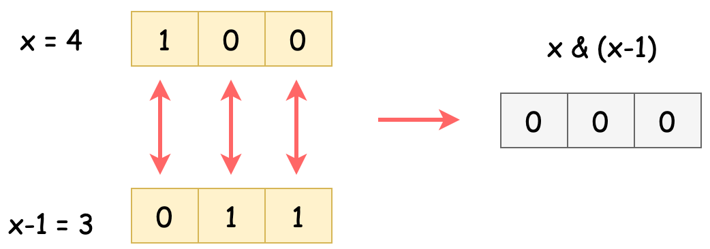

We only need to increase the length when we meet a power of 22.

Also, we can use bitwise operations to replace other executions.

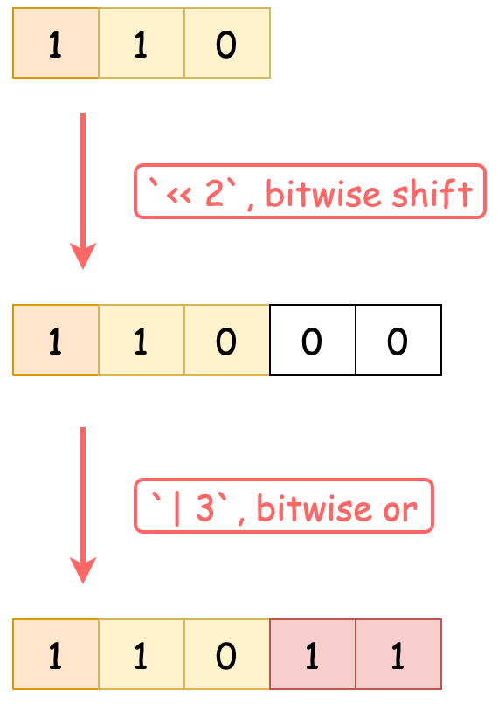

**Algorithm**

*Step 1:* Initialize an integer result to store the final result.

*Step 2:* Iterate from 1 to n. For each number i:

* Find the length of the binary representation of the number. Denote by length.
* Update result to result << length | i.

*Step 3:* Return result.

Challenge: Can you implement the code yourself without seeing our implementations?

**Implementation**

|  |
| --- |
| class Solution {  public int concatenatedBinary(int n) {  final int MOD = 1000000007;  int length = 0; // bit length of addends  long result = 0; // long accumulator  for (int i = 1; i <= n; i++) {  // when meets power of 2, increase the bit length  if ((i & (i - 1)) == 0) {  length++;  }  result = ((result << length) | i) % MOD;  }  return (int) result;  }  } |

* Time Complexity: \mathcal{O}(n)O(*n*). We iterate n*n* numbers, and for each number we spend \mathcal{O}(1)O(1) to add it to the final result.
* Space Complexity: \mathcal{O}(1)O(1), since we do not need any extra data structure.

**Smallest String With A Given Numeric Value**

The **numeric value** of a **lowercase character** is defined as its position (1-indexed) in the alphabet, so the numeric value of a is 1, the numeric value of b is 2, the numeric value of c is 3, and so on.

The **numeric value** of a **string** consisting of lowercase characters is defined as the sum of its characters' numeric values. For example, the numeric value of the string "abe" is equal to 1 + 2 + 5 = 8.

You are given two integers n and k. Return *the****lexicographically smallest string****with****length****equal to n and****numeric value****equal to k.*

Note that a string x is lexicographically smaller than string y if x comes before y in dictionary order, that is, either x is a prefix of y, or if i is the first position such that x[i] != y[i], then x[i] comes before y[i] in alphabetic order.

**Example 1:**

**Input:** n = 3, k = 27

**Output:** "aay"

**Explanation:** The numeric value of the string is 1 + 1 + 25 = 27, and it is the smallest string with such a value and length equal to 3.

**Example 2:**

**Input:** n = 5, k = 73

**Output:** "aaszz"

**Constraints:**

* 1 <= n <= 105
* n <= k <= 26 * n

   Hide Hint #1

Think greedily.

   Hide Hint #2

If you build the string from the end to the beginning, it will always be optimal to put the highest possible character at the current index.

## Solution

#### Overview

We have to build a string of length n*n* that consists of English lowercase characters a-z by ensuring that following conditions are satisfied,

* The numeric value of a string must be equal to a given value k*k*. The numeric value of a string is equal to the sum of numeric values of all its characters. The numeric value of alphabet characters ranges from 11 to 2626, where value of a = 1*a*=1, b=2*b*=2 and so on.
* The string must be lexicographically smallest string. In other words, we must build a string that would be the smallest in its dictionary order for a given numeric value.

The value of k*k* would be at least n*n*. If k = n*k*=*n*, the numeric value of every position would be 11 (a).

Example: if n = 3 and k = 3, result would be aaa.

The value of k*k* would be at most (n * 26)(*n*∗26). If k = (n*26)*k*=(*n*∗26), the numeric value of every position would be 2626 (z).

Example: if n = 3 and k = 78 (3 * 26) , result would be zzz.

Based on these insights, let's implement the solution using different approaches.

#### Approach 1: Build number from left to right

**Intuition**

Typically, we have to build a string by filling each position with a character that satisfies some conditions. To implement the solution for this problem we must answer the following question: How to choose a character to be put for a given position in the string.

To answer this question we must have information on 2 parameters,

1. The remaining value of k*k* at any given point.
2. The number of positions that are yet to be filled.

Let's assume, we are given n = 4*n*=4 and we have the first 22 positions in the result filled with a. Now we have to decide which character to put at 3^{rd}3*rd* position. Let's understand scenarios with different k*k* values.

Scenario 1: If the given k*k* value is 3232. After filling first 2 positions with a ( numeric value = 11), the remaining k*k* value would be 3030. Now we have to split 3030 into remaining 22 positions in such a way that resultant string is lexicographically smallest.

Lexicographically smallest string is always alphabetically sorted. But an alphabetically sorted string may not be always lexicographically sorted. Example, numeric value of dz*dz* (4 + 26 = 30) is same as the numeric value of ey*ey* (5 + 25 = 30). Both the strings are alphabetically sorted. But, the former is also lexicographically sorted while the latter is not.

Thus, we have to choose the character at 3^{rd}3*rd* position in such a way that the character at 4^{th}4*th* position would be as large as possible. We know that the largest possible character is z with a numeric value of 2626. As the remaining k*k* value is 3030, we can reserve 2626 for 4^{th}4*th* position and use the remaining for current position 33.

Hence, the numeric value chosen for 3^{rd}3*rd* position would be 44 (30 - 26) and the character with the numeric value 44 is d*d*. The resultant string would be aadz.

The following figure illustrates the idea.

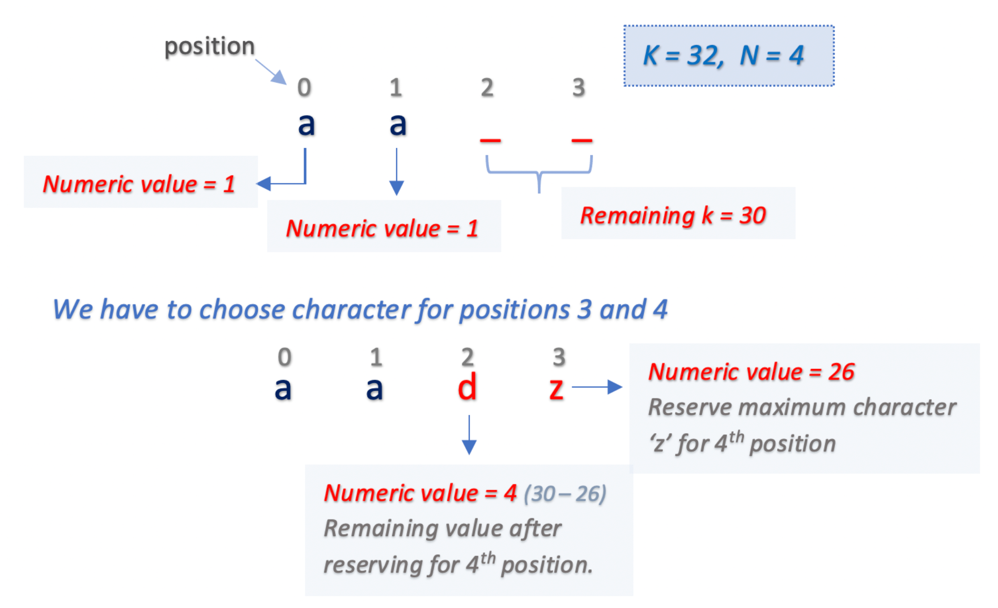

Scenario 2: If the given k*k* value is 2424. After filling first 2 positions with a (numeric value = 1), the remaining k*k* value would be 2222. Now, since the remaining k*k* value is less than 2626, we must assign 3^{rd}3*rd* position with smallest character i.e a having numeric value 11 and leave the rest for 4^{th}4*th* position. The resultant string would be aaau.

The following figure illustrates the idea.

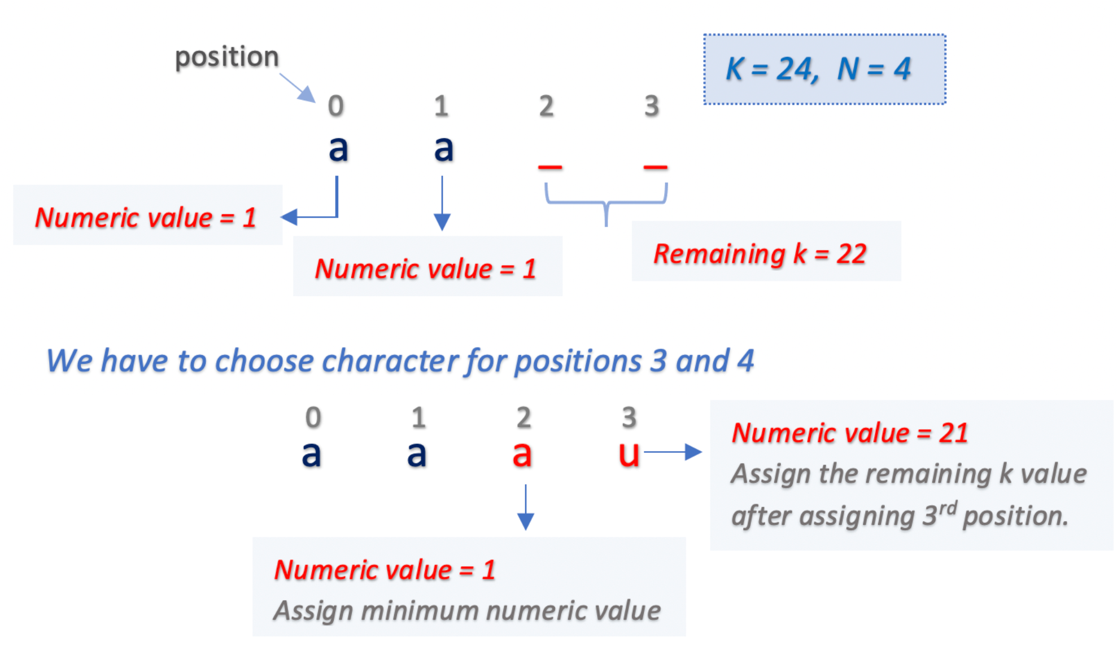

Based on the above examples, we could develop the following intuition to choose a character for a position.

Given a value k*k* and number of positions left to be filled as \text{positionsLeft}positionsLeft,

* If k*k* is greater than \text{positionsLeft} * 26positionsLeft∗26, we can reserve the maximum numeric value 2626 (character = z) for all the positions left. After that we could assign numeric value k - (\text{positionsLeft} * 26)*k*−(positionsLeft∗26) for the current position.
* Otherwise, we must assign the smallest character i.e a at the current position.

**Algorithm**

* Build a string or character array result to store the characters chosen for each position.
* Iterate from position 11 to n*n* and fill the character at each position. Find the positions left to be filled excluding the current position given by positionsLeft as n - position - 1.
  + If value of k*k* is greater than positionsLeft * 26, we could reserve numeric value 2626 (character = z) for all the remaining positions positionsLeft.

The numeric value for current position given by variable add would be k - (positionsLeft * 26). Subtract the calculated value add from k to find the remaining k value after filling the current position.

* + Otherwise, we must fill the the current position with the smallest character a having numeric value 11. Subtract 11 from k to find the remaining k value after filling the current position.
* The process would continue until all the positions are filled.

**Implementation**

|  |
| --- |
| class Solution {  public String getSmallestString(int n, int k) {  char[] result = new char[n];  for (int position = 0; position < n; position++) {  int positionsLeft = (n - position - 1);  if (k > positionsLeft * 26) {  int add = k - (positionsLeft * 26);  result[position] = (char) ('a' + add - 1);  k -= add;  } else {  result[position] = 'a';  k--;  }  }  return new String(result);  }  } |

**Complexity Analysis**

* Time Complexity: \mathcal{O}(n)O(*n*), as we iterate over n*n* positions to build the resultant string.
* Space Complexity: \mathcal{O}(1)O(1), as we use constant extra space to store add and position variables.

#### Approach 2: Build number from right

**Intuition**

There is another way of looking at the problem. We know that we must fill all the n*n* positions and the smallest character could be a with numeric value 11. If we have any k*k* left, we try to reserve as much as possible for the last positions.

Hence, we could first fill all the positions with a. Then iterate from backward: the last position to the first position. As we iterate from n^{th}*nth* position, we must try to allocate the maximum possible value to each position.

**Algorithm**

* Build a string or character array result to store the characters chosen for each position.
* Fill all the n positions in result with character a. Since character a has numeric value 11, subtract n from k. (since we have filled n positions with numeric value 11).
* Now, start iterating from the last position n-1 and allocate the maximum possible numeric value to each position based on the remaining k. As we have already allocated a at each position with a value 11, the maximum additional value that we can add at each position would be 2525 (26 - 1).
* Calculate the additional value to be added given by add as a minimum of 25 and k. Add the calculated value add at the current position and also subtract it from k.
* The process would continue until either all the positions are filled or there are no k values left (k = 0).

**Implementation**

|  |
| --- |
| class Solution {  public String getSmallestString(int n, int k) {  char[] result = new char[n];  Arrays.fill(result, 'a');  k -= n;  for (int position = n - 1; position >= 0 && k > 0; position--) {  int add = Math.min(k, 25);  result[position] = (char) (result[position] + add);  k -= add;  }  return new String(result);  }  } |

**Complexity Analysis**

* Time Complexity: \mathcal{O}(n)O(*n*), as we iterate over n*n* positions to build the resultant string. First, to initialize all the positions with character a and then to add the additional value.
* Space Complexity: \mathcal{O}(1)O(1), as we use constant extra space to store add and position variables.

#### Approach 3: Build number from right - Optimised solution

**Intuition**

In Approach 2, we first filled all the positions with the smallest character a, subtracted 11 numeric value for each position from k*k*, and later calculated the additional value. Instead of that, we could simply leave some value from k*k* for the remaining positions while iterating over each position from backward.

While allocating a numeric value at any position, we must just make sure that there would be sufficient k values left such that all the remaining positions would get at least the smallest numeric value i.e 1.

**Algorithm**

* Build a string or character array result to store the character chosen for each position.
* Start iterating from last position n-1 and allocate maximum possible numeric value to each position based on remaining k.
* We know that the largest character at any position could be z with numeric value 2626. Also, we must leave some value from k, that is, 1 numeric value for each remaining position (k - position). Thus the maximum numeric value for the current position given by add can be calculated as, minimum of k - position and 26.
* Subtract the value calculated for the current position add from k.
* The process would continue until all the positions are filled.

**Implementation**

|  |
| --- |
| class Solution {  public String getSmallestString(int n, int k) {  char[] result = new char[n];  for (int position = n - 1; position >= 0; position--) {  int add = Math.min(k - position, 26);  result[position] = (char) (add + 'a' - 1);  k -= add;  }  return new String(result);  }  } |

**Complexity Analysis**

* Time Complexity: \mathcal{O}(n)O(*n*), as we iterate over n*n* positions to build the resultant string.
* Space Complexity: \mathcal{O}(1)O(1), as we use constant extra space to store add and position variables.

**Number Of Corner Rectangles**

Given a grid where each entry is only 0 or 1, find the number of corner rectangles.

A *corner rectangle* is 4 distinct 1s on the grid that form an axis-aligned rectangle. Note that only the corners need to have the value 1. Also, all four 1s used must be distinct.

**Example 1:**

**Input:** grid =

[[1, 0, 0, 1, 0],

[0, 0, 1, 0, 1],

[0, 0, 0, 1, 0],

[1, 0, 1, 0, 1]]

**Output:** 1

**Explanation:** There is only one corner rectangle, with corners grid[1][2], grid[1][4], grid[3][2], grid[3][4].

**Example 2:**

**Input:** grid =

[[1, 1, 1],

[1, 1, 1],

[1, 1, 1]]

**Output:** 9

**Explanation:** There are four 2x2 rectangles, four 2x3 and 3x2 rectangles, and one 3x3 rectangle.

**Example 3:**

**Input:** grid =

[[1, 1, 1, 1]]

**Output:** 0

**Explanation:** Rectangles must have four distinct corners.

**Note:**

1. The number of rows and columns of grid will each be in the range [1, 200].
2. Each grid[i][j] will be either 0 or 1.
3. The number of 1s in the grid will be at most 6000.

   Hide Hint #1

For each pair of 1s in the new row (say at `new_row[i]` and `new_row[j]`), we could create more rectangles where that pair forms the base. The number of new rectangles is the number of times some previous row had `row[i] = row[j] = 1`.

#### Approach #1: Count Corners [Accepted]

**Intuition**

We ask the question: for each additional row, how many more rectangles are added?

For each pair of 1s in the new row (say at new_row[i] and new_row[j]), we could create more rectangles where that pair forms the base. The number of new rectangles is the number of times some previous row had row[i] = row[j] = 1.

**Algorithm**

Let's maintain a count count[i, j], the number of times we saw row[i] = row[j] = 1. When we process a new row, for every pair new_row[i] = new_row[j] = 1, we add count[i, j] to the answer, then we increment count[i, j].

|  |
| --- |
| class Solution {  public int countCornerRectangles(int[][] grid) {  Map<Integer, Integer> count = new HashMap();  int ans = 0;  for (int[] row: grid) {  for (int c1 = 0; c1 < row.length; ++c1) if (row[c1] == 1) {  for (int c2 = c1+1; c2 < row.length; ++c2) if (row[c2] == 1) {  int pos = c1 * 200 + c2;  int c = count.getOrDefault(pos, 0);  ans += c;  count.put(pos, c+1);  }  }  }  return ans;  }  } |

**Complexity Analysis**

* Time Complexity: O(R*C^2)*O*(*R*∗*C*2) where R, C*R*,*C* is the number of rows and columns.
* Space Complexity: O(C^2)*O*(*C*2) in additional space.

#### Approach #2: Heavy and Light Rows [Accepted]

**Intuition and Algorithm**

Can we improve on the ideas in Approach #1? When a row is filled with X*X* 1s, we do O(X^2)*O*(*X*2) work to enumerate every pair of 1s. This is okay when X*X* is small, but expensive when X*X* is big.

Say the entire top row is filled with 1s. When looking at the next row with say, f 1s that match the top row, the number of rectangles created is just the number of pairs of 1s, which is f * (f-1) / 2. We could find each f quickly using a Set and a simple linear scan of each row.

Let's call a row to be heavy if it has more than \sqrt N*N*​ points. The above algorithm changes the complexity of counting a heavy row from O(C^2)*O*(*C*2) to O(N)*O*(*N*), and there are at most \sqrt N*N*​ heavy rows.

|  |
| --- |
| class Solution {  public int countCornerRectangles(int[][] grid) {  List<List<Integer>> rows = new ArrayList();  int N = 0;  for (int r = 0; r < grid.length; ++r) {  rows.add(new ArrayList());  for (int c = 0; c < grid[r].length; ++c)  if (grid[r][c] == 1) {  rows.get(r).add(c);  N++;  }  }  int sqrtN = (int) Math.sqrt(N);  int ans = 0;  Map<Integer, Integer> count = new HashMap();  for (int r = 0; r < grid.length; ++r) {  if (rows.get(r).size() >= sqrtN) {  Set<Integer> target = new HashSet(rows.get(r));  for (int r2 = 0; r2 < grid.length; ++r2) {  if (r2 <= r && rows.get(r2).size() >= sqrtN)  continue;  int found = 0;  for (int c2: rows.get(r2))  if (target.contains(c2))  found++;  ans += found * (found - 1) / 2;  }  } else {  for (int i1 = 0; i1 < rows.get(r).size(); ++i1) {  int c1 = rows.get(r).get(i1);  for (int i2 = i1 + 1; i2 < rows.get(r).size(); ++i2) {  int c2 = rows.get(r).get(i2);  int ct = count.getOrDefault(200*c1 + c2, 0);  ans += ct;  count.put(200*c1 + c2, ct + 1);  }  }  }  }  return ans;  }  } |

* Time Complexity: O(N \sqrt N + R*C)*O*(*NN*​+*R*∗*C*) where N*N* is the number of ones in the grid.
* Space Complexity: O(N + R + C^2)*O*(*N*+*R*+*C*2) in additional space, for rows, target, and count.

**Vertical Order Traversal of a Binary Tree**

Given the root of a binary tree, calculate the **vertical order traversal** of the binary tree.

For each node at position (row, col), its left and right children will be at positions (row + 1, col - 1) and (row + 1, col + 1) respectively. The root of the tree is at (0, 0).

The **vertical order traversal** of a binary tree is a list of top-to-bottom orderings for each column index starting from the leftmost column and ending on the rightmost column. There may be multiple nodes in the same row and same column. In such a case, sort these nodes by their values.

Return *the****vertical order traversal****of the binary tree*.

**Example 1:**

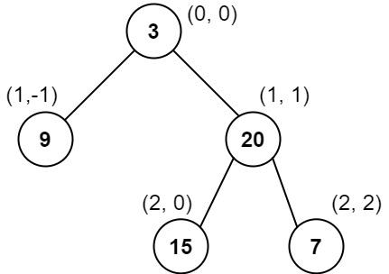

**Input:** root = [3,9,20,null,null,15,7]

**Output:** [[9],[3,15],[20],[7]]

**Explanation:**

Column -1: Only node 9 is in this column.

Column 0: Nodes 3 and 15 are in this column in that order from top to bottom.

Column 1: Only node 20 is in this column.

Column 2: Only node 7 is in this column.

**Example 2:**

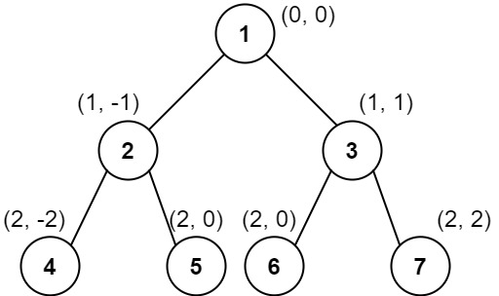

**Input:** root = [1,2,3,4,5,6,7]

**Output:** [[4],[2],[1,5,6],[3],[7]]

**Explanation:**

Column -2: Only node 4 is in this column.

Column -1: Only node 2 is in this column.

Column 0: Nodes 1, 5, and 6 are in this column.

1 is at the top, so it comes first.

5 and 6 are at the same position (2, 0), so we order them by their value, 5 before 6.

Column 1: Only node 3 is in this column.

Column 2: Only node 7 is in this column.

**Example 3:**

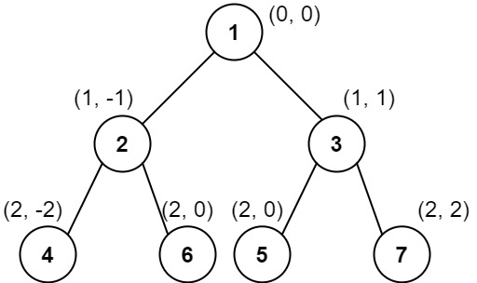

**Input:** root = [1,2,3,4,6,5,7]

**Output:** [[4],[2],[1,5,6],[3],[7]]

**Explanation:**

This case is the exact same as example 2, but with nodes 5 and 6 swapped.

Note that the solution remains the same since 5 and 6 are in the same location and should be ordered by their values.

**Constraints:**

* The number of nodes in the tree is in the range [1, 1000].
* 0 <= Node.val <= 1000

## Solution Article

#### Overview

This is yet another problem about Binary Tree traversals. As one would probably know, the common strategies to traverse a Tree data structure are **Breadth-First Search** (a.k.a. BFS) and **Depth-First Search** (a.k.a. DFS).

The DFS strategy can be further distinguished as preorder DFS, inorder DFS and postorder DFS, depending on the relative order of visit among the node itself and its child nodes.

If one is not familiar with the concepts of BFS and DFS, we have an Explore card called [Queue & Stack](https://leetcode.com/explore/learn/card/queue-stack/) where we cover the [BFS traversal](https://leetcode.com/explore/learn/card/queue-stack/231/practical-application-queue/) as well as the [DFS traversal](https://leetcode.com/explore/learn/card/queue-stack/232/practical-application-stack/). Hence, in this article, we won't repeat ourselves on these concepts.

In this problem, we are asked to return the **vertical** order of a binary tree, which implies three sub-orders (denoted as <column, row, value>) as follows:

* **column-wise order**

First, we look at a binary tree horizontally. Each node would be aligned to a specific column, based on its relative offset to the root node of the tree.

Let us assume that the root node has a column index of 0, then its left child node would have a column index of -1, and its right child node would have a column index of +1, and so on.

* **row-wise order**

Secondly, we look at the binary tree vertically. Each node would be assigned to a specific row, based on its level (i.e. the vertical distance to the root node).

Let us assume that the root node has a row index of 0, then both its child nodes would have the row index of 1. Note that the convention we adopt here is slightly different from the one in the problem description where the row index of a parent node is larger than the one of its child nodes. This, though, would not jeopardize our solution. On the contrary, it would help us to simplify the solution, as one will see later.

* **value-wise order**

Finally, given the definitions of the above two sub-orders, there could be a case where two different nodes have the same <column, row> index. As a result, to resolve the draw situation, as stated in the problem description, the node that has a smaller value should come first.

Given the above definitions, we can now formulate the problem as a task to **sort** the nodes based on the 3-dimensional coordinates (i.e. <column, row, value>) that we defined above.

The priority of each coordinate is determined by its order. For example, the coordinate column comes first, therefore it has the highest priority. A node with the lowest column index would come up first, regardless the other two coordinates.

Before proceeding to the solutions, we would like to mention that there is another almost identical problem called [314. Binary Tree Vertical Order Traversal](https://leetcode.com/problems/binary-tree-vertical-order-traversal/) in the LeetCode.

The only difference between these two problems lies in the third sub-order. When two nodes have the same <column, row> index, in this problem we would further order them based on their values, while in the problem of 314 we would order them based on the horizontal order from left to right. To illustrate the difference, we show an example in the following graph on how two nodes of the same <column, row> index should be ordered respectively in these two problems.

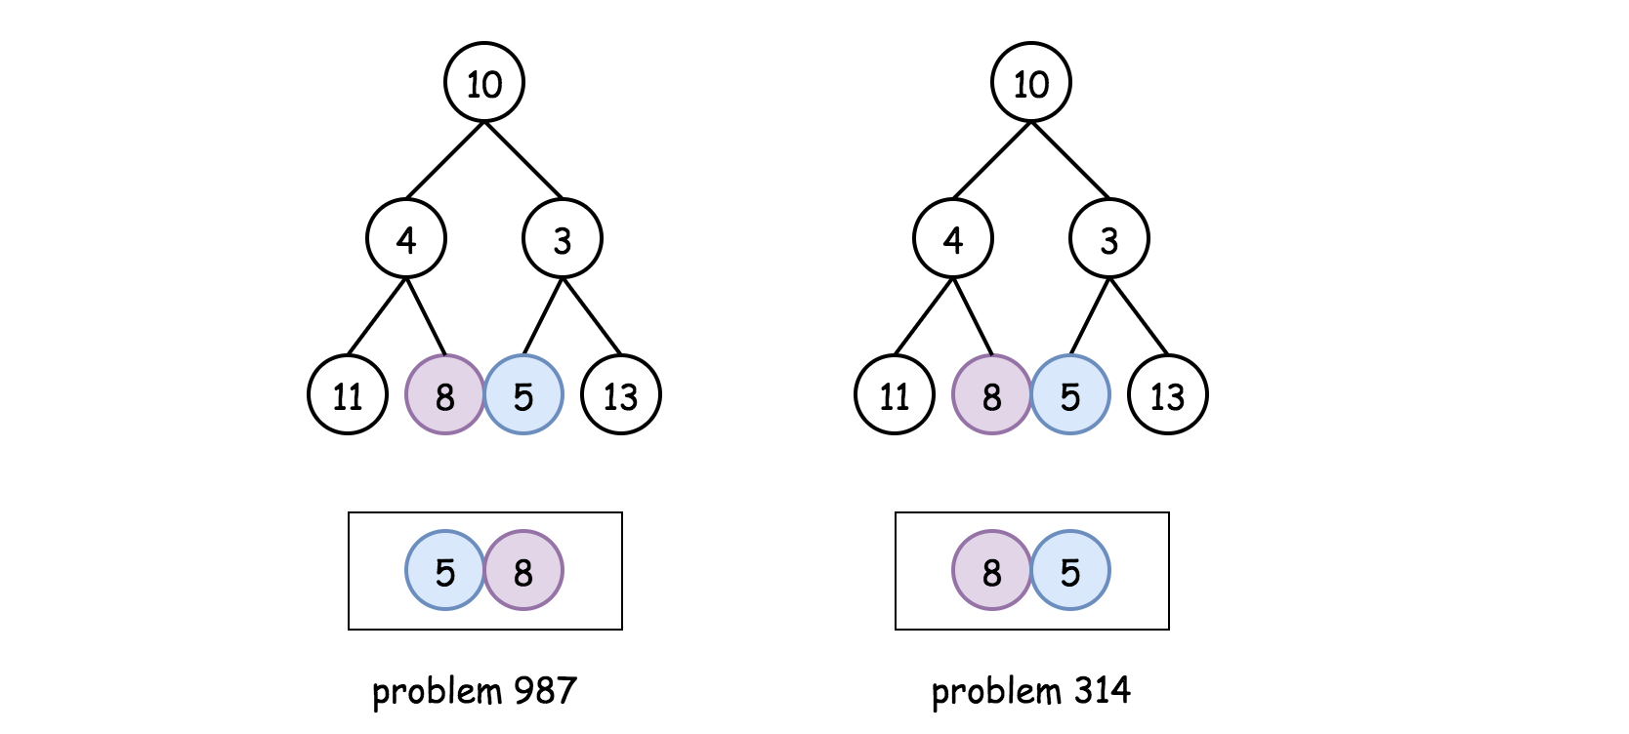

A subtle difference as it seems to be, yet it has a significant impact on the solutions. As a spoiler alert, one could solve the problem of 314 without resorting to the sorting operation, while for this problem the sorting is inevitable due to the third sub-order required in the problem.

#### Approach 1: BFS/DFS with Global Sorting

**Intuition**

In the overview section, we've reduced the problem into a sorting problem, based on the order of 3-dimensional coordinates <column, row, value> as we defined.

As a result, the idea to solve the problem would be as intuitive as **building** a list where each element in the list corresponds to the 3-dimensional coordinates of each node in the tree, and then **sorting** the list based on the coordinates.

To build such a list, we would need to traverse all the nodes in the tree, which we could do with either Breadth-First Search (**BFS**) or Depth-First Search (**DFS**). Most of the time, facing the problems of binary tree traversal, we need to make a choice between them. However, in this case, both of the approaches would work. Because both of them would lead to a list that contains the coordinates of all nodes. Though the order of elements in the list would differ depending on the approach, it does not matter, since we would sort the list anyway.

**Algorithm**

Based on the above intuition, we could implement the solution in 3 simple steps:

* **Step 1)**: we traverse the input tree either by BFS or DFS, in order to generate a list that contains the 3-dimensional coordinates (i.e. <column, row, value>) of each node.
  + Note that, we assign a higher row index value to a node's child node. This convention is at odds with the denotation given in the problem description. This is done intentionally, in order to keep the ordering of all coordinates consistent, i.e. a lower value in any specific coordinate represents a higher order. As a result, a sorting operation in ascending order would work for each coordinate consistently.
* **Step 2)**: Once we generate the desired list, we then sort the list.
* **Step 3)**: From the sorted list, we then extract the results, and group them by the column index.

In the following, we give some sample implementations with both the BFS traversal and the DFS traversal.

***BFS Traversal***

|  |
| --- |
| class Triplet<F, S, T> {  public final F first;  public final S second;  public final T third;  public Triplet(F first, S second, T third) {  this.first = first;  this.second = second;  this.third = third;  }  }  class Solution {  List<Triplet<Integer, Integer, Integer>> nodeList = new ArrayList<>();  private void BFS(TreeNode root) {  Queue<Triplet<TreeNode, Integer, Integer>> queue = new ArrayDeque();  int row = 0, column = 0;  queue.offer(new Triplet(root, row, column));  while (!queue.isEmpty()) {  Triplet<TreeNode, Integer, Integer> triplet = queue.poll();  root = triplet.first;  row = triplet.second;  column = triplet.third;  if (root != null) {  this.nodeList.add(new Triplet(column, row, root.val));  queue.offer(new Triplet(root.left, row + 1, column - 1));  queue.offer(new Triplet(root.right, row + 1, column + 1));  }  }  }  public List<List<Integer>> verticalTraversal(TreeNode root) {  List<List<Integer>> output = new ArrayList();  if (root == null) {  return output;  }  // step 1). BFS traversal  BFS(root);  // step 2). sort the global list by <column, row, value>  Collections.sort(this.nodeList, new Comparator<Triplet<Integer, Integer, Integer>>() {  @Override  public int compare(Triplet<Integer, Integer, Integer> t1,  Triplet<Integer, Integer, Integer> t2) {  if (t1.first.equals(t2.first))  if (t1.second.equals(t2.second))  return t1.third - t2.third;  else  return t1.second - t2.second;  else  return t1.first - t2.first;  }  });  // step 3). extract the values, partitioned by the column index.  List<Integer> currColumn = new ArrayList();  Integer currColumnIndex = this.nodeList.get(0).first;  for (Triplet<Integer, Integer, Integer> triplet : this.nodeList) {  Integer column = triplet.first, value = triplet.third;  if (column == currColumnIndex) {  currColumn.add(value);  } else {  output.add(currColumn);  currColumnIndex = column;  currColumn = new ArrayList();  currColumn.add(value);  }  }  output.add(currColumn);  return output;  }  } |

Note: when extracting the desired result from the sorted list, one would use the hashmap data structure, which could make the code more concise, as we did in the Python implementation.

Or, one could do so solely with the list data structure as we did in the Java implementation, which theoretically could be more efficient since we do not need to convert the results from hashmap to list.

***DFS Traversal***

|  |
| --- |
| class Triplet<F, S, T> {  public final F first;  public final S second;  public final T third;  public Triplet(F first, S second, T third) {  this.first = first;  this.second = second;  this.third = third;  }  }  class Solution {  List<Triplet<Integer, Integer, Integer>> nodeList = new ArrayList<>();  private void DFS(TreeNode node, Integer row, Integer column) {  if (node == null)  return;  nodeList.add(new Triplet(column, row, node.val));  // preorder DFS traversal  this.DFS(node.left, row + 1, column - 1);  this.DFS(node.right, row + 1, column + 1);  }  public List<List<Integer>> verticalTraversal(TreeNode root) {  List<List<Integer>> output = new ArrayList();  if (root == null) {  return output;  }  // step 1). DFS traversal  DFS(root, 0, 0);  // step 2). sort the list by <column, row, value>  Collections.sort(this.nodeList, new Comparator<Triplet<Integer, Integer, Integer>>() {  @Override  public int compare(Triplet<Integer, Integer, Integer> t1,  Triplet<Integer, Integer, Integer> t2) {  if (t1.first.equals(t2.first))  if (t1.second.equals(t2.second))  return t1.third - t2.third;  else  return t1.second - t2.second;  else  return t1.first - t2.first;  }  });  // step 3). extract the values, grouped by the column index.  List<Integer> currColumn = new ArrayList();  Integer currColumnIndex = this.nodeList.get(0).first;  for (Triplet<Integer, Integer, Integer> triplet : this.nodeList) {  Integer column = triplet.first, value = triplet.third;  if (column == currColumnIndex) {  currColumn.add(value);  } else {  output.add(currColumn);  currColumnIndex = column;  currColumn = new ArrayList();  currColumn.add(value);  }  }  output.add(currColumn);  return output;  }  } |

**Complexity Analysis**

Let N*N* be the number of nodes in the input tree.

* Time Complexity: \mathcal{O}(N \log N)O(*N*log*N*), which applies to both the BFS and DFS approaches.
  + In the first step of the algorithm, we traverse the input tree with either BFS or DFS, which would take \mathcal{O}(N)O(*N*) time.
  + Secondly, we sort the obtained list of coordinates which contains N*N* elements. The sorting operation would take \mathcal{O}(N \log N)O(*N*log*N*) time.
  + Finally, we extract the results from the sorted list, which would take another \mathcal{O}(N)O(*N*) time.
  + To summarize, the overall time complexity of the algorithm would be \mathcal{O}(N \log N)O(*N*log*N*), which is dominated by the sorting operation in the second step.
* Space Complexity: \mathcal{O}(N)O(*N*). Again this applies to both the BFS and DFS approaches.
  + In the first step of the algorithm, we build a list that contains the coordinates of all the nodes. Hence, we need \mathcal{O}(N)O(*N*) space for this list.
  + Additionally, for the BFS approach, we used a queue data structure to maintain the order of visits. At any given moment, the queue contains no more than **two levels** of nodes in the tree. The maximal number of nodes at one level is \frac{N}{2}2*N*​, which is the number of the leaf nodes in a balanced binary tree. As a result, the space needed for the queue would be \mathcal{O}(\frac{N}{2} \cdot 2) = \mathcal{O}(N)O(2*N*​⋅2)=O(*N*).
  + Although we don't need the queue data structure for the DFS approach, the recursion in the DFS approach incurs some additional memory consumption on the function call stack. In the worst case, the input tree might be completely imbalanced, e.g. each node has only the left child node. In this case, the recursion would occur up to N*N* times, which in turn would consume \mathcal{O}(N)O(*N*) space in the function call stack.
  + To summarize, the space complexity for the BFS approach would be \mathcal{O}(N) + \mathcal{O}(N) = \mathcal{O}(N)O(*N*)+O(*N*)=O(*N*). And the same applies to the DFS approach.

#### Approach 2: BFS/DFS with Partition Sorting

**Intuition**

As we can see in the above approaches, the overall time complexity is dominated by the sorting operation on the list of coordinates. In order to further optimize the solution, we can try to do something with the sorting.

It would be hard, if not impossible, to eliminate the sorting operation, since we still need a means to resolve the draw situation when two nodes share the same <column, row> index.

One might argue that we could use the **heap** data structure (also known as PriorityQueue in Java) to maintain the list of coordinates. The elements in the heap data structure are ordered automatically, and this does eliminate the sorting operation. However, to maintain the elements in order, each insertion operation in heap would take \mathcal{O}(\log N)O(log*N*) time complexity. In other words, one can consider the heap data structure as another form of sorting, which amortizes the cost of sorting operating over each insertion.

One could apply the head data structure to replace the sorting operation here, which could make the code more concise. But this is not the main point here.

That being said, one thing that we can do is to reduce the scope of sorting, by **partitioning** the list of coordinates into subgroups based on the column index.

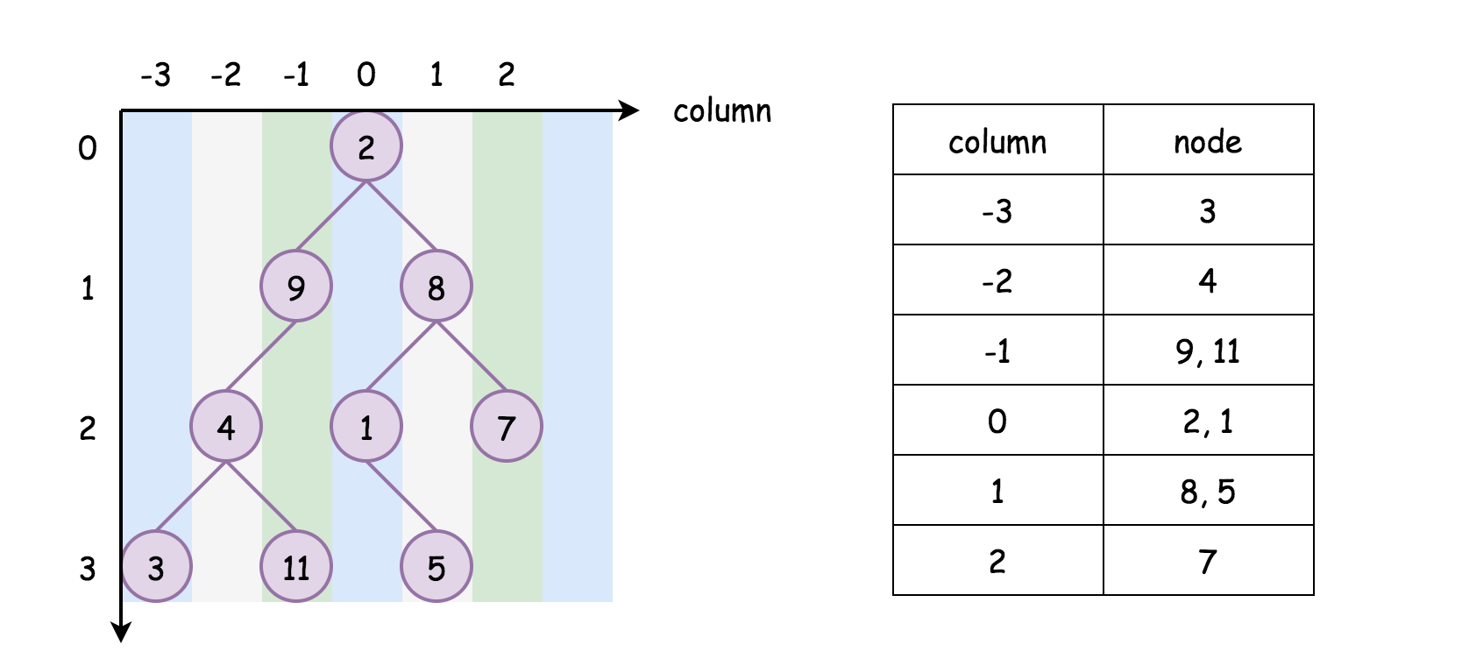

Although we would still need to sort the subgroups respectively, it would be **faster** to sort a series of subgroups than sorting them all together in a single group. Here is a not-so-rigid proof.

Suppose that we have a list of N*N* elements, it would then take \mathcal{O}(N \log N)O(*N*log*N*) time to sort this list.

Next, we divide the list into k*k* sublists equally. Each list would contain \frac{N}{k}*kN*​ elements. Similarly, it would take \mathcal{O}(\frac{N}{k} \log \frac{N}{k})O(*kN*​log*kN*​) time to sort each sublist.

In total, to sort all the k*k* sublists, it would take \mathcal{O}(k \cdot \frac{N}{k} \log \frac{N}{k}) = \mathcal{O}(N \log \frac{N}{k})O(*k*⋅*kN*​log*kN*​)=O(*N*log*kN*​), which is **less than** the time complexity of sorting the original list (i.e. \mathcal{O}(N \log N)O(*N*log*N*)).

More importantly, another rationale to partition the list into column based groups is that this is also the format of results that are asked in the problem.

Once we sort the column based groups, we can directly return the groups as results, without the need for extraction as we did in the previous approach.

This is also the reason why we would not recommend to further partition the list based on the combination of <column, row> index. Although theoretically, the more groups that we partition the list into, the faster the sorting operations would be.

If we partition the list into the groups lead by <column row> index, we would need some additional processing to extract the results. Hence, it would become an overkill.

**Algorithm**

We could implement the above intuition based on the previous approaches. Again, we could break it down into 3 steps:

* **Step 1)**: First of all, we create a hashmap called columnTable with the column index as key and the list of <row, value> tuples as value. This hashmap is used to hold the groups of coordinates.
  + We traverse the input tree by either BFS or DFS. During the traversal, we populate the hashmap that we created above.
  + Meanwhile, we also note down the minimal and maximal column index during the traversal. The minimal and maximal column index defines the range of column index. With this range, we could iterate through columns in order without the need for sorting, as one will see later.
* **Step 2)**: Once we populate the above hashmap, we then sort the value in each entry of the hashmap, i.e. we sort each group of coordinates led by the column index.
* **Step 3)**: From the sorted hashmap, we extract the results that are grouped by the column index.

In the following, we give some sample implementations with both the BFS traversal and the DFS traversal.

***BFS Traversal***

|  |
| --- |
| class Solution {  // key: column; value: <row, node_value>  Map<Integer, ArrayList<Pair<Integer, Integer>>> columnTable = new HashMap();  int minColumn = 0, maxColumn = 0;  private void BFS(TreeNode root) {  // tuples of <column, <row, value>>  Queue<Pair<TreeNode, Pair<Integer, Integer>>> queue = new ArrayDeque();  int row = 0, column = 0;  queue.offer(new Pair(root, new Pair(row, column)));  while (!queue.isEmpty()) {  Pair<TreeNode, Pair<Integer, Integer>> p = queue.poll();  root = p.getKey();  row = p.getValue().getKey();  column = p.getValue().getValue();  if (root != null) {  if (!columnTable.containsKey(column)) {  columnTable.put(column, new ArrayList<Pair<Integer, Integer>>());  }  columnTable.get(column).add(new Pair<>(row, root.val));  minColumn = Math.min(minColumn, column);  maxColumn = Math.max(maxColumn, column);  queue.offer(new Pair(root.left, new Pair(row + 1, column - 1)));  queue.offer(new Pair(root.right, new Pair(row + 1, column + 1)));  }  }  }  public List<List<Integer>> verticalTraversal(TreeNode root) {  List<List<Integer>> output = new ArrayList();  if (root == null) {  return output;  }  // step 1). BFS traversal  this.BFS(root);  // step 2). retrieve the value from the columnTable  for (int i = minColumn; i < maxColumn + 1; ++i) {  // order by both "row" and "value"  Collections.sort(columnTable.get(i), new Comparator<Pair<Integer, Integer>>() {  @Override  public int compare(Pair<Integer, Integer> p1, Pair<Integer, Integer> p2) {  if (p1.getKey().equals(p2.getKey()))  return p1.getValue() - p2.getValue();  else  return p1.getKey() - p2.getKey();  }  });  List<Integer> sortedColumn = new ArrayList();  for (Pair<Integer, Integer> p : columnTable.get(i)) {  sortedColumn.add(p.getValue());  }  output.add(sortedColumn);  }  return output;  }  } |

***DFS traversal***

|  |
| --- |
| class Solution {  Map<Integer, ArrayList<Pair<Integer, Integer>>> columnTable = new HashMap();  int minColumn = 0, maxColumn = 0;  private void DFS(TreeNode node, Integer row, Integer column) {  if (node == null)  return;  if (!columnTable.containsKey(column)) {  this.columnTable.put(column, new ArrayList<Pair<Integer, Integer>>());  }  this.columnTable.get(column).add(new Pair<Integer, Integer>(row, node.val));  this.minColumn = Math.min(minColumn, column);  this.maxColumn = Math.max(maxColumn, column);  // preorder DFS traversal  this.DFS(node.left, row + 1, column - 1);  this.DFS(node.right, row + 1, column + 1);  }  public List<List<Integer>> verticalTraversal(TreeNode root) {  List<List<Integer>> output = new ArrayList();  if (root == null) {  return output;  }  // step 1). DFS traversal  this.DFS(root, 0, 0);  // step 2). retrieve the value from the columnTable  for (int i = minColumn; i < maxColumn + 1; ++i) {  // order by both "row" and "value"  Collections.sort(columnTable.get(i), new Comparator<Pair<Integer, Integer>>() {  @Override  public int compare(Pair<Integer, Integer> p1, Pair<Integer, Integer> p2) {  if (p1.getKey().equals(p2.getKey()))  return p1.getValue() - p2.getValue();  else  return p1.getKey() - p2.getKey();  }  });  List<Integer> sortedColumn = new ArrayList();  for (Pair<Integer, Integer> p : columnTable.get(i)) {  sortedColumn.add(p.getValue());  }  output.add(sortedColumn);  }  return output;  }  } |

**Complexity Analysis**

Let N*N* be the number of nodes in the tree.

* Time Complexity: \mathcal{O}(N \log{\frac{N}{k}})O(*N*log*kN*​) where k*k* is the width of the tree, *i.e.* k*k* is also the number of columns in the result.
  + In the first step, it takes \mathcal{O}(N)O(*N*) time complexity for both the BFS and DFS traversal.
  + In the second step, we need to sort the hashmap entry by entry. As we shown in the intuition section, the time complexity of sorting k*k* equal-sized subgroups of with total N*N* elements would be \mathcal{O}(k \cdot \frac{N}{k} \log{\frac{N}{k}}) = \mathcal{O}(N \log{\frac{N}{k}})O(*k*⋅*kN*​log*kN*​)=O(*N*log*kN*​). If we assume that the nodes are evenly aligned in the columns, then this would be the time complexity of sorting the obtained hashmap.
  + Finally, it takes another \mathcal{O}(N)O(*N*) time complexity to extract the results from the hashmap.
  + As a result, the overall time complexity is \mathcal{O}(N \log{\frac{N}{k}})O(*N*log*kN*​).
  + Although the sorting operation in the second step still dominates, it is more optimized compared to the previous approach of sorting the entire coordinates. Let us look at one particular example. In the case where the tree is complete imbalanced (*e.g.* a node has only left node), the tree would be partitioned into exactly N*N* groups. Each group contains a single element. It would take no time to sort each group. As a result, the overall time complexity of this approach becomes N \cdot \mathcal{O}(1) = \mathcal{O}(N)*N*⋅O(1)=O(*N*). While for the previous approach, its overall time complexity remains \mathcal{O}(N \log N)O(*N*log*N*).
* Space Complexity: \mathcal{O}(N)O(*N*). Again this applies to both the BFS and DFS approaches. The analysis is the same as the previous approach.

**Minimize Deviation in Array**

You are given an array nums of n positive integers.

You can perform two types of operations on any element of the array any number of times:

* If the element is **even**, **divide** it by 2.
  + For example, if the array is [1,2,3,4], then you can do this operation on the last element, and the array will be [1,2,3,2].
* If the element is **odd**, **multiply** it by 2.
  + For example, if the array is [1,2,3,4], then you can do this operation on the first element, and the array will be [2,2,3,4].

The **deviation** of the array is the **maximum difference** between any two elements in the array.

Return *the****minimum deviation****the array can have after performing some number of operations.*

**Example 1:**

**Input:** nums = [1,2,3,4]

**Output:** 1

**Explanation:** You can transform the array to [1,2,3,2], then to [2,2,3,2], then the deviation will be 3 - 2 = 1.

**Example 2:**

**Input:** nums = [4,1,5,20,3]

**Output:** 3

**Explanation:** You can transform the array after two operations to [4,2,5,5,3], then the deviation will be 5 - 2 = 3.

**Example 3:**

**Input:** nums = [2,10,8]

**Output:** 3

**Constraints:**

* n == nums.length
* 2 <= n <= 105
* 1 <= nums[i] <= 109

   Hide Hint #1

Assume you start with the minimum possible value for each number so you can only multiply a number by 2 till it reaches its maximum possible value.

   Hide Hint #2

If there is a better solution than the current one, then it must have either its maximum value less than the current maximum value, or the minimum value larger than the current minimum value.

   Hide Hint #3

Since that we only increase numbers (multiply them by 2), we cannot decrease the current maximum value, so we must multiply the current minimum number by 2.

## Solution

#### Overview

The problem can be solved in many ways. With heap, we can directly solve it by simulation (and a little greedy idea). Also, with some pretreatments, we can transform it into [Smallest Range Covering Elements from K Lists](https://leetcode.com/problems/smallest-range-covering-elements-from-k-lists/).

Below, we will discuss five approaches: Simulation + Heap, Pretreatment + Sorting + Sliding Window, Pretreatment + Heap + Sliding Window, Pretreatment + Heap + Pointers, and Pretreatment + Sorting + Pointers.

Generally, we recommend the first approach since it is easy to implement and has good performance. We provide other approaches to explore possibilities and leave them for interested readers. In fact, there are many different approaches to tackle this problem, and the given five approaches are not enough to cover them all.

#### Approach 1: Simulation + Heap

**Intuition**

The problem gives two operations:

1. If the element is even, we can divide it by 2.
2. If the element is odd, we can multiply it by 2.

Consequently, we have two insights:

1. If the element is even, we can **not** increase it.
2. If the element is odd, we can **not** decrease it.

We can try to increase all numbers to their maximum and reduce them step by step.

According to the problem description:

\text{deviation} = \text{maximum} - \text{minimum}deviation=maximum−minimum

Hence, there are only two ways to decrease \text{deviation}deviation: decrease \text{maximum}maximum, or increase \text{minimum}minimum.

If we have increased all numbers to their maximum, then we can **not** increase \text{minimum}minimum. If we want smaller \text{deviation}deviation, we can only decrease \text{maximum}maximum.

If the maximum is odd, then we can not decrease \text{maximum}maximum neither. In this case, we just return the recorded minimum deviation, since we can not decrease it anymore.

However, there is a remaining problem: we need to find the maximum and minimum after each modification. We do not want to iterate the whole list, since it is slow. Luckily, there is a data structure called [heap](https://en.wikipedia.org/wiki/Heap_(data_structure)) that maintains the maximum value in **logarithmic** time and returns the maximum value in **constant** time.

For the minimum, we just need to update it for each decrease of maximum.

It's also OK to decrease all numbers to their **minimum** and then increase them step by step. Again, there are many possibilities.

**Algorithm**

Step 1: Initialize a max-heap evens.

* For an even number in nums, put it directly into evens; for the odd number in nums, multiply by 2 and put it into evens.

Step 2: Maintain an integer minimum to keep tracking the smallest element in evens.

Step 3: Take out the maximum number in evens. Use the maximum and the maintained minimum to update the minimum deviation. If the maximum number is even, divide by 2 and push into evens.

Step 4: Repeat Step 3 until the maximum number in evens is odd.

Step 5: Return the minimum deviation.

Challenge: Can you implement the code yourself without seeing our implementations?

**Implementation**

|  |
| --- |
| class Solution {  public int minimumDeviation(int[] nums) {  PriorityQueue<Integer> evens = new PriorityQueue<>(Collections.reverseOrder());  int minimum = Integer.MAX_VALUE;  for (int num : nums) {  if (num % 2 == 0) {  evens.offer(num);  minimum = Math.min(minimum, num);  } else {  evens.offer(num * 2);  minimum = Math.min(minimum, num * 2);  }  }  int minDeviation = Integer.MAX_VALUE;  while (!evens.isEmpty()) {  int currentValue = evens.poll();  minDeviation = Math.min(minDeviation, currentValue - minimum);  if (currentValue % 2 == 0) {  evens.offer(currentValue / 2);  minimum = Math.min(minimum, currentValue / 2);  } else {  // if the maximum is odd, break and return  break;  }  }  return minDeviation;  }  } |

Note: in the C++ and Java code, we push num into evens one by one. You can push them into a list and then change the list into a heap. That would yield faster performance but requires more codes. Our implementation is enough to pass the test.

**Complexity Analysis**

Let N*N* be the length of nums, and M*M* be the largest number in nums. In the worst case when M*M* is the power of 22, there are \log(M)log(*M*) possible values for M*M*. Therefore, in the worst case, the total possible candidate number (denoted by K*K*) is K = N \cdot \log(M) = N\log(M)*K*=*N*⋅log(*M*)=*N*log(*M*).

* Time Complexity: \mathcal{O}(K\log(N)) = \mathcal{O}(N\log(M)\log(N))O(*K*log(*N*))=O(*N*log(*M*)log(*N*)). In worst case, we need to push every candidate number into evens, and the size of evens is \mathcal{O}(N)O(*N*). Hence, the total time complexity is \mathcal{O}(K \cdot \log(N)) = \mathcal{O}(N\log(M)\log(N))O(*K*⋅log(*N*))=O(*N*log(*M*)log(*N*)).
* Space Complexity: \mathcal{O}(N)O(*N*), since there are at most N*N* elements in evens.

#### Approach 2: Pretreatment + Sorting + Sliding Window

**Intuition**

In Approach 1, we maintain a list and keep changing the elements of the list. Can we pre-calculate all the changeable candidates?

Yes, with a little pretreatment. For each even number, we divide it by 22 until it becomes an odd number; for each odd number, we add itself and the twice of itself.

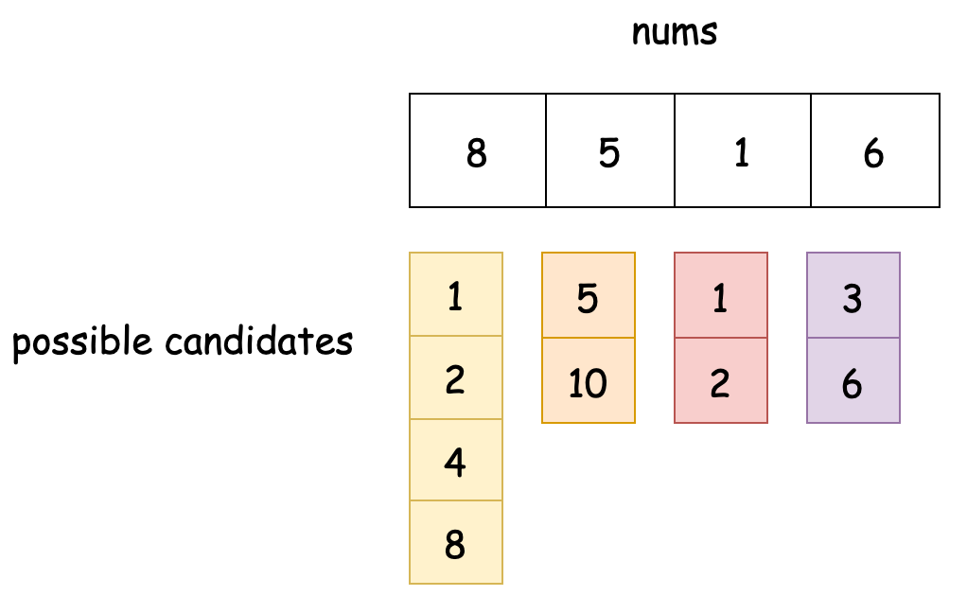

In this case, we transform it into a similar problem: select one number from each candidate list such that the deviation is minimum.

That is exactly [Smallest Range Covering Elements from K Lists](https://leetcode.com/problems/smallest-range-covering-elements-from-k-lists/). We highly recommend finishing it before continuing reading if you have not solved it.

From Approach 2 to Approach 5, we will apply this pretreatment and use different methods to handle the following.

In this approach, we put all candidates into a single list and then sort the list. Suddenly, it becomes a sliding window problem.

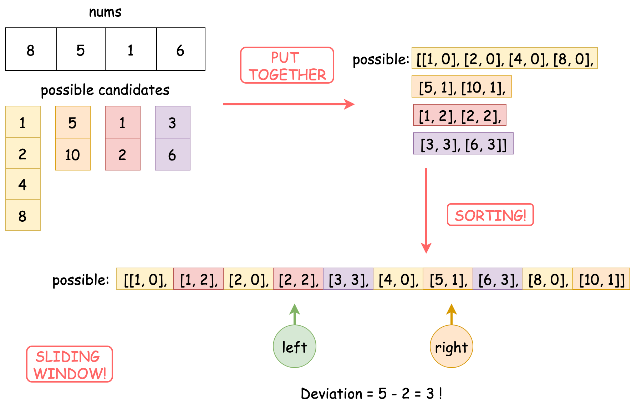

All we need to do is find out the minimum interval such that the interval contains all index's candidates (i.e., contains all colors in the Figure above).

Of course, the length of the interval should be calculated by the difference between the ending value and the starting value.

Also, we can sort the list from large to small alternatively. That is similar.

**Algorithm**

Step 1: Initialize a list possible.

* Iterate nums. For each nums[i], push all possible [candidate, i] pairs into the possible list.

Step 2: Sort possible.

Step 3: Initialize a vector needInclude, where needInclude[i] marks if the sliding window includes i's candidates or not (and how many it includes). Initialize an integer notIncluded representing the total number of index whose all candidates are not in the sliding window.

Step 4: Move the right pointer of the sliding window to one unit right.

* If notIncluded shows that the sliding window includes every index's candidates (i.e., notIncluded == 0), move the left pointer to right until the sliding window does not include them. Update the minimum deviation during this period.

Step 5: Repeat Step 4 until the right pointer reaches the end of possible.

Step 6: Return the minimum deviation.

Challenge: Can you implement the code yourself without seeing our implementations?

**Implementation**

|  |
| --- |
| class Solution {  public int minimumDeviation(int[] nums) {  int n = nums.length;  List<int[]> possible = new ArrayList<>();  // pretreatment  for (int i = 0; i < n; i++) {  if (nums[i] % 2 == 0) {  int temp = nums[i];  possible.add(new int[] { temp, i });  while (temp % 2 == 0) {  temp /= 2;  possible.add(new int[] { temp, i });  }  } else {  possible.add(new int[] { nums[i], i });  possible.add(new int[] { nums[i] * 2, i });  }  }  possible.sort(Comparator.comparingInt(p -> p[0]));  // start sliding window  int minDeviation = Integer.MAX_VALUE;  int notIncluded = n;  int currentStart = 0;  int[] needInclude = new int[n];  for (int i = 0; i < n; i++) {  needInclude[i] = 1;  }  for (int[] current : possible) {  int currentValue = current[0];  int currentItem = current[1];  needInclude[currentItem] -= 1;  if (needInclude[currentItem] == 0) {  notIncluded -= 1;  }  if (notIncluded == 0) {  while (needInclude[possible.get(currentStart)[1]] < 0) {  needInclude[possible.get(currentStart)[1]] += 1;  currentStart += 1;  }  if (minDeviation > currentValue - possible.get(currentStart)[0]) {  minDeviation = currentValue - possible.get(currentStart)[0];  }  needInclude[possible.get(currentStart)[1]] += 1;  currentStart += 1;  notIncluded += 1;  }  }  return minDeviation;  }  } |

**Complexity Analysis**

Let N*N* be the length of nums, and M*M* be the largest number in nums. In the worst case when M*M* is the power of 22, there are \log(M)log(*M*) candidates for M*M*. Therefore, in the worst case, the total candidate number (denoted by K*K*) is K = N \cdot \log(M) = N\log(M)*K*=*N*⋅log(*M*)=*N*log(*M*).

* Time Complexity: \mathcal{O}(K\log(K)) = \mathcal{O}(N\log(M)\log(N\log(M)))O(*K*log(*K*))=O(*N*log(*M*)log(*N*log(*M*))). In the worst case, possible has K*K* elements, and we need to sort it, which costs \mathcal{O}(K\log(K))O(*K*log(*K*)). For the sliding window, we need \mathcal{O}(K)O(*K*) time, since the left pointer and the right pointer visit every element in possible once.
* Space Complexity: \mathcal{O}(K) = \mathcal{O}(N\log(M))O(*K*)=O(*N*log(*M*)), since in the worst case, possible has K*K* elements.

#### Approach 3: Pretreatment + Heap + Sliding Window

**Intuition**

If you do not love sorting all candidates immediately, we can put all of them in a min-heap, and produce the next element on the fly when the right pointer moves to the right.

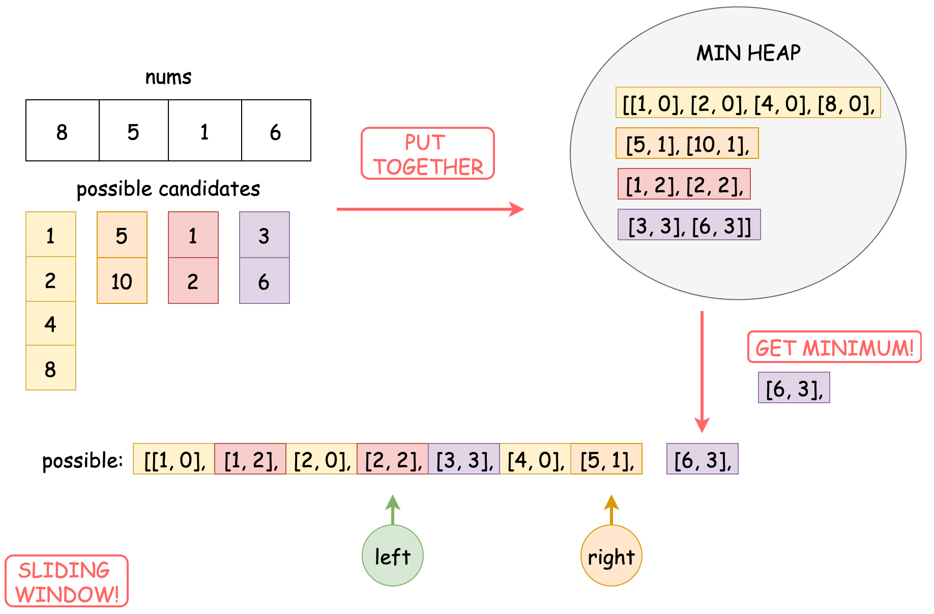

Note that this would not save you time complexity, just show the possibilities of solving this problem.

Also, we can put all candidates in a max-heap instead of a min-heap. That is similar.

**Algorithm**

Step 1: Initialize a list possible.

* Iterate nums. For nums[i], push all possible [candidate, i] pairs into the possible list.

Step 2: Initialize a min-heap from possible.

Step 3: Initialize a vector needInclude, where needInclude[i] marks if the sliding window includes i's candidates or not (and how many it includes). Initialize an integer notIncluded representing the total number of index whose all candidates are not in the sliding window.

Step 4: Move the right pointer of the sliding window to one unit right. When the right pointer needs to go right, pop the minimum from the heap as the next element.

* If notIncluded shows that the sliding window includes every index's candidates (i.e., notIncluded == 0), move the left pointer to right until the sliding window does not include them. Update the minimum deviation during this period.

Step 5: Repeat Step 4 until the right pointer reaches the end of possible.

Step 6: Return the minimum deviation.

Challenge: Can you implement the code yourself without seeing our implementations?

**Implementation**

|  |
| --- |
| class Solution {  public int minimumDeviation(int[] nums) {  int n = nums.length;  // pretreatment  List<int[]> possible = new ArrayList<>();  for (int i = 0; i < n; i++) {  if (nums[i] % 2 == 0) {  int temp = nums[i];  possible.add(new int[] { temp, i });  while (temp % 2 == 0) {  temp /= 2;  possible.add(new int[] { temp, i });  }  } else {  possible.add(new int[] { nums[i], i });  possible.add(new int[] { nums[i] * 2, i });  }  }  PriorityQueue<int[]> priorityQueue = new PriorityQueue<>(Comparator.comparingInt(p -> p[0]));  priorityQueue.addAll(possible);  int minDeviation = Integer.MAX_VALUE;  int notIncluded = n;  int currentStart = 0;  int[] needInclude = new int[n];  for (int i = 0; i < n; i++) {  needInclude[i] = 1;  }  List<int[]> seen = new ArrayList<>();  // get minimum from heap  while (!priorityQueue.isEmpty()) {  int[] current = priorityQueue.poll();  seen.add(current);  int currentValue = current[0];  int currentItem = current[1];  needInclude[currentItem] -= 1;  if (needInclude[currentItem] == 0) {  notIncluded -= 1;  }  if (notIncluded == 0) {  while (needInclude[seen.get(currentStart)[1]] < 0) {  needInclude[seen.get(currentStart)[1]] += 1;  currentStart += 1;  }  if (minDeviation > currentValue - seen.get(currentStart)[0]) {  minDeviation = currentValue - seen.get(currentStart)[0];  }  needInclude[seen.get(currentStart)[1]] += 1;  currentStart += 1;  notIncluded += 1;  }  }  return minDeviation;  }  } |

Note: The C++ version is likely to yield Time Limit Exceeded. This might be because the time limit of C++ is tighter.

**Complexity Analysis**

Let N*N* be the length of nums, and M*M* be the largest number in nums. In the worst case when M*M* is the power of 22, there are \log(M)log(*M*) candidates for M*M*. Therefore, in the worst case, the total candidate number (denoted by K*K*) is K = N \cdot \log(M) = N\log(M)*K*=*N*⋅log(*M*)=*N*log(*M*).

* Time Complexity: \mathcal{O}(K\log(K)) = \mathcal{O}(N\log(M)\log(N\log(M)))O(*K*log(*K*))=O(*N*log(*M*)log(*N*log(*M*))). In the worst case, possible has K*K* elements, and we need to pop every elements from it, which costs \mathcal{O}(K\log(K))O(*K*log(*K*)). For the sliding window, we need \mathcal{O}(K)O(*K*) time, since the left pointer and the right pointer visit every element in possible once.
* Space Complexity: \mathcal{O}(K) = \mathcal{O}(N\log(M))O(*K*)=O(*N*log(*M*)), since in the worst case, possible has K*K* elements.

#### Approach 4: Pretreatment + Heap + Pointers

**Intuition**

Still, with some pretreatments, we transform it into [Smallest Range Covering Elements from K Lists](https://leetcode.com/problems/smallest-range-covering-elements-from-k-lists/).

This time, we borrow some ideas from [Merge k Sorted Lists](https://leetcode.com/problems/merge-k-sorted-lists/) and Approach 1.

For each index, we initialize a pointer and point it to the top element (i.e., the minimum element).

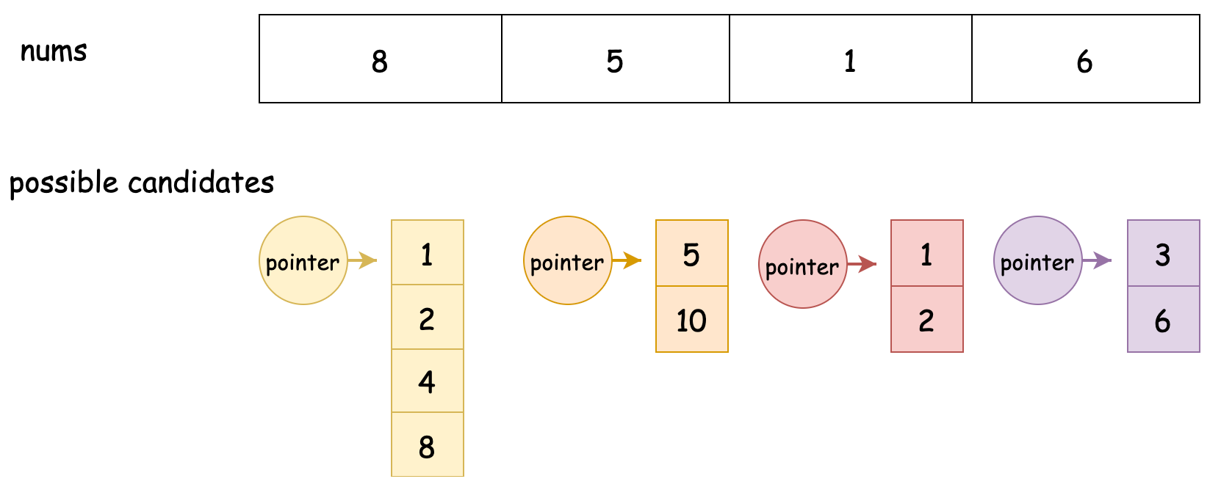

According to some ideas in Approach 1,

\text{deviation} = \text{maximum} - \text{minimum}deviation=maximum−minimum

There are only two ways to decrease \text{deviation}deviation: decrease \text{maximum}maximum, or increase \text{minimum}minimum.

If we point all the pointers to the minimum element in the candidate list, that is similar to change all the numbers in num to the minimum candidate. In this case, we can **not** decrease \text{maximum}maximum. We can only increase \text{minimum}minimum.

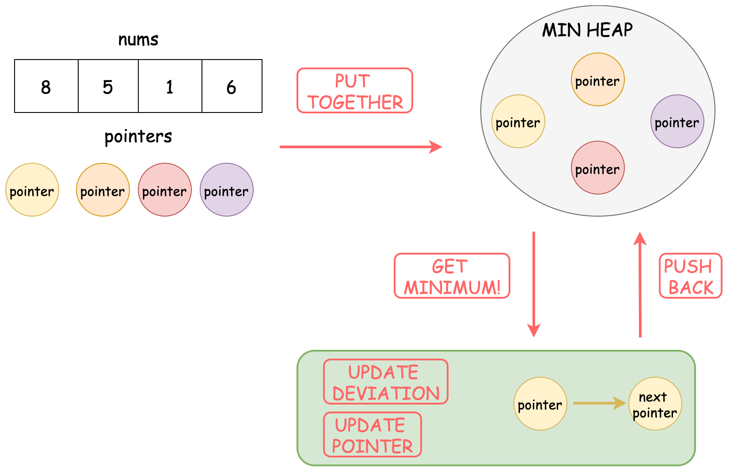

Therefore, we can keep getting the minimum pointer from the heap, update the deviation, move the pointer point to the next element, and then push back the pointer to the heap.

Of course, you can use a max heap instead of a min-heap. That requires some corresponding changes in the code.

Essentially, this solution is similar to Approach 1 except we pre-calculate all the candidates.

**Algorithm**

Step 1: Initialize a list possibleList.

* possibleList[i] contains a list of all possible candidates of nums[i].

Step 2: Initialize a heap pointers containing starting pointers. Each starting pointer should point to the start of each candidate list.

Step 3: From pointers take out the minimum number. Update the minimum deviation. Push the next number of that pointer into pointers.

Step 4: Repeat Step 3 until one of the pointers reaches the end.

Step 5: Return the minimum deviation.

Challenge: Can you implement the code yourself without seeing our implementations?

**Implementation**

|  |
| --- |
| class Solution {  public int minimumDeviation(int[] nums) {  // pretreatment  int n = nums.length;  List<List<Integer>> possibleList = new ArrayList<>();  for (int i = 0; i < n; i++) {  List<Integer> candidates = new ArrayList<>();  if (nums[i] % 2 == 0) {  int temp = nums[i];  candidates.add(temp);  while (temp % 2 == 0) {  temp /= 2;  candidates.add(temp);  }  } else {  candidates.add(nums[i] * 2);  candidates.add(nums[i]);  }  // reverse candidates to sort from small to large  Collections.reverse(candidates);  possibleList.add(candidates);  }  List<int[]> pointers = new ArrayList<>();  for (int i = 0; i < n; i++) {  pointers.add(new int[] { possibleList.get(i).get(0), i, 0 });  }  PriorityQueue<int[]> priorityQueue = new PriorityQueue<>(Comparator.comparingInt(p -> p[0]));  priorityQueue.addAll(pointers);  int minDeviation = Integer.MAX_VALUE;  int currentEnd = 0;  for (int i = 0; i < n; i++) {  currentEnd = Math.max(currentEnd, possibleList.get(i).get(0));  }  // get minimum from heap  while (!priorityQueue.isEmpty()) {  int[] current = priorityQueue.poll();  int currentStart = current[0];  int index = current[1];  int indexInCandidates = current[2];  if (minDeviation > currentEnd - currentStart) {  minDeviation = currentEnd - currentStart;  }  // if the pointer reach last  if (indexInCandidates + 1 == possibleList.get(index).size()) {  return minDeviation;  }  int nextValue = possibleList.get(index).get(indexInCandidates + 1);  currentEnd = Math.max(currentEnd, nextValue);  priorityQueue.offer(new int[] { nextValue, index, indexInCandidates + 1 });  }  return minDeviation;  }  } |

Note: The C++ version is likely to yield Time Limit Exceeded. This might be because the time limit of C++ is tighter.

**Complexity Analysis**

Let N*N* be the length of nums, and M*M* be the largest number in nums. In the worst case when M*M* is the power of 22, there are \log(M)log(*M*) candidates for M*M*. Therefore, in the worst case, the total candidate number (denoted by K*K*) is K = N \cdot \log(M) = N\log(M)*K*=*N*⋅log(*M*)=*N*log(*M*).

* Time Complexity: \mathcal{O}(K\log(N)) = \mathcal{O}(N\log(M)\log(N))O(*K*log(*N*))=O(*N*log(*M*)log(*N*)). In the worst case, possibleList has K*K* candidates, and we need to push every candidates into pointers, which cost \mathcal{O}(K\log(N))O(*K*log(*N*)).
* Space Complexity: \mathcal{O}(N)O(*N*), since pointers always has N*N* elements.

#### Approach 5: Pretreatment + Sorting + Pointers

**Intuition**

Similar to Approach 4, if you do not like using the heap, we can pre-sort the pointers in the order we need, and get the next pointer one by one.

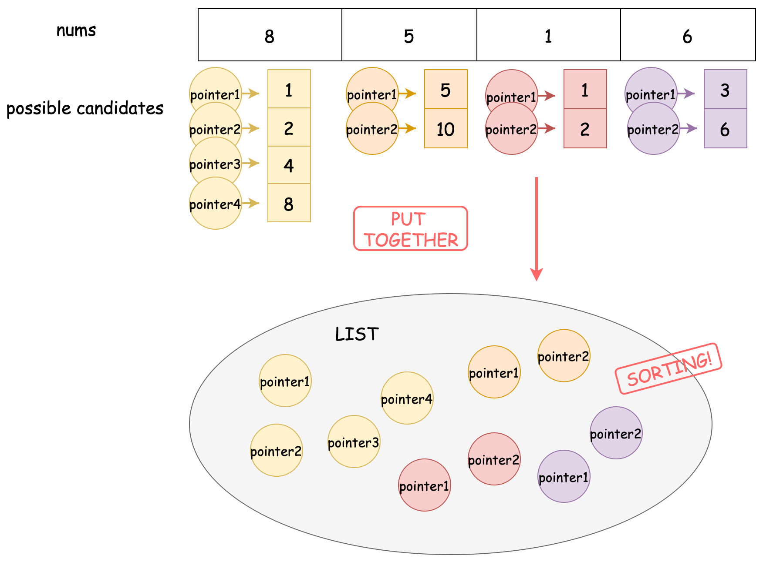

**Algorithm**

Step 1: Initialize a list possibleList.

* possibleList[i] contains a list of all possible candidates of nums[i].

Step 2: Initialize a list pointers containing all pointers. Each pointer should point to one different candidate in possibleList.

Step 3: Sort pointers.

Step 4: From pointers take out the minimum number. Update the minimum deviation. Get the next pointer in the same candidate list.

Step 5: Repeat Step 4 until one of the candidate lists reaches the end.

Step 6: Return the minimum deviation.

Challenge: Can you implement the code yourself without seeing our implementations?

**Implementation**

|  |
| --- |
| class Solution {  public int minimumDeviation(int[] nums) {  int n = nums.length;  // pretreatment  List<List<Integer>> possibleList = new ArrayList<>();  for (int i = 0; i < n; i++) {  List<Integer> candidates = new ArrayList<>();  if (nums[i] % 2 == 0) {  int temp = nums[i];  candidates.add(temp);  while (temp % 2 == 0) {  temp /= 2;  candidates.add(temp);  }  } else {  candidates.add(nums[i] * 2);  candidates.add(nums[i]);  }  // reverse candidates to sort from small to large  Collections.reverse(candidates);  possibleList.add(candidates);  }  List<int[]> pointers = new ArrayList<>();  for (int i = 0; i < n; i++) {  int size = possibleList.get(i).size();  for (int j = 0; j < size; j++) {  pointers.add(new int[] { possibleList.get(i).get(j), i, j });  }  }  pointers.sort(Comparator.comparingInt(p -> p[0]));  int minDeviation = Integer.MAX_VALUE;  int currentEnd = 0;  for (int i = 0; i < n; i++) {  currentEnd = Math.max(currentEnd, possibleList.get(i).get(0));  }  for (int[] current : pointers) {  int currentStart = current[0];  int index = current[1];  int indexInCandidates = current[2];  if (minDeviation > currentEnd - currentStart) {  minDeviation = currentEnd - currentStart;  }  // if the pointer reach last  if (indexInCandidates + 1 == possibleList.get(index).size()) {  return minDeviation;  }  int nextValue = possibleList.get(index).get(indexInCandidates + 1);  currentEnd = Math.max(currentEnd, nextValue);  }  return minDeviation;  }  } |

Note: The C++ version is likely to yield *Time Limit Exceeded*. This might be because the time limit of C++ is tighter.

**Complexity Analysis**

Let N*N* be the length of nums, and M*M* be the largest number in nums. In the worst case when M*M* is the power of 22, there are \log(M)log(*M*) candidates for M*M*. Therefore, in the worst case, the total candidate number (denoted by K*K*) is K = N \cdot \log(M) = N\log(M)*K*=*N*⋅log(*M*)=*N*log(*M*).

* Time Complexity: \mathcal{O}(K\log(K)) = \mathcal{O}(N\log(M)\log(N\log(M)))O(*K*log(*K*))=O(*N*log(*M*)log(*N*log(*M*))). In the worst case, possibleList has K*K* candidates, and we need to sort K*K* pointers, which cost \mathcal{O}(K\log(K))O(*K*log(*K*)).
* Space Complexity: \mathcal{O}(K)O(*K*), since pointers has K*K* elements in the worst case.